Docker

Why industry wants to use Docker?

In the industry there will be developers and operations team one who develops the application & another one who builds and deploys the application in the production

Below are all the stakeholders you see while working in the developers team

* Architects
* Developers
* QA
* DevOps

Below all the stakeholders you see while working in the operations team/infrastructure

* IT Infrastructure team
* Provisioning team
* Storage admin
* Network engineers
* Operations
* Platform team
* Monitoring team

Both the teams will have their own responsibilities while developing or deploying the applications, but there will be a huge gap in understanding each other role

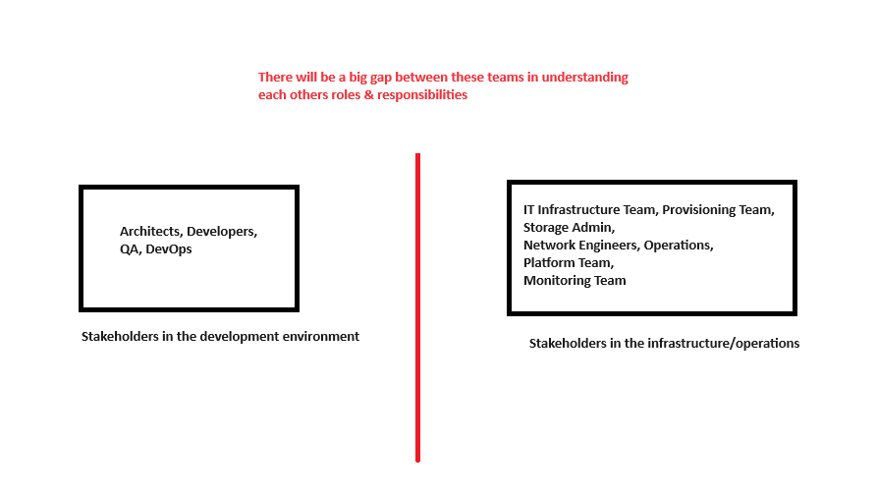

The developers team role would be about identifying below technologies & tools

* Language
* Framework
* Development tools
* Version control system

The developers team role ends by writing the code, testing the code, integrating the code & committing the changes to the version control system, once they commit the final code goes to the build server which is ready for the build & deployment

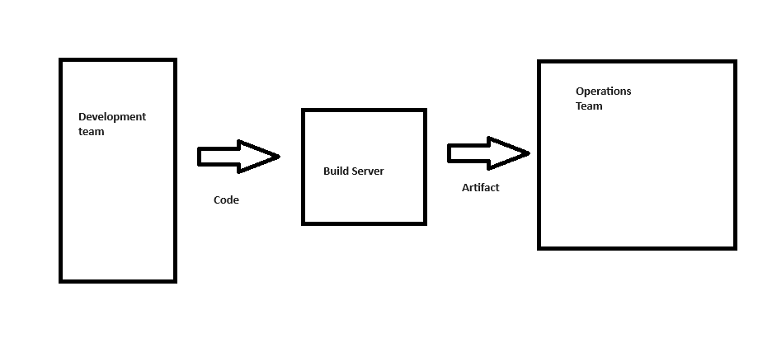

What can be the Build Server

It can be

* Jenkins
* TeamCity
* Bamboo

The build server responsibility is to take the input which is the source code & build it by compiling, testing & building and producing the output which is a software artifact.

These artifacts can be of different type based on the language you use like jar, war, dist, exe, dll and etc.

What does Operations team do

Once they get the software artifact, they do list of tasks to deploy the application like

* Procure the infrastructure
* Install the platforms
* Install the dependencies
* Install the servers
* Install the databases
* Deploy the application

Then they start monitoring, scaling, patching, troubleshooting the application

Now what will be the issue?

Both the teams will not have an idea about the processes & challenges the other team faced to run the application but at the end of the day both are responsible for their work, but the issue will come when there’s an outage because this part of deployment is a shared deployment model or shared ownership where both of them are owning the same deployment, when there’s a production issue it leads to the friction between the developers & operations team, because the developers say our application runs fine in our machine with the configuration what they have & infrastructure team says it doesn’t work against the production configuration machine, which leads to the unnecessary friction between the teams and impacts the workflow.

What is the solution?

We need to bring both the teams together so that both are on the same page, instead of blaming each others team like developers team telling the infrastructure team must know Java, Node, Python and etc, however the infrastructure team need to follow different steps while deploying the application based on the type of application they are deploying, because the deployment steps for java, python, node would vary, since both the teams are dependent on each other and development team wouldn’t be comfortable with the infrastructure, we need a common format which will bridge both the teams, which is nothing but a Docker.

What is a Docker?

Docker is a platform that simplifies the process of building, shipping and running applications within an environment called a container.

What is a Container?

It is a process which runs on a host, It is a lightweight isolated environment which packages everything you need to run the application such as code, libraries, runtime, configurations, Host OS

What is an isolated environment

Containers run independently from other containers and from the Host System, this isolation ensures that application within the container don’t interfere with each other or the host system

Note: When the application is developed in one machine it will be built and deployed in another machine, obviously the application must be independent from the host machines, docker makes these things much easier now

Why Docker instead of Virtual Machines

Below diagram shows the architecture of both VM & Docker

Virtual Machines: Here you can see the Hypervisor in the first diagram which is a VM that needs a Guest OS, which will have its own inbuilt programs running in the background, which may not be required to run the application, on top of these Guest OS Applications are deployed, when you want to run another application in a different OS you need to have another Guest OS on top of the VM and on that you need to run the application, which will make the VMs heavier,

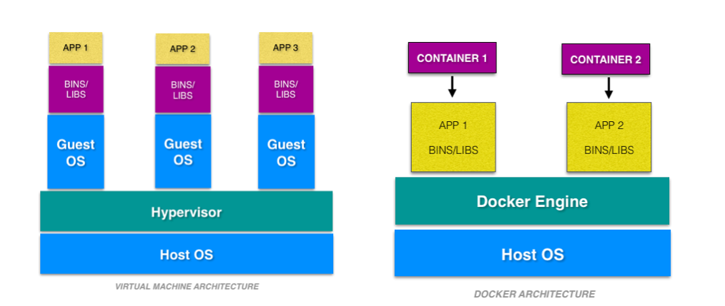

Docker: In Docker you don’t need a Guest OS and all their unnecessary inbuilt programs which are bound to the Guest OS, what you need is a Docker engine (available for all the OS) which is a runtime environment that can launch the container and inside the container the application and its related dependencies, runtime environment and also the OS that is required to run the application will be present in it, however these Operating Systems are not like the Guest OS you install in the VM, rather they are tailor made OS whose size will vary between 50MB to 500MB, these are created specially to run within the container, they will not take too much of resources as they will not have any unnecessary programs which application doesn’t need, if another application needs to be run, then you can run a different container with the required tailor made OS + application and their dependencies, from Docker you can spin up any number of containers as you wish, if it needs to be run on a different HOST, then you can just ship these containers as docker images and having docker engine installed in it you can run the docker images that creates a container without installing any softwares on the base OS you can easily run the applications by including the required dependencies within the container

What are Docker images now?

A Docker image is a lightweight, standalone, executable package that includes everything needed to run an application, including the code, runtime, libraries, environment variables & configurations

How to create Docker images

Docker images are created using a text file named ‘Dockerfile’ which will have set of instructions to build a Docker image, you will not run Dockerfile rather you build an image from this Dockerfile & then run those images which creates a container

A simple Dockerfile looks to launch a Java HelloWorld program looks like this

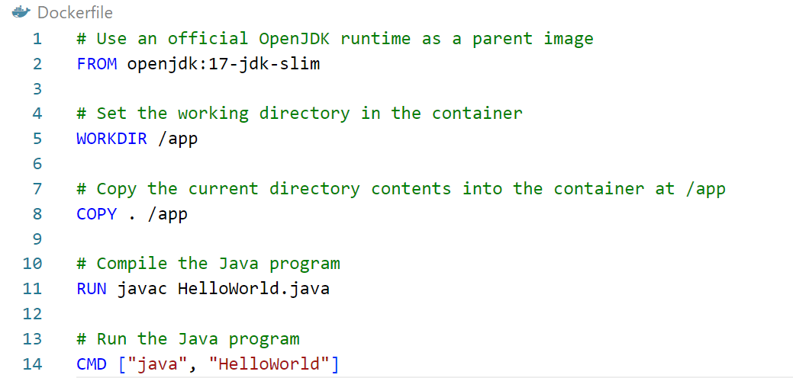

A simple command to build a docker image from a Dockerfile looks like this

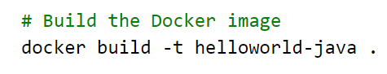

Finally the command to run the image looks like this

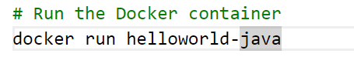

Note: If all these looks weird and confusing, don’t worry as we are going to discuss everything practically that clears all of your doubts

Benefits of Docker images

* Docker images are used to create docker containers, when you run a Docker image, it becomes a container.
* They are reusable and can be shared via Docker Hub or other container registries
* Images can be layered, meaning one image can be built on top of another, we will understand about layers of images later.

Note: Docker images are immutable, they cannot be altered once they are created, this read-only nature ensures the consistency & reliability, as the same image can be deployed across multiple environments without changes.

What are the roles of Developers in Docker

Below are the roles of Developer in Docker

* Writing Dockerfiles
* Building Docker images
* Isolating Dependencies
* Deploy and Test in local environments
* Collaboration
* Documentation

What are the roles of Developers in Docker

Below are the roles of Operations team in Docker

* Infrastructure management
* Deployment and Release management
* Monitoring and Logging
* Scaling and Load Balancing
* Backup and Recovery
* Documentation

Software’s required

1. Docker Engine (Docker desktop for windows)

Once you install the Docker desktop in your machine you can see the docker image as below you must double click on it.



Once you double click you see a UI and at the bottom left you must see the docker engine running status which must be in green color as shown, If it is in green color then docker engine is running

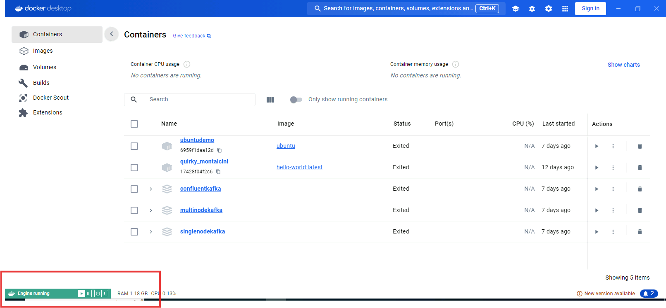

Open terminal to check the version of docker using docker --version command

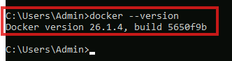

You can list the docker images using docker images command



If you running docker images command for the first time you will see an empty table, it means that there are no images in the machine right now, but soon we are going to use some images.

Pulling our first image: hello-world

Use docker pull hello-world

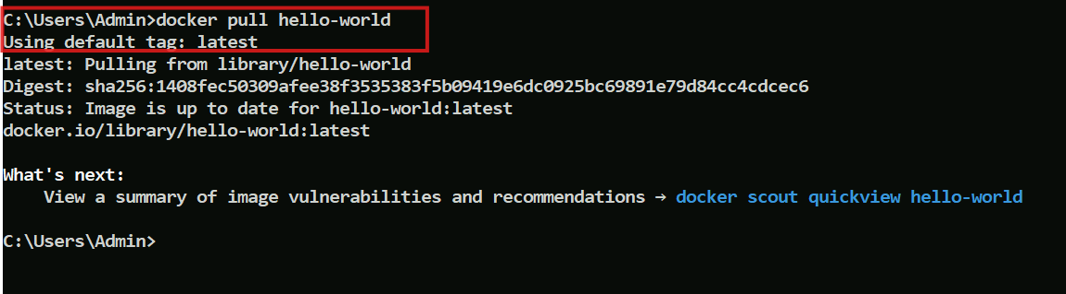

What docker pull does

It by default checks in the docker hub registry and pulls the hello-world image, which is a hello world program written in C,

You can search hello-world in the docker desktop, where you get the hello-world image downloaded from the docker hub registry.

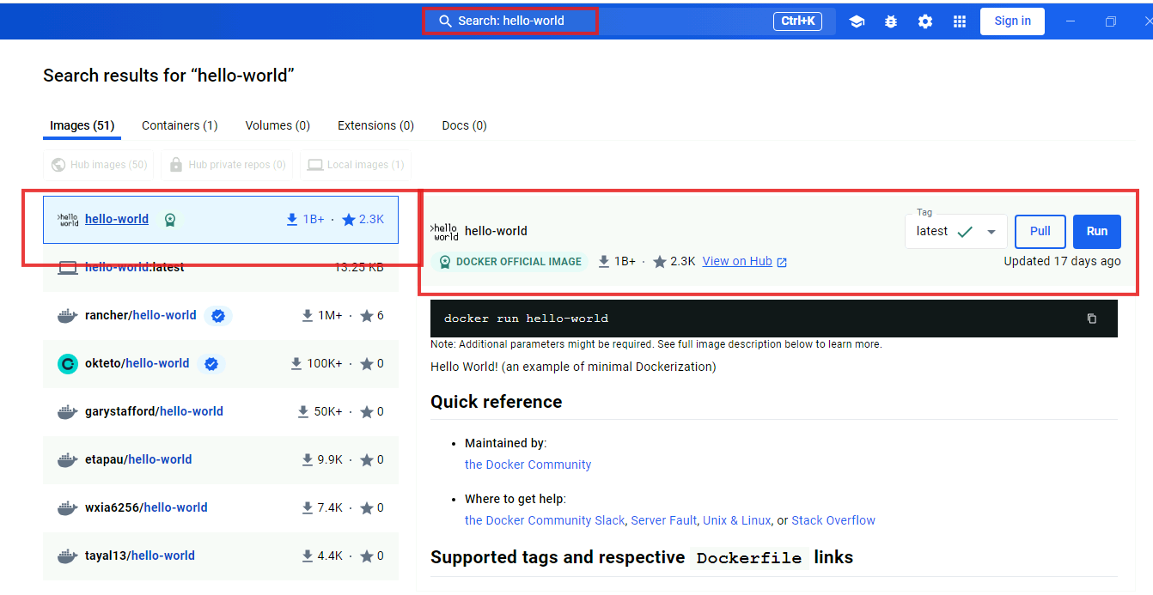

You can also see the command to run just below the Pull & Run buttons at the right side, which runs the image and creates a container for hello-world application.

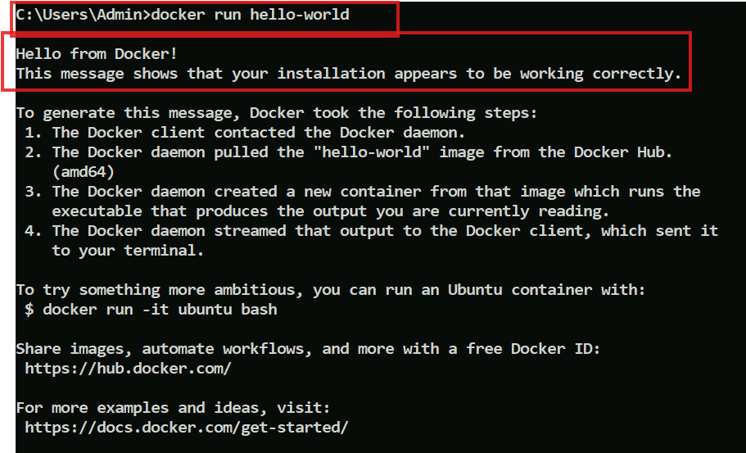

You can see the output of the application, which is executed without installing any runtime environment for C program, this hello-world has all the dependencies to run the program.

You can scroll down to check how this image is created as well

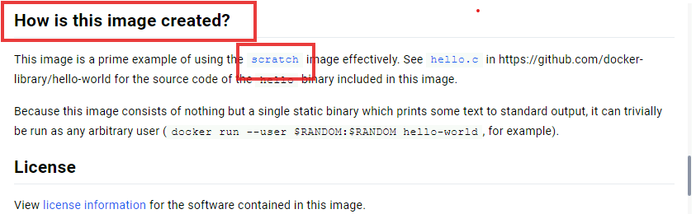

It says it is using the scratch, which is another image, when you click on scratch you will see the below window that gives an idea which specific OS it is using to run this application within the container.

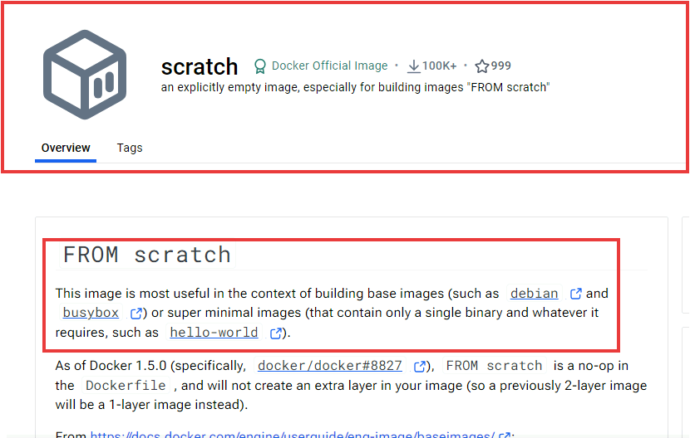

You can pull the debian and busybox as well to check what is there in it.

You can visit Debian or busybox to see what it is, below is the description we get when we visit busybox

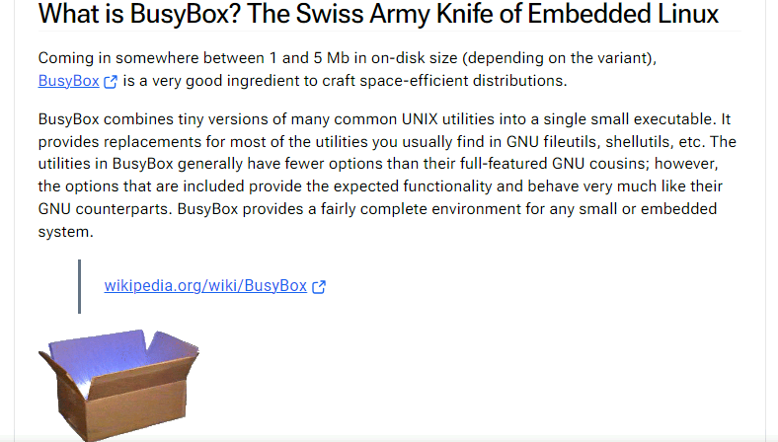

Let us pull and run the busybox and see what happens

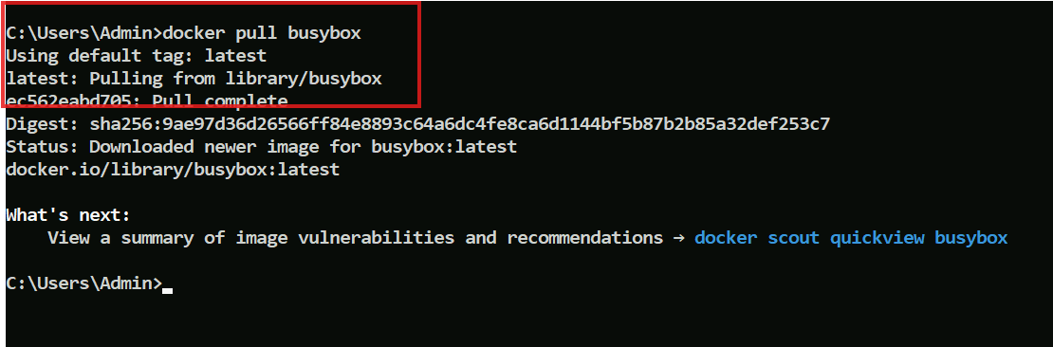busybox is a tiny OS of Unix distribution, it is around 5MB, you can check by using docker images, below is the output of docker images



We can also run busybox, but we don’t get the output as it doesn’t print any thing in the standard console, unlike our hello-world program, however you can always get inside this utility with some commands lets see what it is.

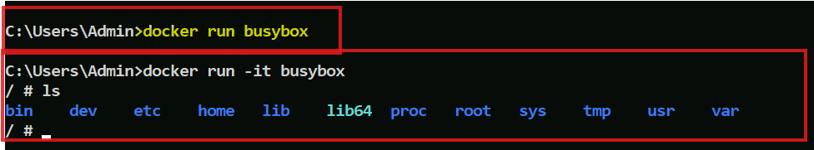

You can observe the yellow highlighted command didn’t do much, but using -it with docker run takes us inside the container where we can perform any task we need.

Listing all the running containers

docker container ls is the command you can use

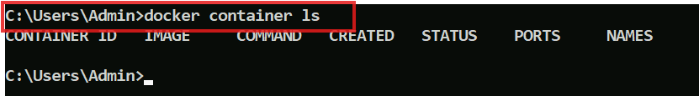

Since there are no containers running the table is empty.

You can use --all to see all the containers

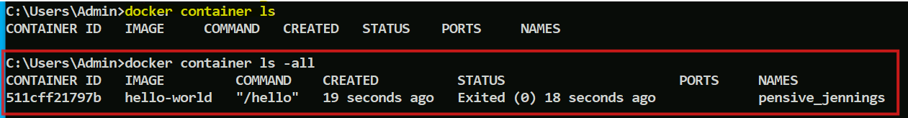

What are these containers

Containers are like programs which will start then execute and then completes the job and terminates, just like the way you install the software, where it takes the binary installs it and once the job completes it terminates, these are called as short-lived process, you will also see long-lived process from the containers like databases, servers, these services don’t terminate unless you stop the services, these are the nature of the container that depends on the instructions encoded in the image.

Every container will have container-id which is an unique to the container, status that says whether its running or exited, names that is unique to every container which will be divided into 2 things i.e., adjective and author-name



Note: Every image will also have an unique id

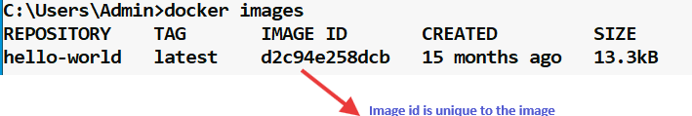

Difference between images and container

Images are templates from that you can create container, images are like zip/archive and containers are like files and folders you get after the unzip, but when you want to ship the files & folders you will zip and ship it, same way you can ship the images to share it with others so that they can create container from the image.

In Docker you can create containers from the images and also images from the container, both are possible

Images are made up of multiple layers

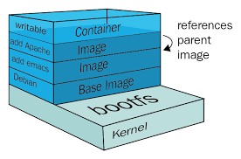

You can observe the above diagram, where you will have a kernel and a base image, the base image is a tailor made OS i.e., Debian in this case, from this base image you can create a container and install some software’s then you will convert that into an image which is done by building an image, again from this image you can create a container and write something and convert it into another image on top of the previous image and create a container from the image and then write some thing, build the image on top of the previous image and so on you can create multiple layers of the image

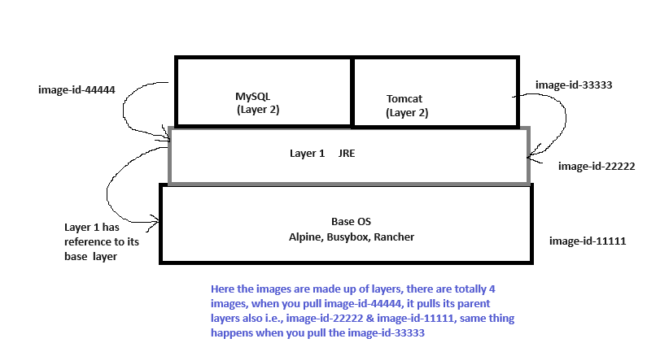

The layers in the images are created from the container, i.e., from the base-os image you create a container and install JRE in the container from that you will build a new image in the Layer 1, from the Layer 1 you will create a container then install tomcat and build a new brand image on Layer 2, using the container created from Layer 1 you can install other software’s and build different images that comes in the Layer 2, the size of the image is determined from all the underlying layers to which it refers, i.e., MySQL at Layer2 refers to the JRE at Layer 1 which in turn refers to the Base OS image, similarly Tomcat at Layer2 refers to the JRE at Layer 1 which in turn refers to the Base OS image

Note: Images are immutable or read-only, when you want to write anything first you must create a container and write in the container and then build an image from the container

Note: When a top-most image is pulled then all of its parent images will be pulled, which you can notice at the time pulling where the terminal shows the image downloading process with the image-id, which looks something like below

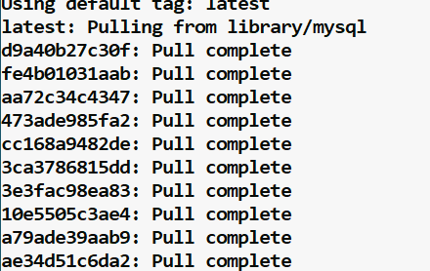

The above screenshot is just to show what happens when an image mysql is pulled, notice the different image-ids that are getting downloaded which are the depends of mysql

What is the relationship between the images and the container

Every image will have an unique id and even containers also will have an unique id, from one image you can create multiple containers, which means it has one to many relationship, and all the containers created from a image will have the same configurations as per the instructions encoded in the image

Where are these images present?

These images are hosted in the registry, the default registry is docker hub, docker hub has a docker registry where all the images are stored, this is similar to the npm registry for node libraries or maven registry for java libraries

Pulling nginx: nginx is an open source reverse proxy servers for HTTP, HTTPS and other protocols

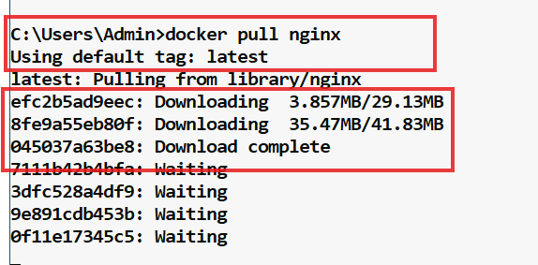

Notice the different layers that are pulled when nginx is pulled and it is pulled from the docker.io/library which is nothing but the from the docker registry it is pulled, which is shown in the below screen shot

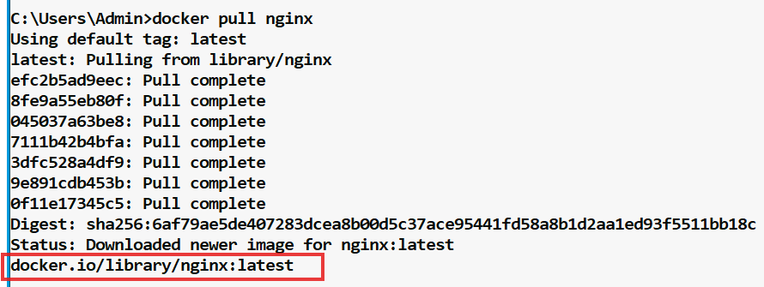

Listing the images

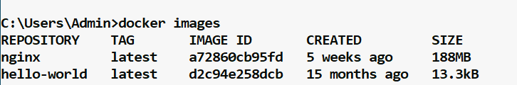

Observe the size of the nginx which is 188MB, which is very less when we compare it with the regular VM’s

Running the nginx container

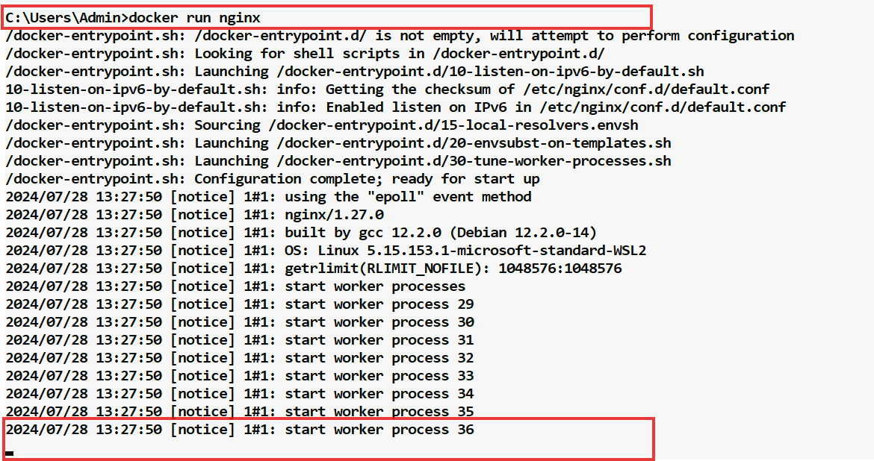

The terminal is also attached to the process, hence we need to exit this mode and run the container in detached mode, to come out of the attached mode press control + c a few times, and then run the container in detached mode using -d

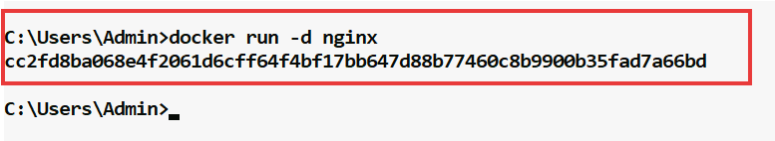

-d stands for detached

You can see the containers list now using docker container ls



You can see the container is not terminated it is up & running in the STATUS & taken the PORT 80

Earlier when you executed docker run nginx without -d it produced some logs, these logs are written in the log files in the detached mode also to see that you can use below command.

docker container logs <<container-id>>

Output:

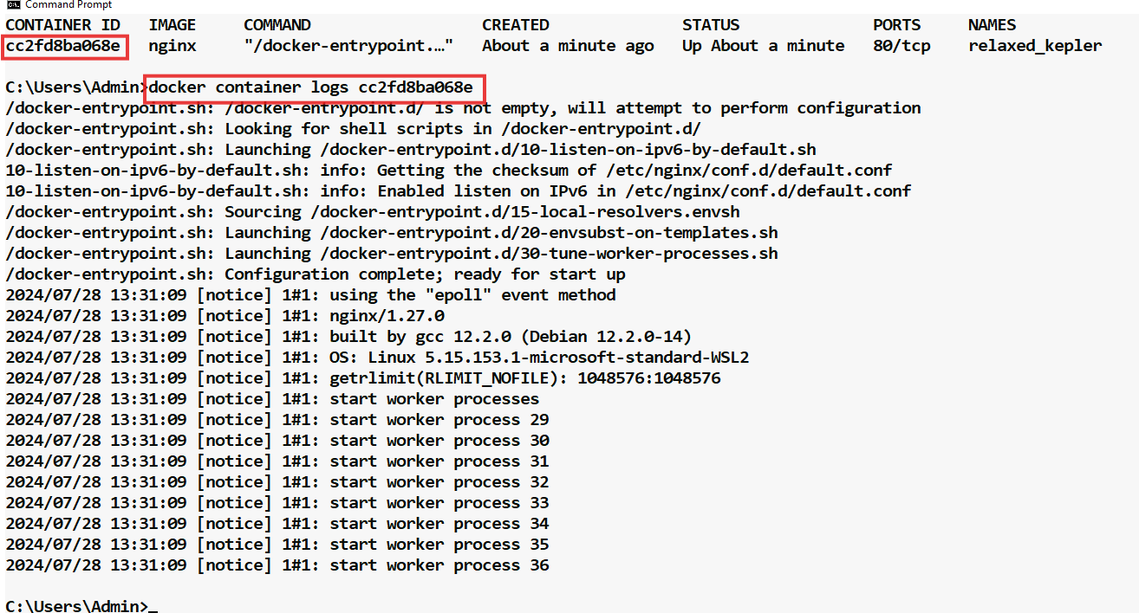

Note:

docker logs <<container-id>> also gives you the same output like docker container logs <<container-id>>, similarly you can use docker ps to list the containers, but these commands must be avoided as the docker has segregated the image commands and container commands and deprecated them and in future they may remove them, hence the recommended approach is to use docker container logs instead of using docker logs

We can navigate also navigate to the container

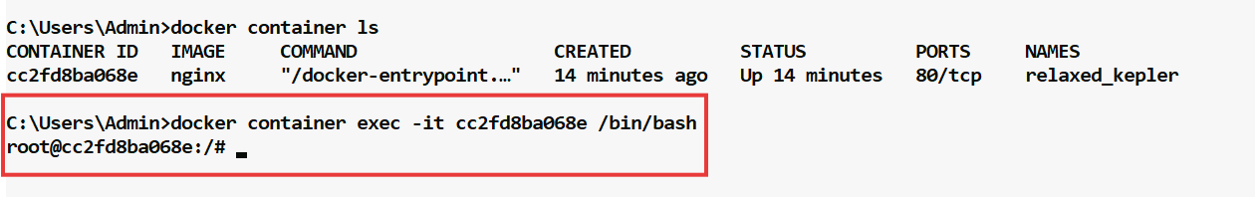

The above command has taken you inside the container, now the terminal is not in the local host rather its inside the container.

You can use a curl command to see the default output of the nginx server page, this displays the HTML content in the terminal itself

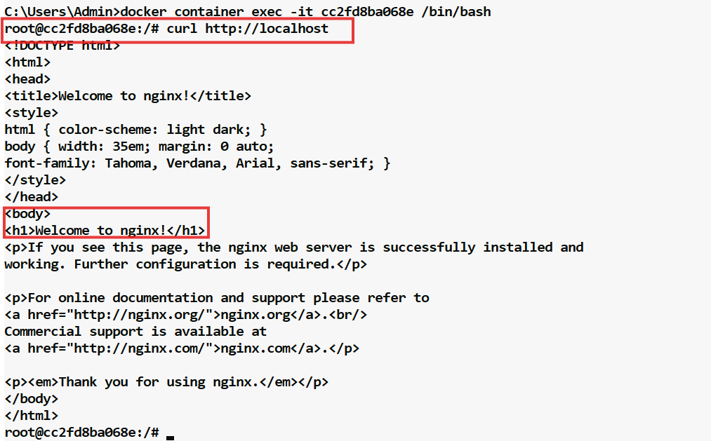

We can also edit the content of this page by navigating to /usr/share/nginx/html folder, this page content is present in index.html, let us navigate to /usr/share/nginx/html

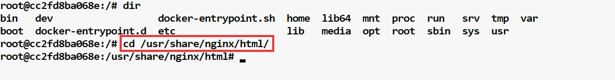

Though we are inside a container, it uses unix based OS, we don’t have all the unix softwares, because it has only those primitives which are required to run the container, using vi gives the below error

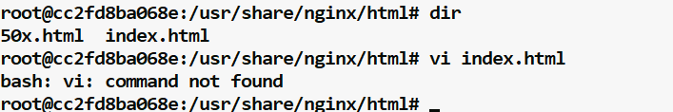

We can use echo content > index.html to edit the file

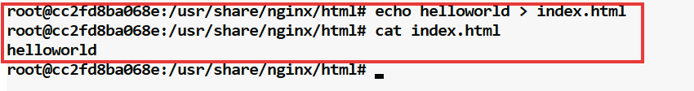

What we have done is we have edited using echo and seeing the content using cat, but we need to open this html using curl

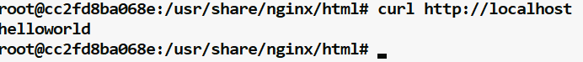

Now the changes done will be there as long as the container is running, but the changes will be lost once the container is deleted, because the changes is happened in the container not on the source image, when we create the container again we get the content what is encoded in the image, not what we written in the container

Let us stop and remove the container using below commands

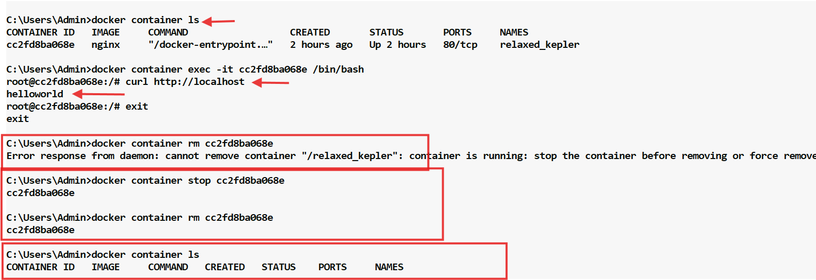

Before removing notice the 3rd arrow which is the current content of the index.html which we got from the curl, let us again create the container from the nginx image

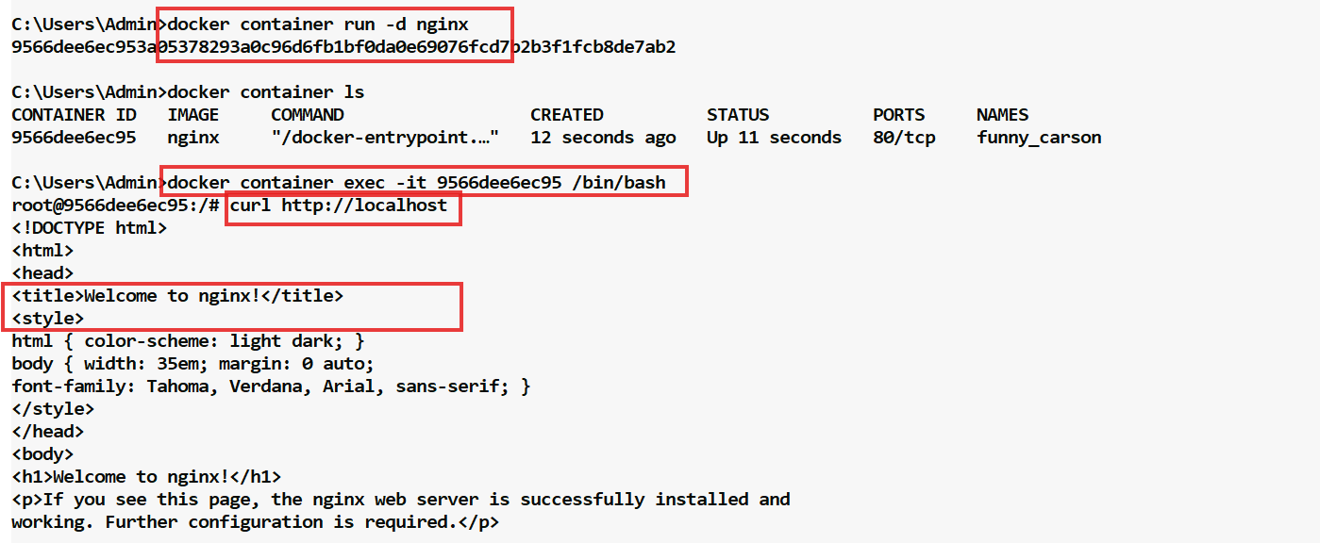

But if you had created the image from the container a new image will be built with whatever the changes you have made, let us do below steps

1. Create the container from the nginx
2. Get inside the container & navigate to the /usr/share/nginx/html
3. echo some content to the index.html
4. Create a new brand image
5. Create a container from the new image that is built after the changes done
6. You must see the container showing changes, however the nginx container doesn’t show the new changes if in case you remove the container and re-create it

Step 1: Create the container from nginx

docker container run -d nginx

Step 2: Get inside the container & navigate to the /usr/share/nginx/html

docker container exec -it 9566dee6ec95 /bin/bash

Step 3: echo some content to the index.html

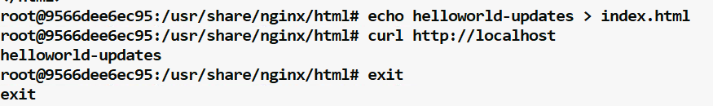

Step 4: Create a new brand image using docker commit <<container-id>> <<name>>:version

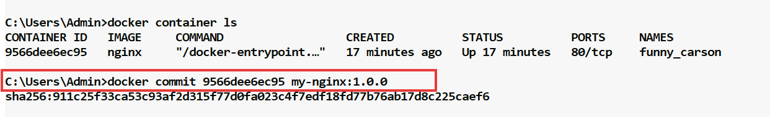

List the image to see the new image

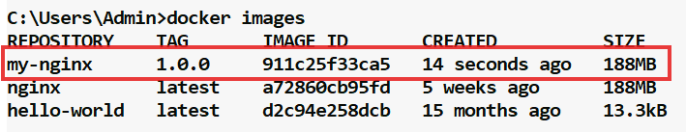

Step 5: Create a container from the new image



Step 6: Container showing the changes

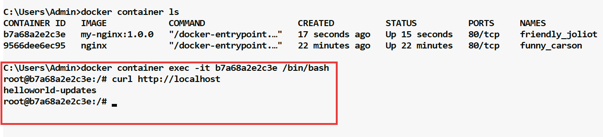

Note: nginx container shows the changes done in the container, but if you remove and then re-create the container again then you will see the default content of the index.html, because that is what encoded in nginx, but in the new-nginx we have encoded the changes in index.html that will be shown when we remove and recreate the container

When to make changes to the container?

Whenever you want to create a new layer to the image and want to share with others then you can persist the changes and create a new layer to the image

Note: We can create containers from the images as well as images from the container

Images can be created with versions

First update the index.html with some content as



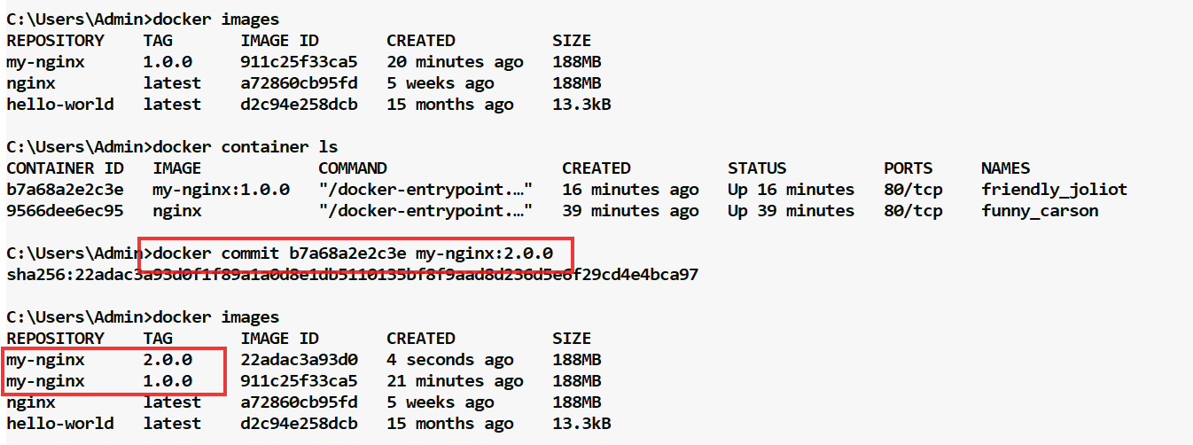

Now you can run the my-nginx:2.0.0 and see those new changes

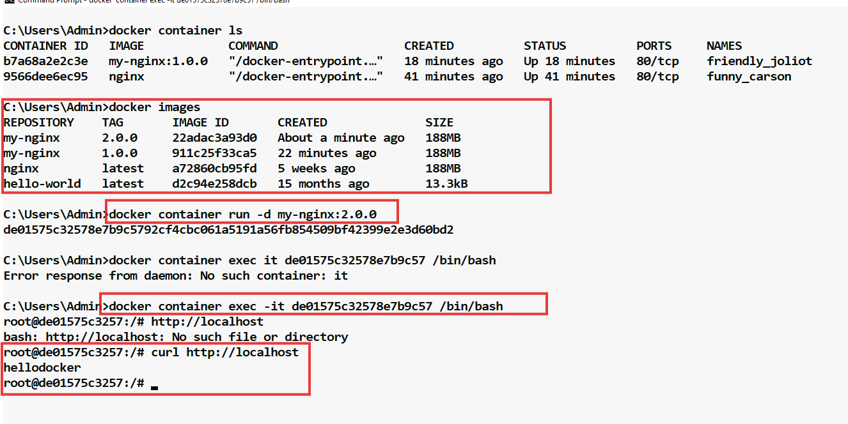

Now you can see the layers in the images

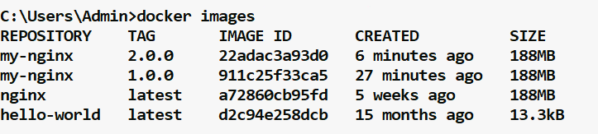

We have created my-nginx:1.0.0 from nginx, then from my-nginx:1.0.0 we created my-nginx:2.0.0, Things to observe here are:-

* When you pull my-nginx:2.0.0 you get hellodocker as the output
* When you pull my-nginx:1.0.0 you get helloworld-updates as the output
* When you pull nginx you get default output

How to stop, start, restart and remove the containers

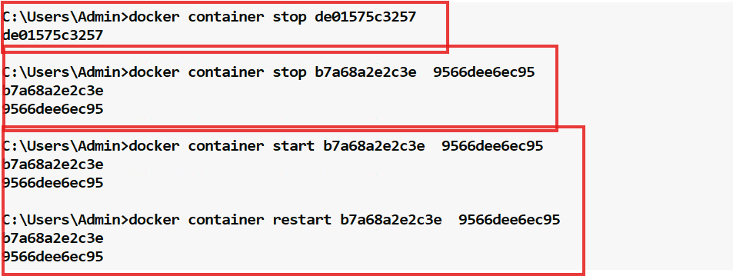

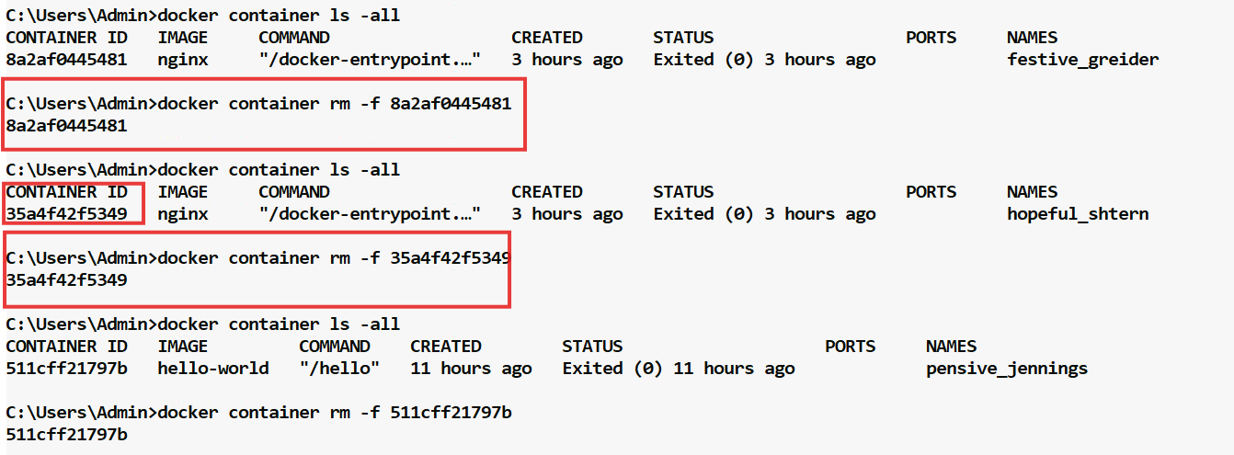

Note: You can use one or more container-ids separated by space

How to remove the images

Firstly you need to know the image id which you can get using docker images

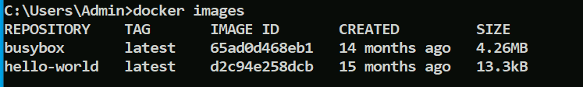

Then you can use docker rmi image-id image-id or docker rmi -f image-id image-id

You can mention multiple image-id’s separated by a space and use -f to forcibly remove the image, if its being used by stopped container, just as shown below

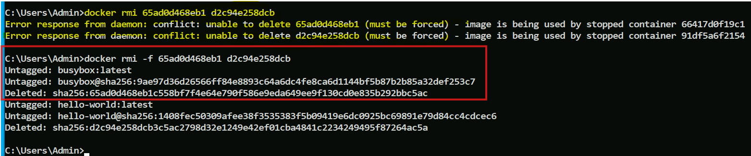

Notice the image-ids are separated by spaces where we are trying to remove 2 images at the same time, however you get an error response, hence the other command uses -f to forcibly remove the images.

What docker container run does if image is not present in the local machine

If the image is not present then it pulls from the registry and runs, below is the example where nginx is not present in the local machine, it pulls the image and creates the container

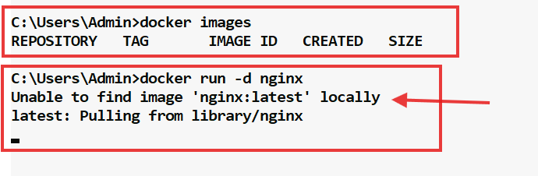

You can observe there are no images on the first command, and on the second command you can observe it says unable to find image locally and starts pulling the nginx

Port binding

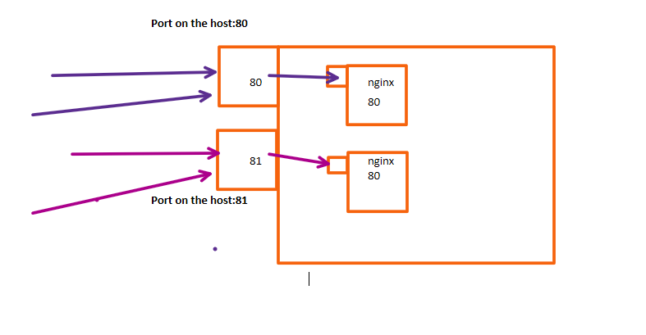

Whatever the containers running on the host they are jailed, means they are not accessible to the public, hence we need to bind the port of the host machine to the container, we must also know that every container has its own IP, so whenever you create same container they all take same port however will maintain separate IP, these are jailed & not accessible to the public, hence we need to map the host port to these containers port which are called as port binding or binding the host port to container port, so that any incoming traffic to the host can be directed to the container, if you don’t do port binding then you can’t interact with the container from outside

Syntax:

docker container run --name <<container-name>> -d -p host-port:container-port image-name

Here --name is the container name  
-d is detached mode  
-p is the port binding option where you give host port : container port  
image-name is the image that you need to run to create the container

When we try the command

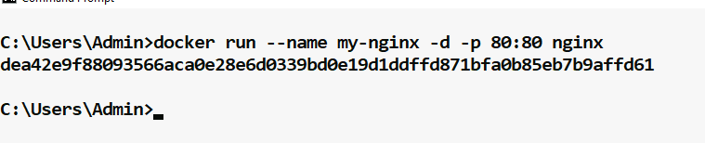

Now you can list the container to see the port binding



Now from your host machine you can access the container without getting inside the container for that you open your favorite browser and type <http://localhost>, mentioning port 80 is optional because that is the default port chosen on the host.

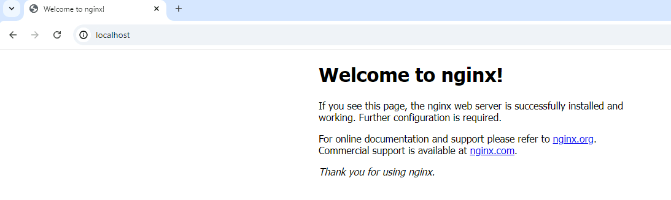

Let us bind another host port to the same container with a different container-name

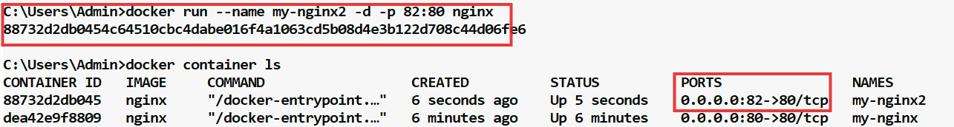

Trying to access from the local machine using port 82, this time you need to mention localhost:82

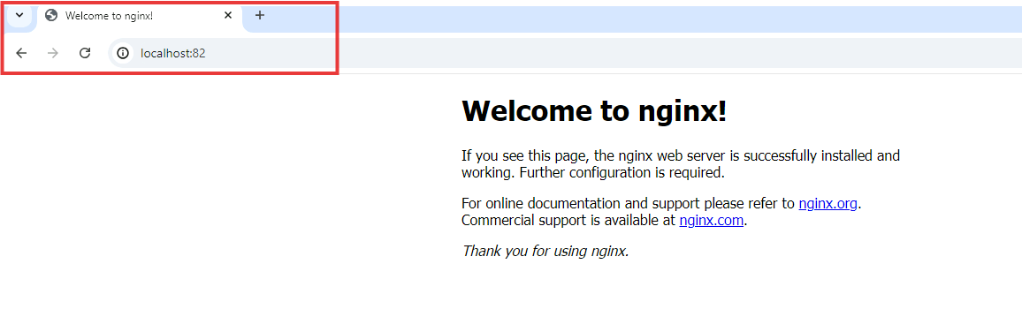

Attaching to the process of the container

Since we have created the container with -d option, the console will not be attached, however we can attach to the process of the container after it is created, for that you must use docker container attach container-id command.

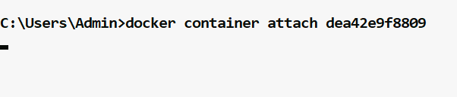

You can see our terminal is attached, this lets you view its output or control it interactively, use control + c to exit, which stops the container.

Where are we getting all these images

We are getting all these images from the docker registry which we can visit using hub.docker.com

Search for nginx, where we get the image which is released by the nginx company, which we can recognize when the image has official build below the image name, as shown below

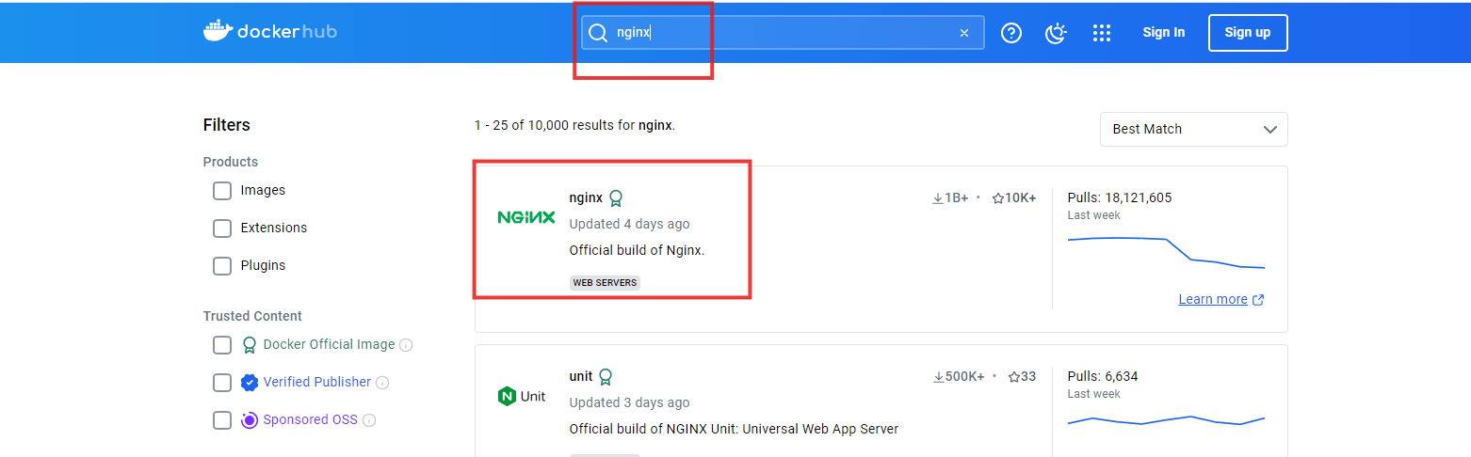

So, its always recommended to use the official build images as they are verified publishers, many communities will improve by adding certain features to these images as these images are open source, but whenever they upload they need to upload with their company names ex: you can see nginx image that includes logrotate, uploaded by some company here.

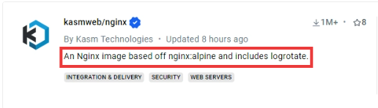

However such images don’t come under verified publishers, because these images may not be a trusted content, hence you can always use the images that are verified publishers/trusted.

Using containerized databases

Using local containerized database offers flexibility and ease of setup, letting you mirror production environments closely without the overhead of traditional database installations, Most popular database systems, including MySQL, PostgreSQL, MongoDB have official docker image available on Docker hub.

MongoDB

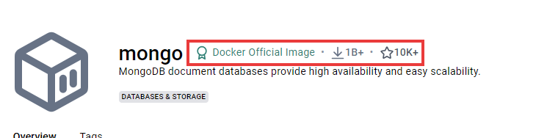

PostgreSQL



MariaDB forked from MySQL

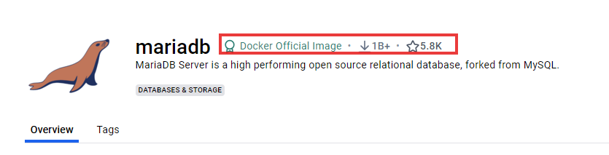

Using MongoDB image

MongoDB is a free and open source cross platform document oriented database program classified as a NoSQL database program, it maintains the data in JSON format.

How to use mongodb

If you visit the official image in the docker hub you will see the commands to run the mongodb image

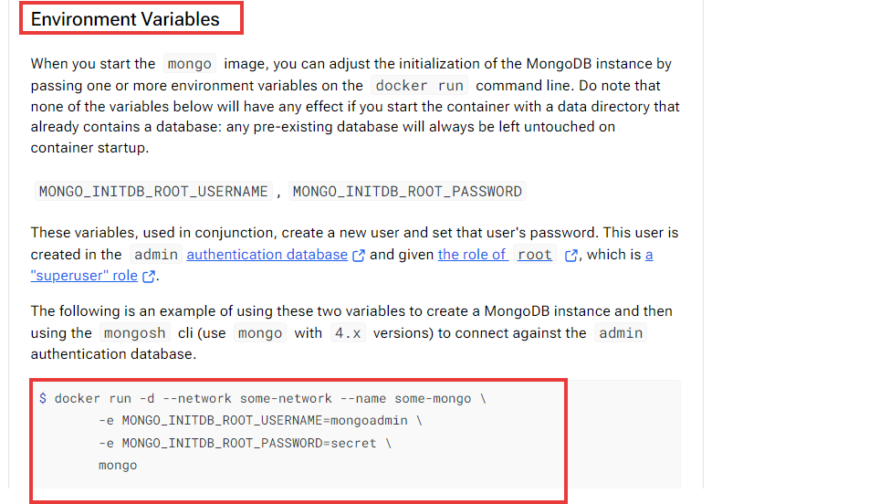

We will copy the commands and format them a bit because we don’t need to give network, name, but notice the username & password which are passed as an environmental variables.



Enter this command in the terminal

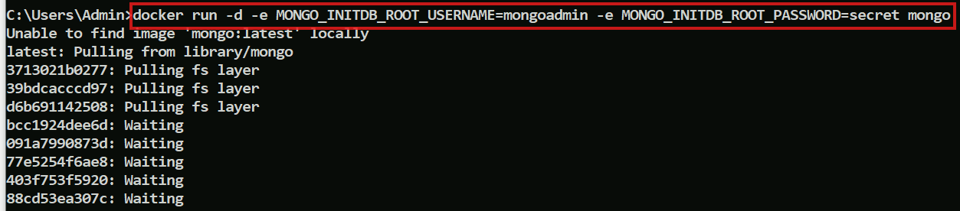

Now you can see the container id and can login to the mongo shell



Let us get inside the container and use the mongo shell which is mongosh but it must be used with -u and -p

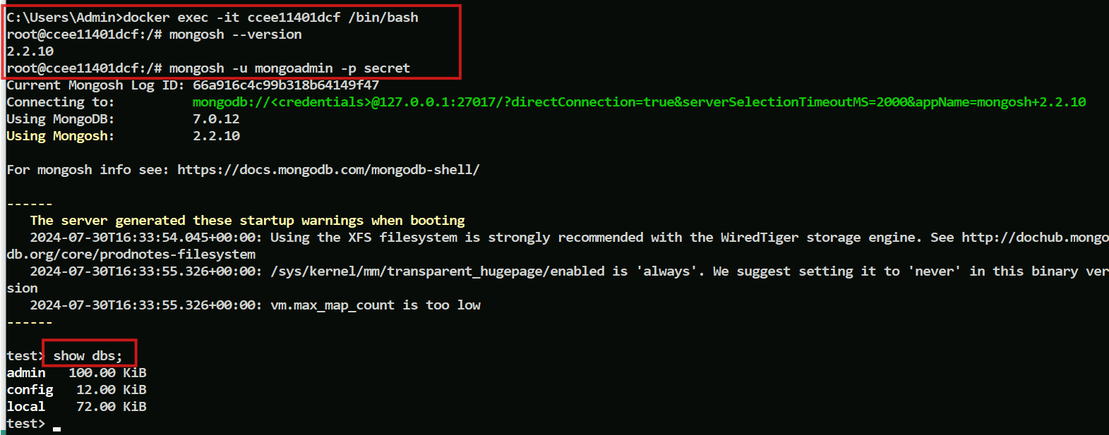

We can create collections & documents just to test the mongo commands

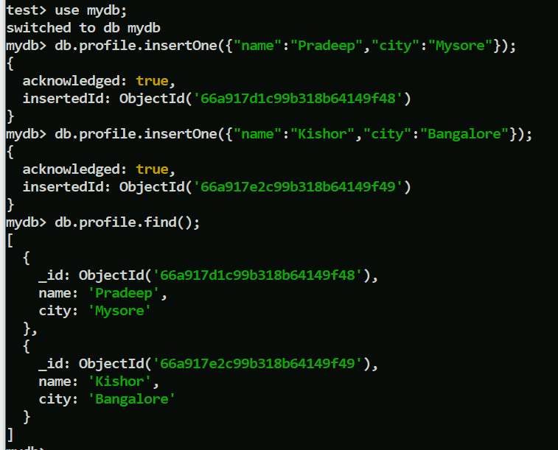

Using MariaDB Image

It is a relational database made by original developers of MySQL.

How to use this image

From the official docker hub it is mentioned that we must follow the below commands.

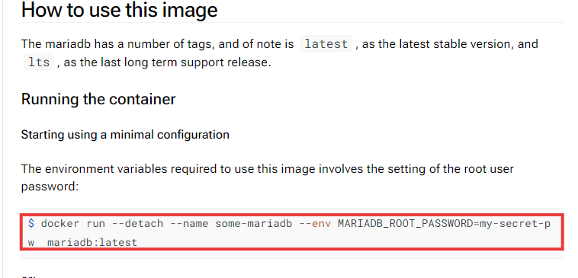

Let us use the above commands

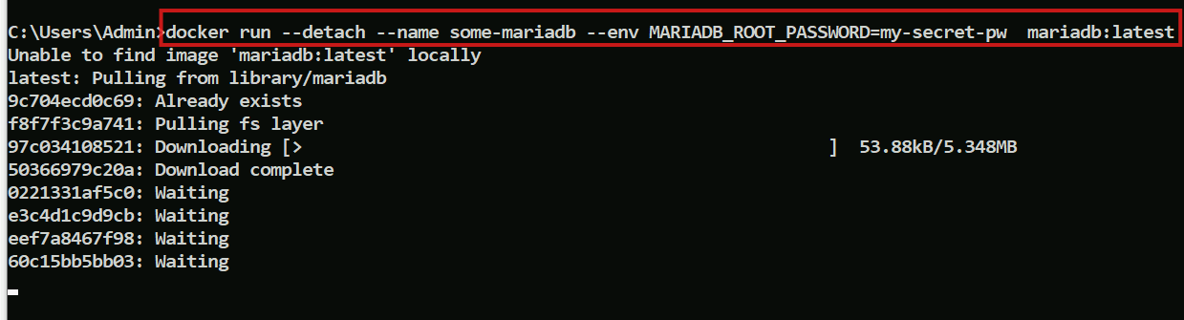

List the containers to see the container id for mariadb



Let us get inside the container and login to mariadb

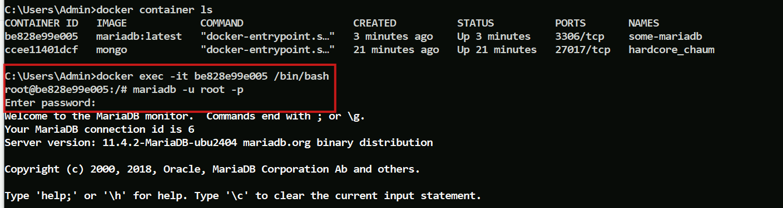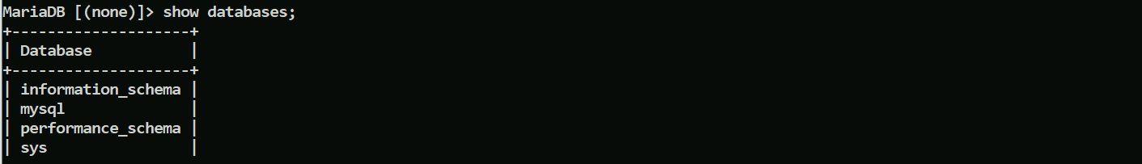

Test some commands

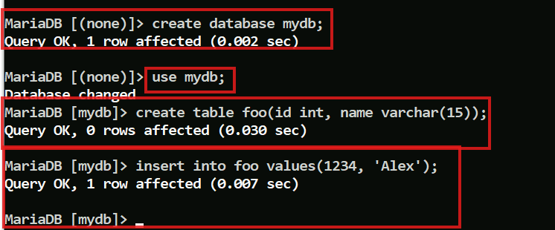

How to create our own docker images from our application

One thing to always remember is for operation team it doesn’t matter they are going to run which type of application whether its java or node or python or etc, because operation team writes commands to pull the image and run the containers or stop or start or restart the containers, this is now much more better for Operations team compare to the traditional approach of running the application and setting up all the infrastructure before launching the application

So its developers responsibility now to create the docker images and operations team needs to only run the docker containers & monitor them

Steps to follow to create docker images

* Have a running application
* You need to create a Dockerfile, this will have all the instructions to build the docker image, it is a file without any extension
* Run the build command, which makes docker to execute all the instructions in Dockerfile and build an image for the application

We already created an image earlier without the Dockerfile, but its not correct

Though we created a brand new image from another image, it was not correct because we need to create a container and then make changes to it, then create an image from the container, then destroy the old container if not required, then from the brand image again we repeat the steps to create a final image, but this process is manual and its no where documented, we don’t know whether its going through change management process, you cannot commit it into version control system, Hence we use a Dockerfile where we document all those steps where docker takes care of creating a container between the layers to create a new brand image.

We have a various applications stored in this git repository starting from helloworld to more complex application, each having the Dockerfile, which is in the following URL

<https://gitlab.com/classpath-docker/docker-lab.git>

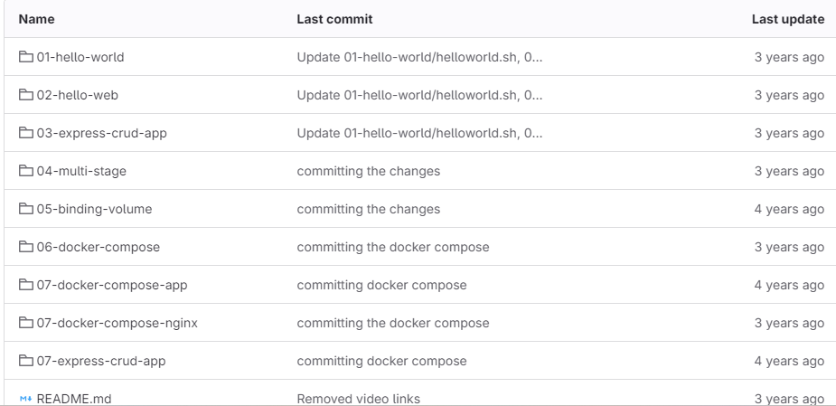

Let us download all these applications into our local machine by using the git clone command

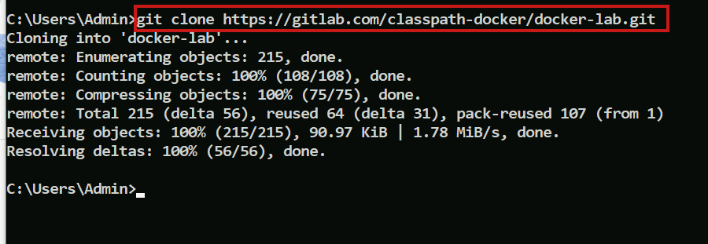

Check for the docker-lab folder

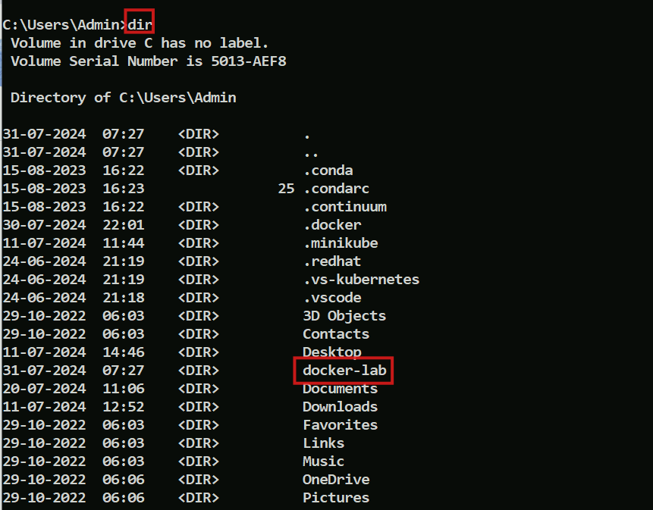

open the docker-lab in the vs-code

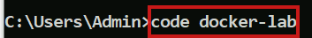

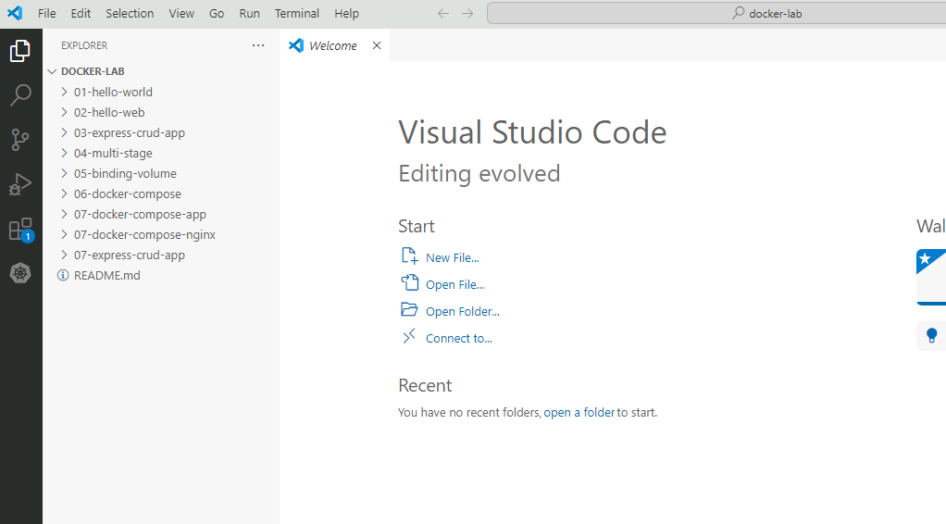

Open the 01-hello-world, where you can see a shell script, which prints Hello World from Docker and the date

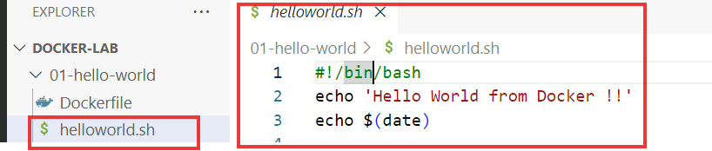

To run this you don’t need to install any softwares, developers just need to give the instructions in the Dockerfile, build the image and then ship it to the operations team

Open the Dockerfile and you will see the instructions to build the image

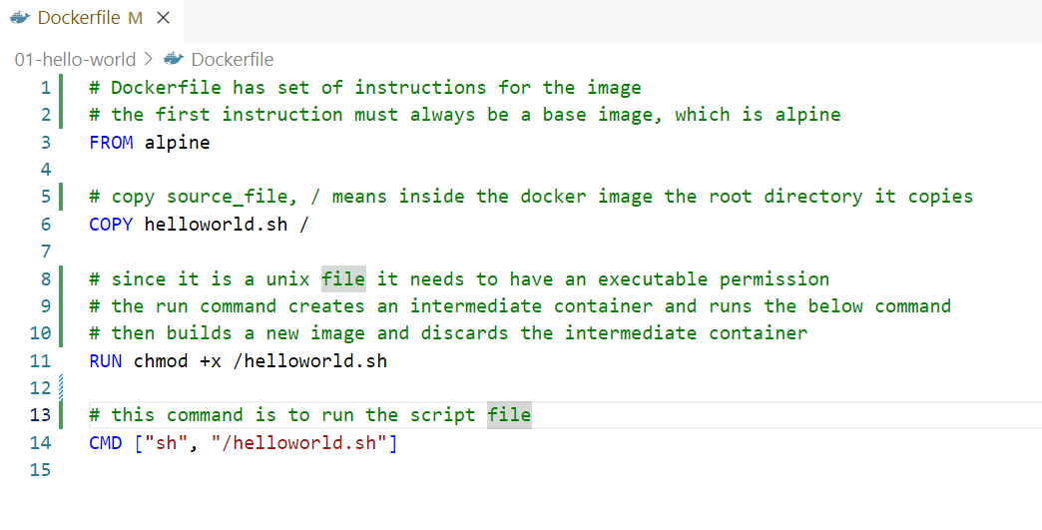

Now we can build an image from this Dockerfile

You must be inside the parent directly having Dockerfile to enter a build command

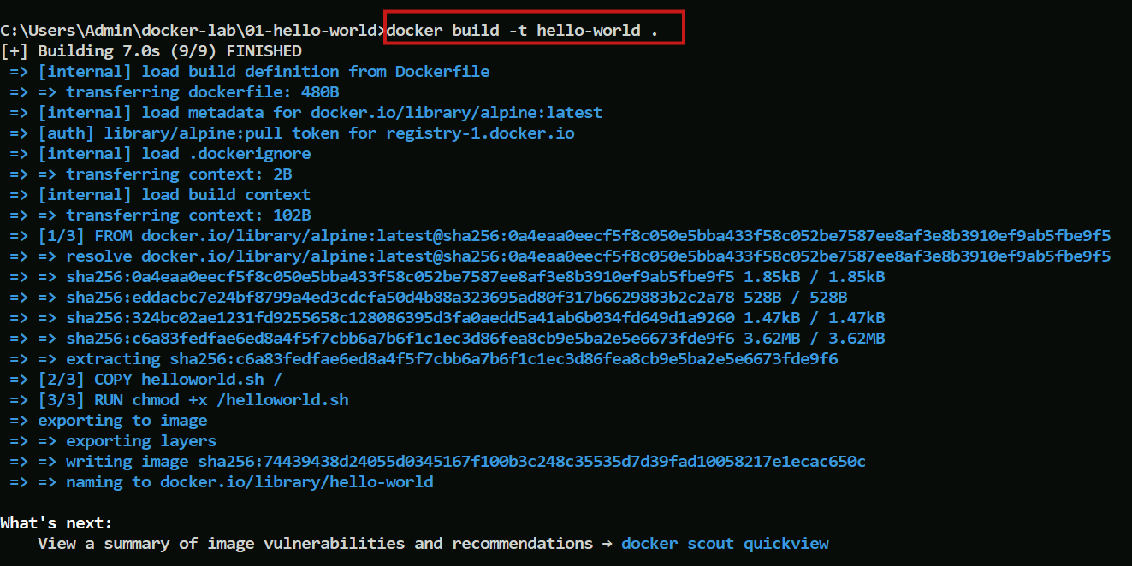

Now use the docker images command

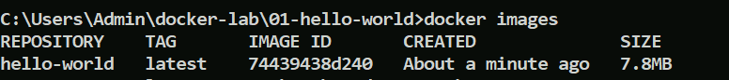

You can see the hello-world image present

Seeing the image layers

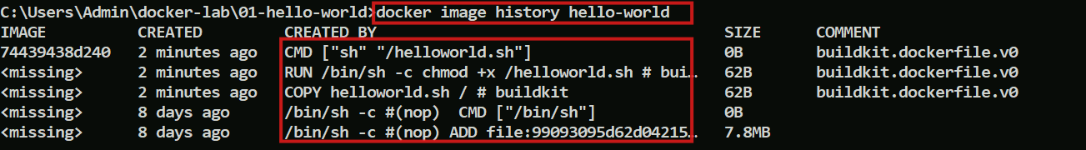

We can see the final image id created and rest are missing as they were discarded and they are not required to be shown

Let us run the image to create container

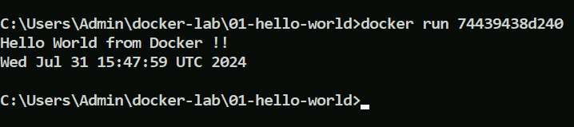

You can also run in detached mode and use logs to see what was the output

 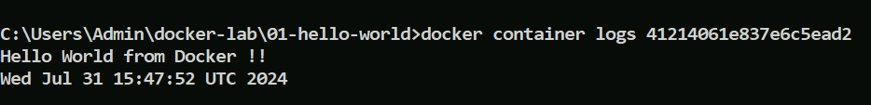

Note: As a devops engineer you don’t worry about the vulnerabities in the base image as they will be fixed by the creators, and it will be abstract, we will concentrate on building or using the images which are built on top of these base images or some runtime environment.

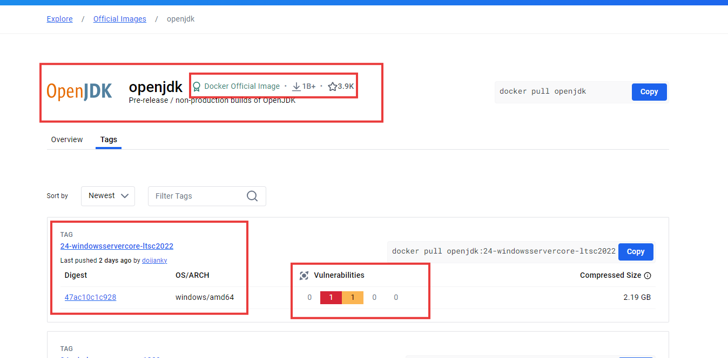

Look at the openjdk 17 where the vulnerabilities are fixed, these creators frequently be patching the images to reduce the vulnerabilities

How do people in the production will upgrade their package having vulnerability removed without impacting the production

You will give the version in the Dockerfile with upgraded version, ex: FROM alpine:2.0, build it and get it tested, once its approved you will use it in the production.

Note: If you don’t specify version it uses latest, however different company has differnet meaning for latest, some think latest is the new release, some think latest as the stable release, some company uses trunk as the latest releaase, some uses main as the latest release, it all depends on what company uses so its recommened to know what is the source of truth and use the version accordingly.

Building an image that uses nginx build on top of alpinie

Open 02-hello-web project from the repository and locate index.html & Dockerfile

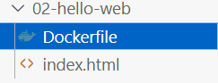

index.html has just an hello world, however the Dockerfile has following content

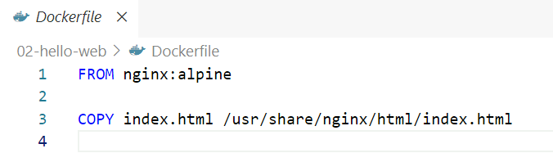

Here the FROM nginx:alpine specifies that you are using nginx built on top of alpine, & specified to copy the index.html to docker image i.e., /usr/share/nginx/html/index.html which is the location where the image need to search for the html to launch, these are responsibilities of the developer.

There are many versions of nginx in that we use alpine, if we visit hub.docker we can see different versions of nginx built on many other images

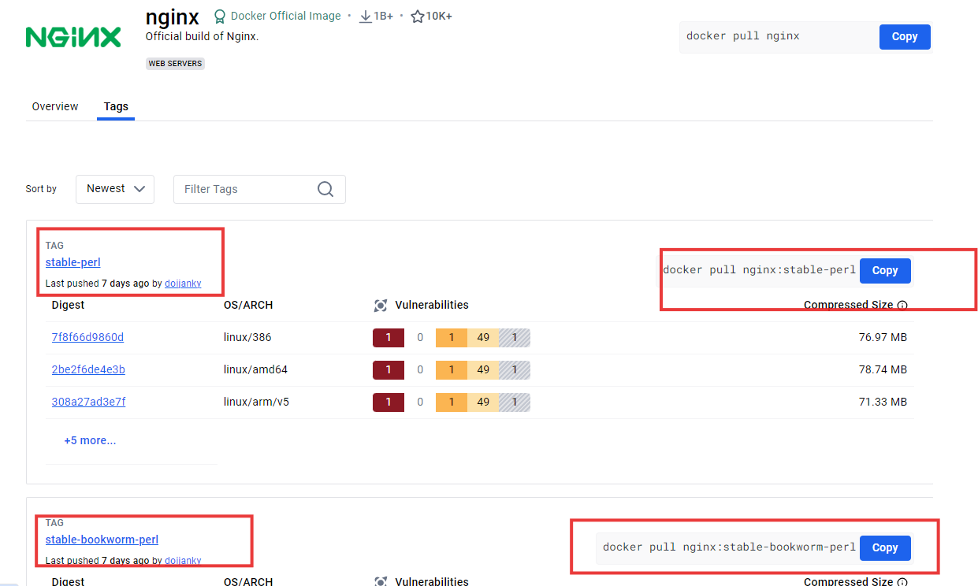

In nginx:alpine also there are many versions released

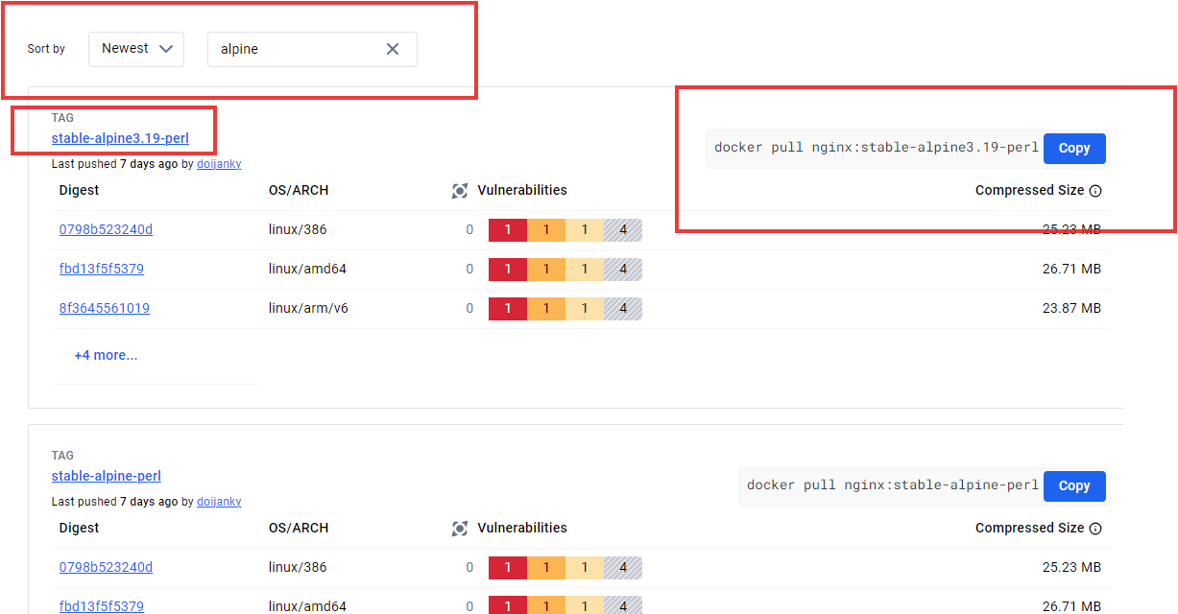

The developer team/DevOps uses only one command i.e., docker build -t tag-name .

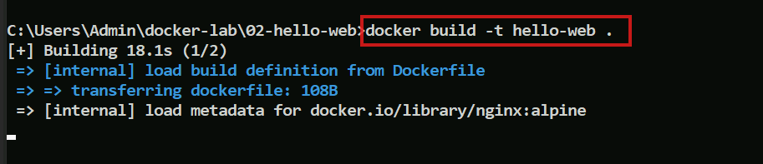

You can see the docker images

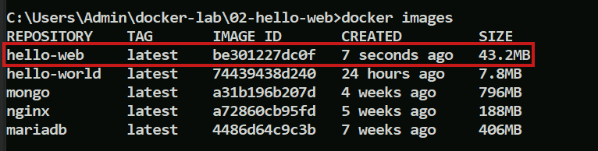

Now we will see another example where we will have the dependencies in the project, let us use the 3rd project of the repository

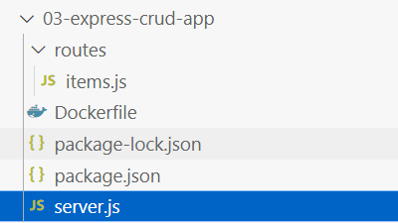

This project is a node.js application has items.js, which has some end points

items.js

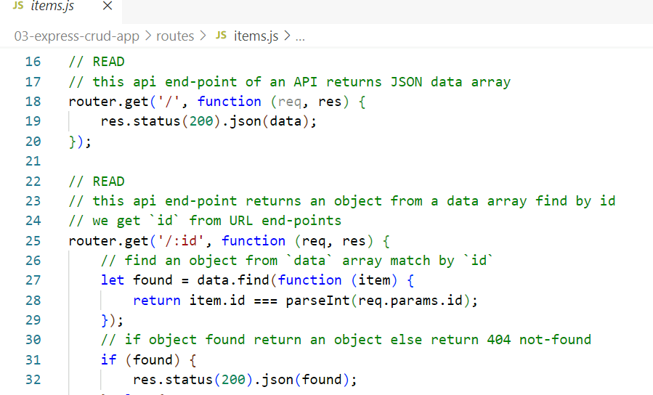

package.json

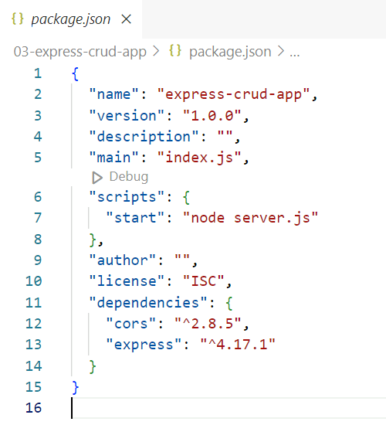

Dockerfile: This will have an instruction to build an image, which will have a template that can be used for any programming language.

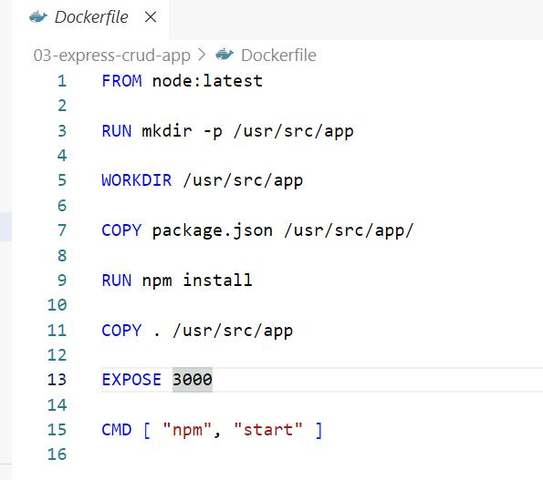

It uses node from the latest, the RUN mkdir -p /usr/src/app creates an intermediate container and creates a directory, then WORKDIR is like CD command, the COPY command copies the package.json to the /usr/src/app, the RUN npm install will create an intermediate container & installs all the dependencies, the COPY copies all the content from the source i.e., dot to /usr/src/app in the image, then you are exposing the port 3000, then when you run the container command the npm start will be triggered that will launch the application

How to write the Dockerfile

An Image author must write the instructions those don’t change at the top and those that often change at the bottom in the Dockerfile, because the docker images caches each layer & they are dependent on their parent layers and if any changes happen in the parent layer it has to rebuild it, once the image is rebuilt the image-id changes, then it starts rebuilding their dependent layers and that lets all their top layers to rebuild, it seriously affects the performance, hence we must know what is the correct way to write the Dockerfile, which is why in the Dockerfile we first installed the dependencies and then copied the source file as the source files would often change and dependencies wouldn’t often change.

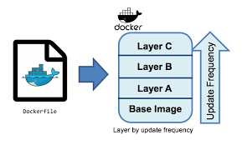

If you notice the above diagram, you can see the update frequency arrow, what you write in the Dockerfile from top to bottom is built from bottom to top in the images as layers, here Layer C is referring to Layer B which is referring to Layer A that is referring to Base Image, if Layer A is changed, it rebuilds its image-id changes and there won’t be any caching of new images hence its reference layers needs to be rebuilt as they have the old image reference, this leads all their top layers to be rebuilt.

How this Dockerfile & Images solves the problems faced by developers and DevOps team

Earlier Developer machine will be having the code & the instructions to build an artifact would in the Jenkin server, this had a dependency they often used to tell it works in their machine but I don’t know why it doesn’t work on your machine, but with Docker the images are built in a standalone machine, if it works in one machine it works across all the machines, this gives the confidence for both the teams as the images will consistently run across all the machines with Docker on their platform.

Let us build this image

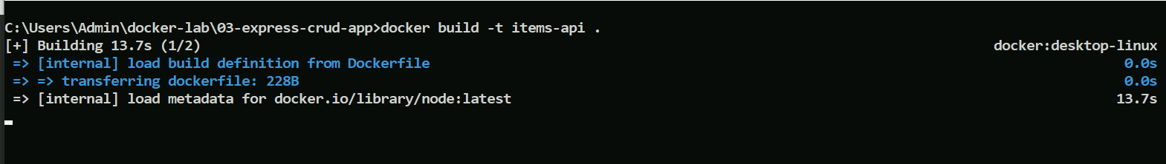

We can the docker image for this application

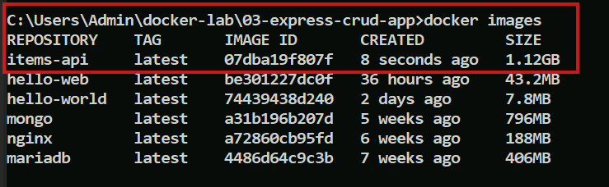

Now the job of the Devops team

Its same command of creating an image

For the Infrastructure team/Operations engineer

Not to get into the nuances of development, because earlier they were involved in developers problems also, but that doesn’t give any result because why would an operation team guy get into development issues, his/her job is to maintain the application in the production, so now with the Docker the operations engineer role will be

* To run the container
* To manage the life cycle of the container
* To scale the containers
* To deploy the container
* To do the service discovery
* To maintain resiliency
* Monitoring

These are the challenges the operation teams will be responsible of and DevOps team will take care of building an image for operations engineer.

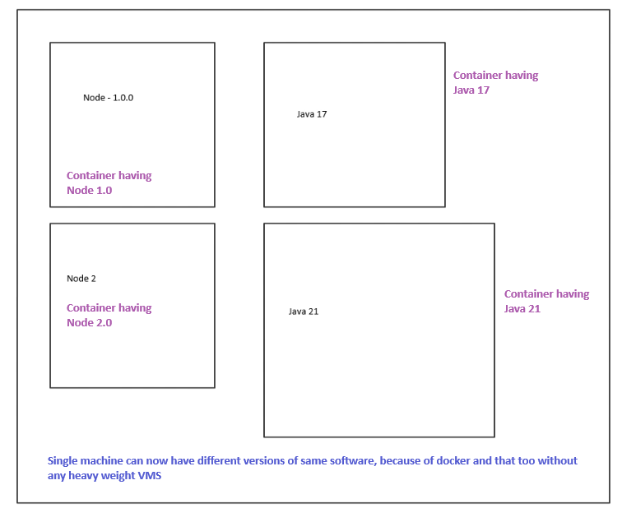

Notice the port in the Dockerfile

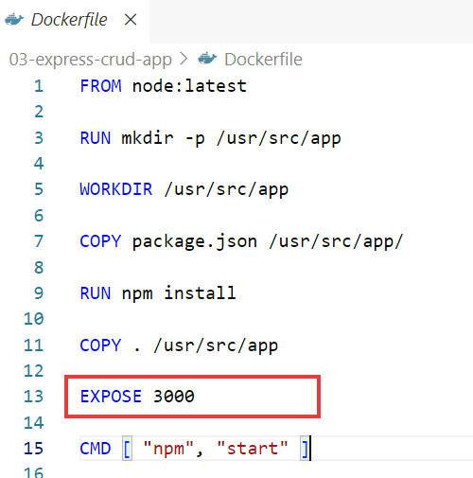

This doesn’t matter, it is only for the documentation purpose, if any body sees the Dockerfile they must know the application is running in 3000, but the source of truth might be in the application configuration file / the code, in this example the source of truth is in the server.js

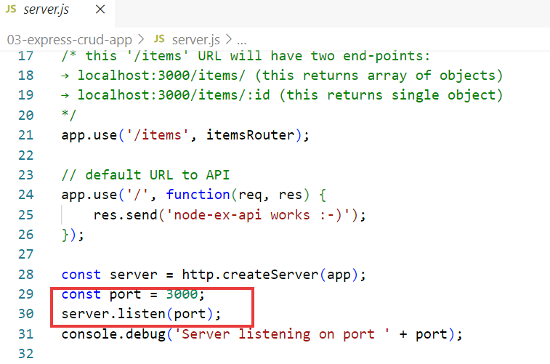

See the port the application needs to take, the EXPOSE 3000 in the Dockerfile is just for the documentation

Till now we saw a simple applications and simple Dockerfile, but once we get into the complex applications you will have multi stage Dockerfile and the best practices to follow while writing the Dockerfile

In Java, .NET there will be compilation process, however in Node.js we don’t have this process

There’s an another which is a spring boot project

Clone it using: git clone <https://gitlab.com/12-12-vmware-microservices/orders-microservice>

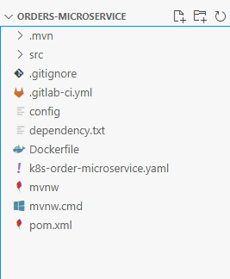

Point to note here

* It is a spring boot application
* It has pom.xml that has all the dependencies
* It is maven based
* It needs JRE that is the bare minimum software we need to run this application

The Dockerfile of the application looks like below

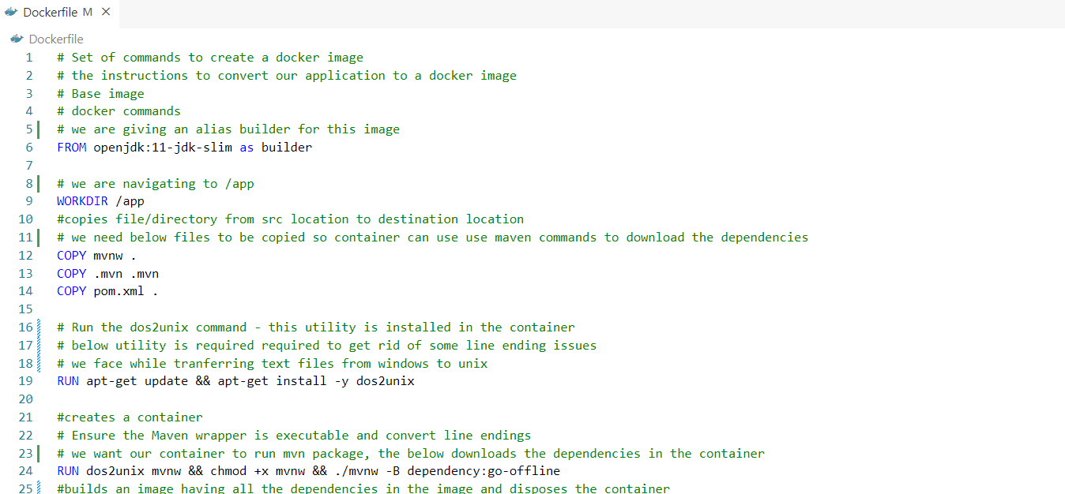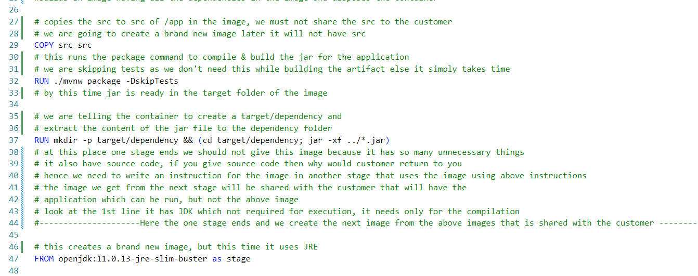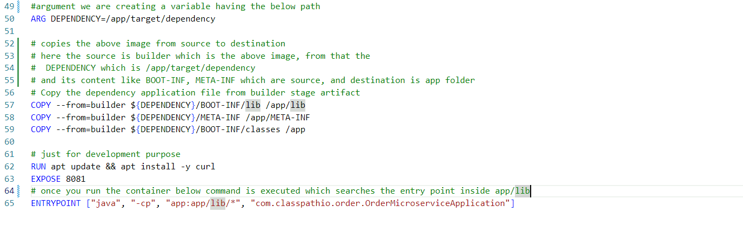

The Dockerfile instructions from 57th to 59th line says that the output of the first image(builder) is the input for the second image(stage), the first image which has source code will be discarded and the second image that will take first image as an input is given to the customer

Let us build Docker image for this application



It goes through lot of steps in from copying necessary filesystems to the image, creating a container downloading the dependencies inside it, building a brand new image and many other layers as per the instructions in the Dockerfile

Docker image for the application



Let us create a container from the image

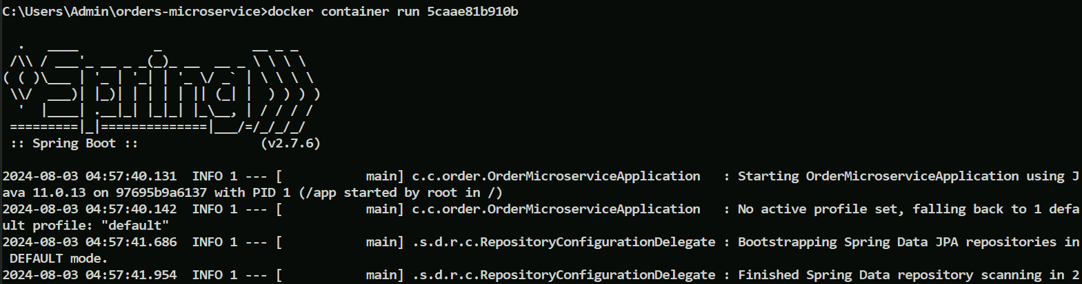

Observe the logs which launched the spring application.

Lets stop and re-run this time with port binding



You can observe the end point from the source code and access it from the browser where you see some JOSN information

End point source of truth

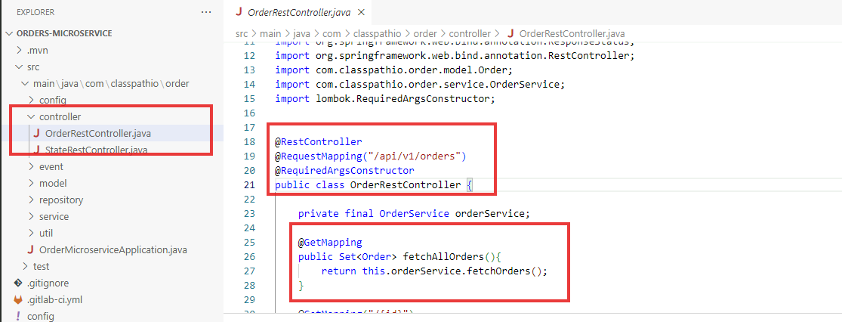

Output

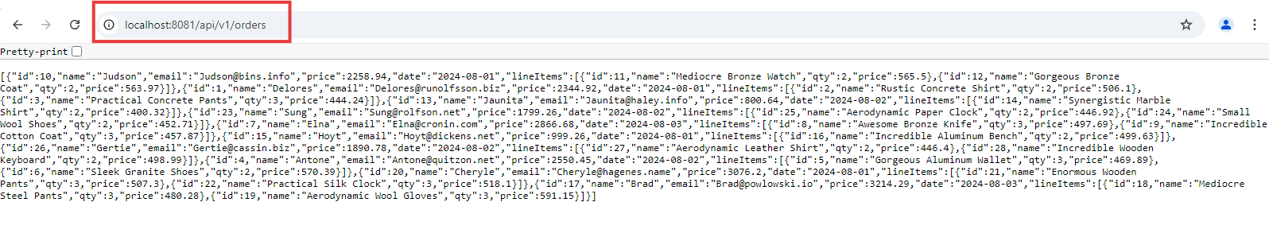

Pretty output shows that user Judson made what all the orders that is represented in the line items

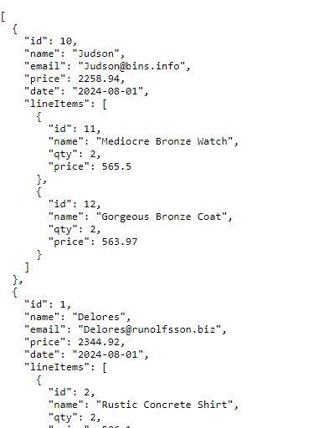

How to debug if something goes wrong at the time of building the image

By observing the logs understand where you need to stop the instruction and there you write

ENTRYPOINT [“sleep”, “1000”], something as below

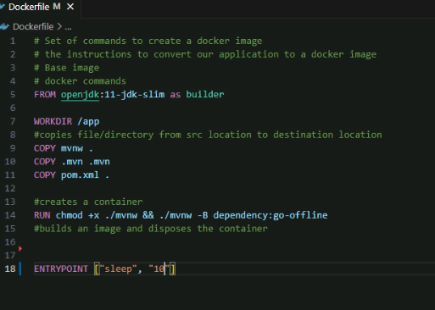

Now create the container & get inside and check the content to see what all the things are created, just as shown below, where we are inside the container through exec -it command

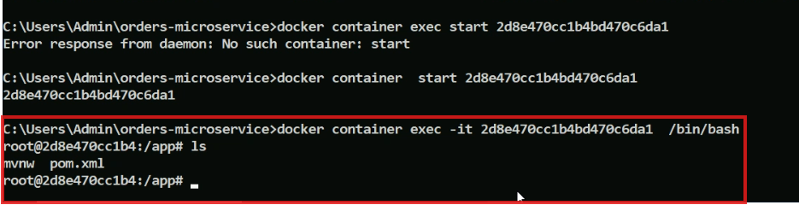

Doubt

How sleep does?

How image is built and deployed

As a DevOps engineer you can configure the docker build command in the Jenkins job or in todays world all the version control system comes with pipeline as a service, you can observe the .gitlab-ci.yml file

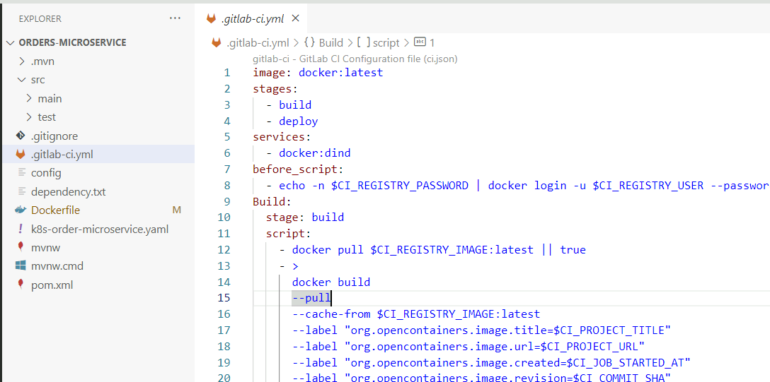

You are going to write the instructions in multiple phases and write what needs to be done, whenever you commit some changes the instructions in the file will be run on the fly inside a container, means they provision a container inside the container the above commands will be run and once the command is executed the container will be destroyed(parent container will be destroyed).

Setup the CI to automate the process of image creation

Modern tools like Github/Gitlab have the serverless offering to build the image pipeline as a code, for that

* You need to write the script to automate the build process and trigger on commit
* Pipeline will be committed to the repository for change management process.

Below are the list of tools & the files that can have for the pipeline as a code

1. Git Hub has Actions
2. Git lab has Pipeline which is .gitlab-ci.yml
3. AWS has Codebuild which is buildspec.yml
4. Azure has AzureDevOps

Once there is a commit in the version control system, the .gitlab-ci.yml will be triggered from the Git Lab, Same process happens in other tools.

We will observe what all happens in this build and deploy process

Firstly, run the command to pull a docker image classpathio/order-microservice

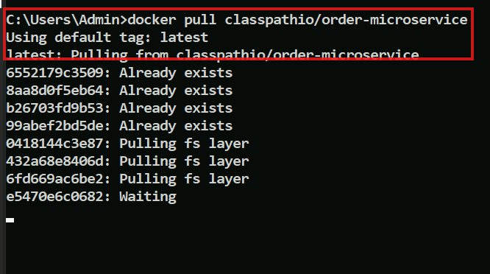

You must see below image

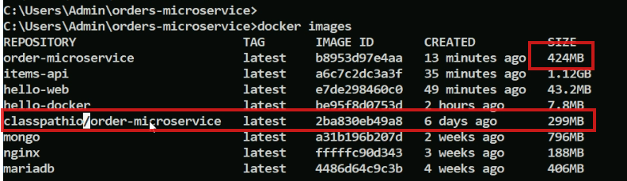

The size of the image is 299MB, which includes OS, JRE, Tomcat, jar file, configuration file, 299MB is very small, compare this with JDK which itself is much bigger than this image, you almost get 40% reduction incase your image has JRE instead of JDK

Note: The application we are using now is a microservice, older projects had services which communicate locally, with microservice you deploy each service of the application independently, each microservice can have different scaling requirement

Let us see how the change management process works in the git lab

You can see the project which is the git-lab.

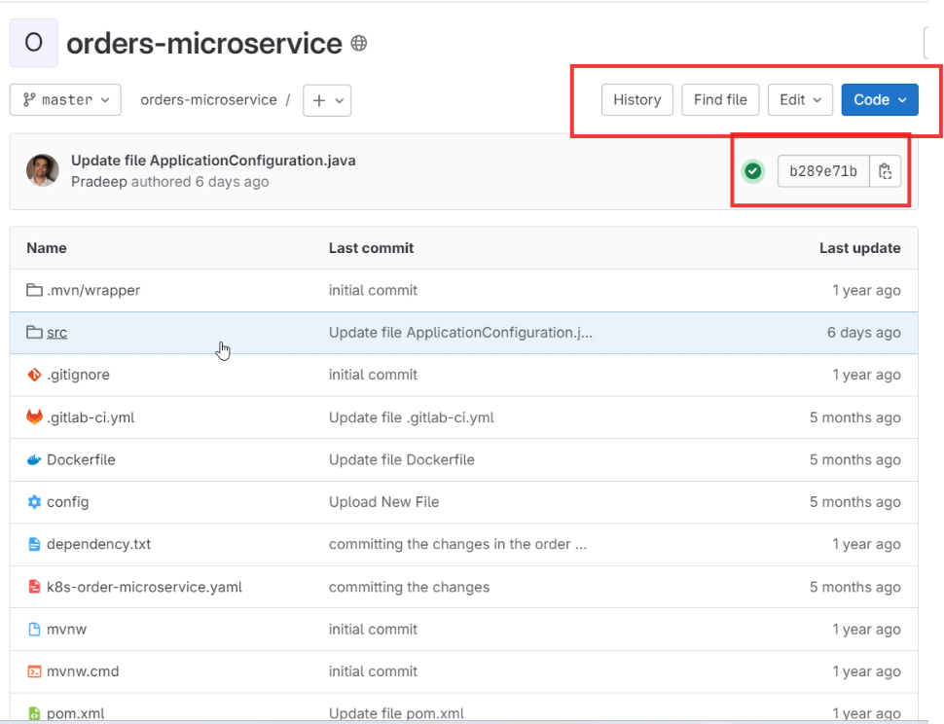

On the fly you can edit this code and once its committed you can see the tool will create the container on the fly and builds an image

Make changes and click on the branch icon

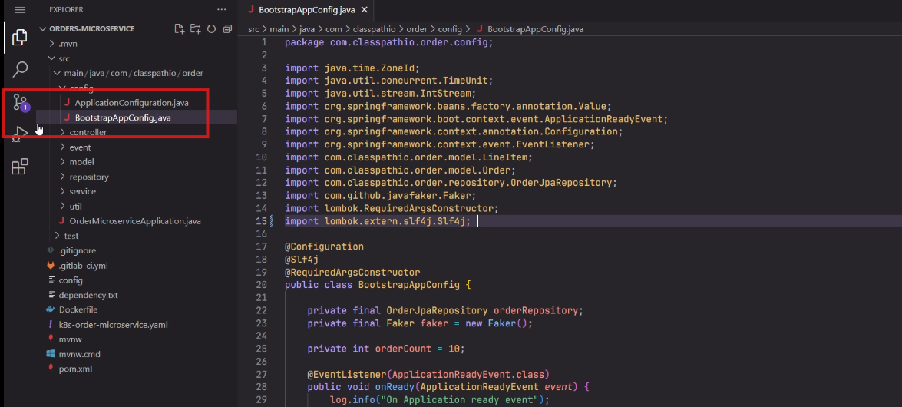

Commit the changes to the master and get back to the git-lab website to see those process of building

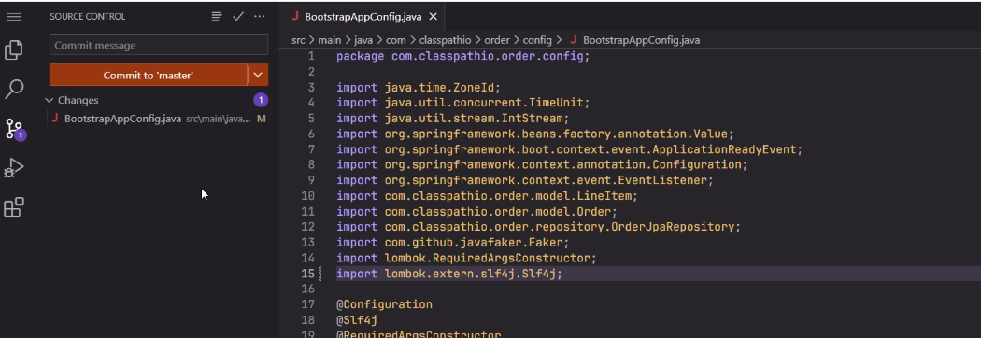

Refresh the page in the Git-lab

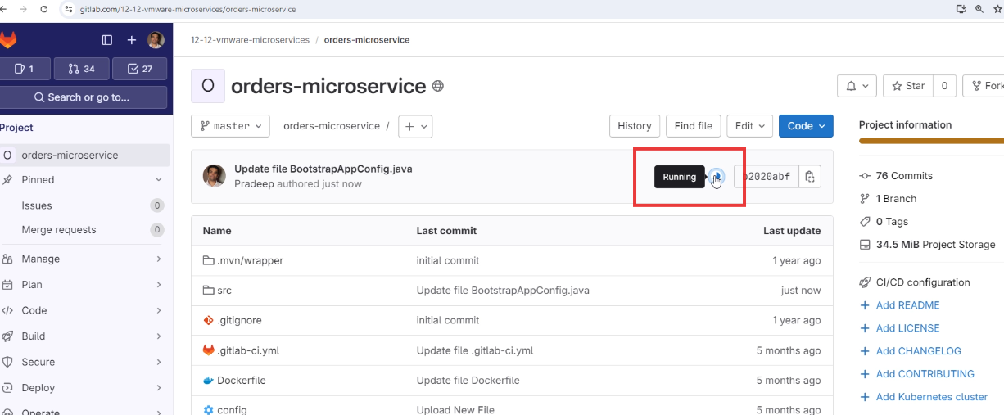

Click on the build process icon

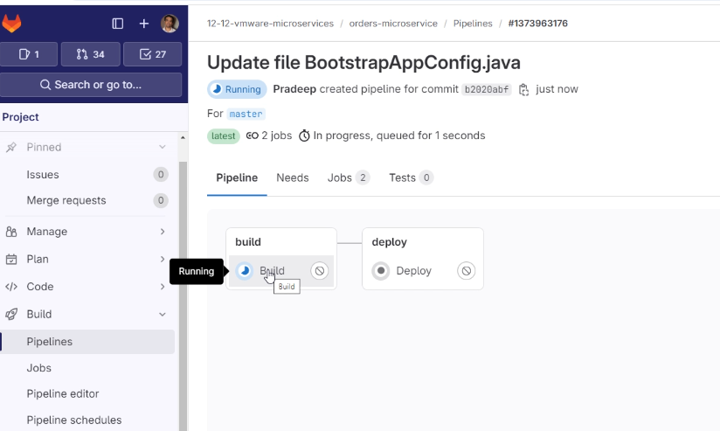

You can see the automated build process, observe the images are pulled on the fly,

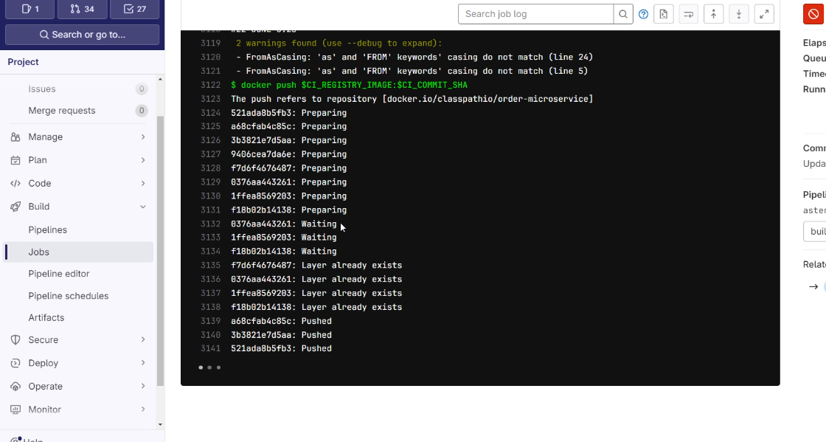

What you need to understand here is

You don’t need to have a separate Jenkin server, you don’t have to patch those servers, update the servers, scale the servers, you don’t need a separate team to manage all these process, these processes are done on the fly

The .gitlab-ci.yml has 2 stages in the orders-microservice

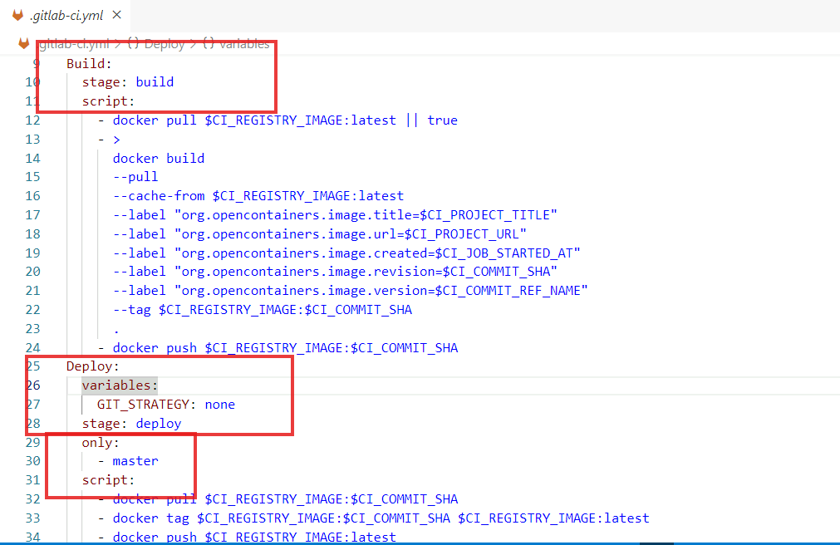

It says for every build there will be an image, whose version number will be of the commit-id and once the changes are merged to the master there will be a final image with version number which you can see in the line 34.

Things to observe here is

Even the build process is also part of version control system any changes you are going to do also goes through the change management process

Doubt?

What is Change Management Process

How to push the images to the registry

Whatever the images we built are on local machines, if the instances crash or we want to share the images then we need to push the image to the registry with the push command and others who need the image will use the pull command, just similar to how we used pull command to pull lot of images previously.

Rules while pulling the images

* To pull an image from the public repo, you do not need credentials
* To pull/push an image to/from the private repo, you need to present the credentials

Default registry used while pushing or pulling

By default docker uses docker hub, however you can append the other registries as show below

For AWS: your-account-ecr.amazonaws.com/repo-name

For Azure: registry-id/repo-name

In orders-microservice we have given the credentials as well because it pushes the image after build which you can notice here

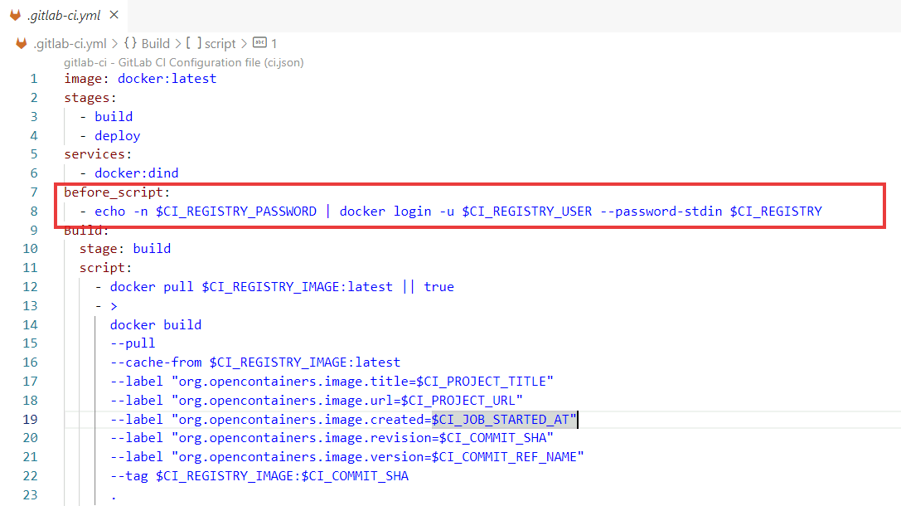

In Gitlab settings we provide the credentials which has those key names like $CI_REGISTRY_USER, $CI_REGISTRY

Navigate from your account to settings, select CI/CD pipeline

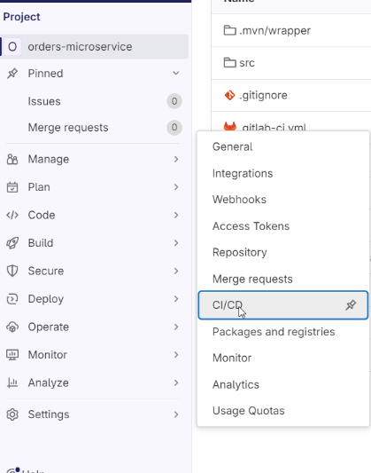

Select Variables

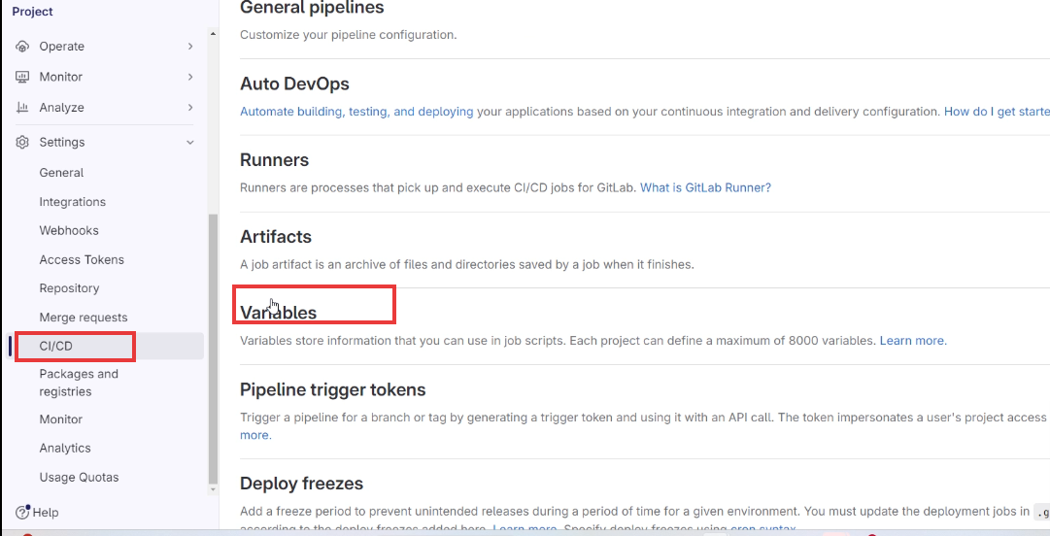

You see CI/CD variables, where you can put your secrets

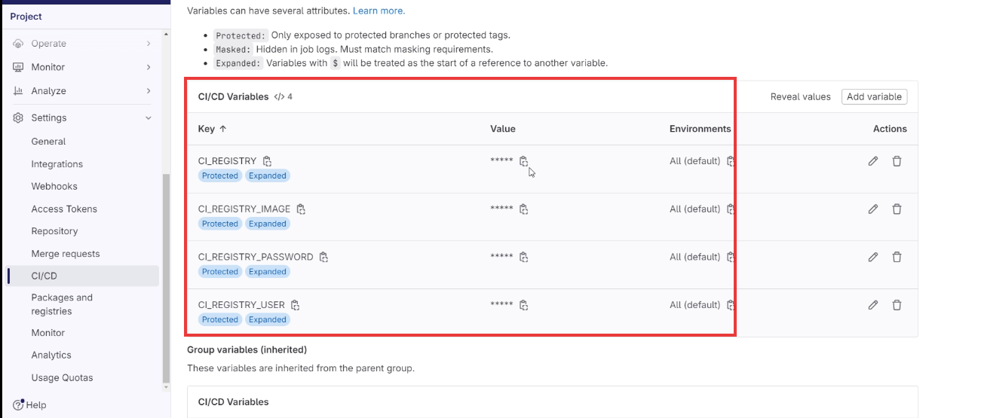

you can observe what is the registry name, password and etc, these variables names are used in the pipeline code so that their respective values are read when the build process takes place.

Let us see how to push an image to the docker registry

Firstly make sure you have signed up in the docker hub web site

You need to login from your command prompt using docker login command, just follow the below instructions.



The command prompt will ask for username & password just type the right credentials, when you enter password the cursor doesn’t move to the next character for security purpose, hence you type the entire password and hit enter, it must show now login succeeded.

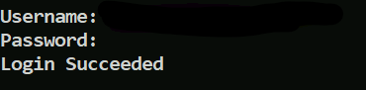

Now go to the command prompt in which you logged in and enter below commands

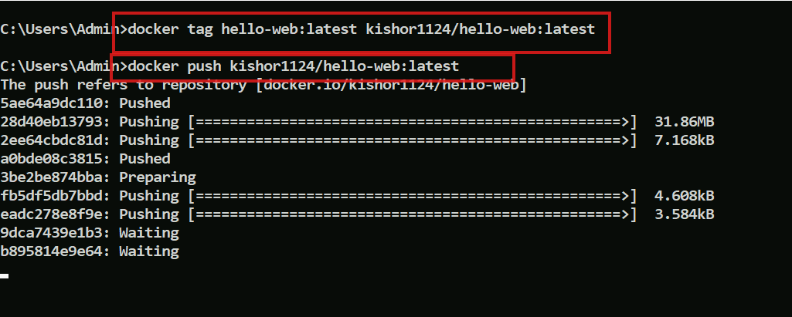

You must see the docker image in your docker account in the docker website



How to push the docker images in AWS ECR

ECR is a service provided by aws to store the docker images, ECR stands for Elastic Container Registry.

Steps

Goto ECR services, then select Mumbai region

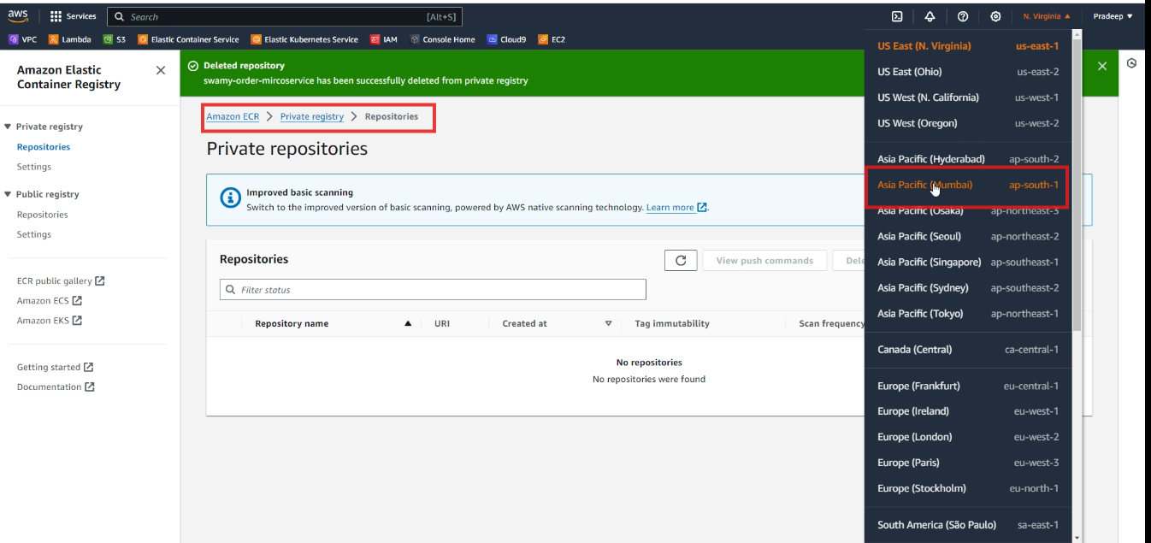

Be in the private repository

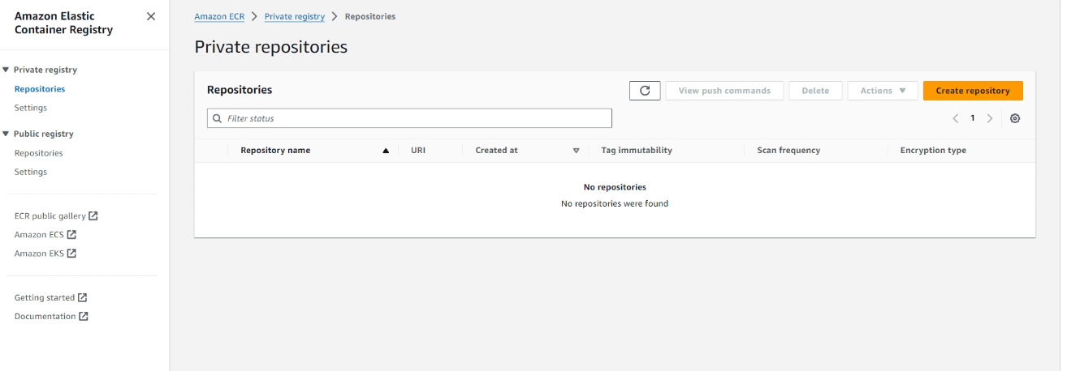

Note: ECR is the official registry provided by AWS, similarly other cloud provides also provide these services.

Just for an instance in Git Lab also there’s a container registry, you need to goto Build>Artifacts>Container Registry

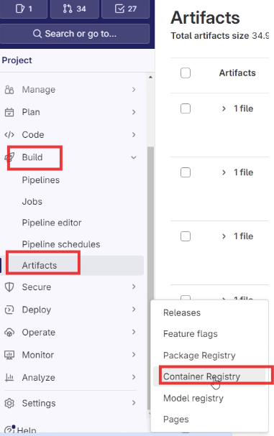

In Git Lab Container Registry you can see the images

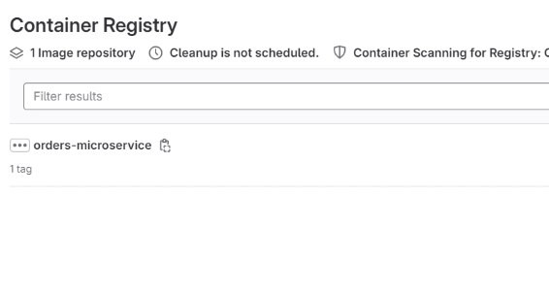

Back to AWS-ECR, we will click on Create Repository

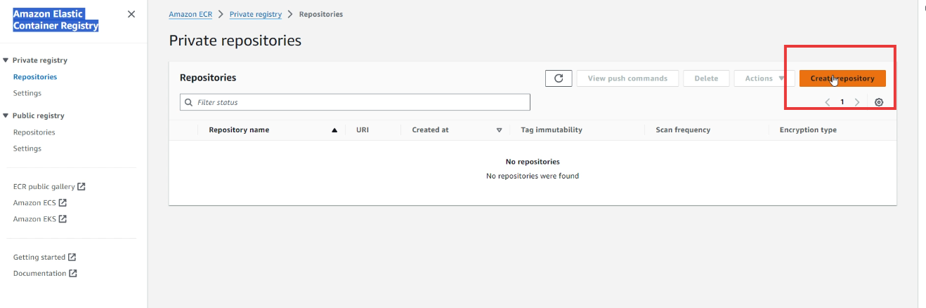

Enter the Repository name: ex your-name-app-nme

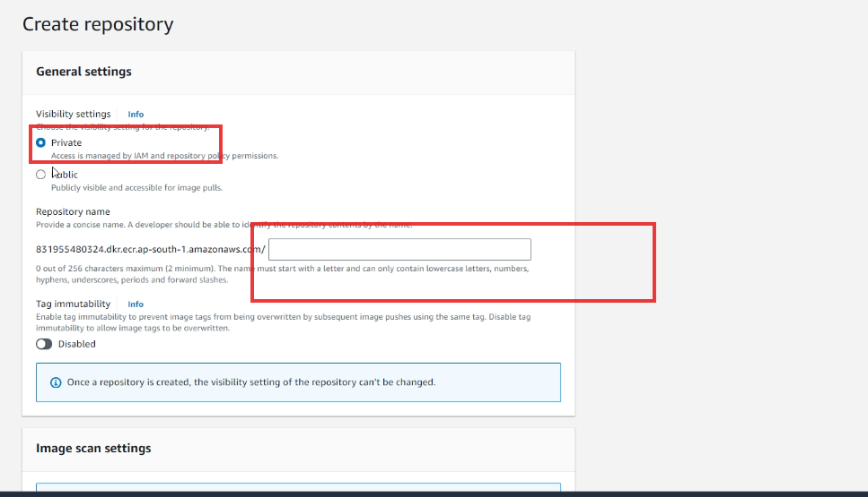

Scroll down & click on create repository

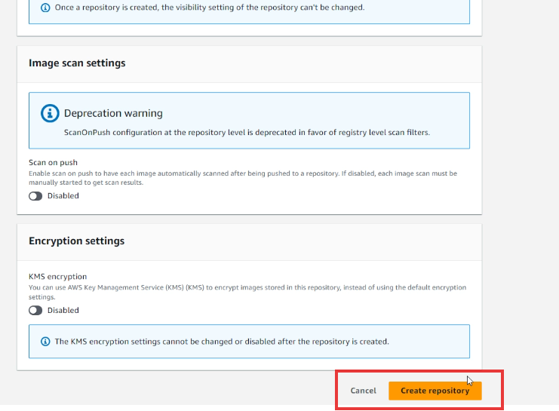

You can see the repository created

You must see the URI column which has the format registry-url/repository-name



We have images in the local machine, lets push that to the aws ECR, firstly click on the repository where you will see view push commands in your repository

Select your repository



Click on the view push commands



You get a window like this

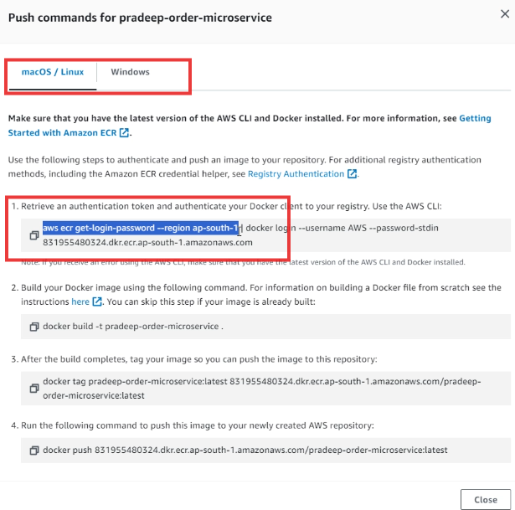

We copy the highlighted command to authenticate to AWS from our local machine

Note: aws command line must be installed in the machine

When you enter the aws ecr get-login-password you get the error as shown below

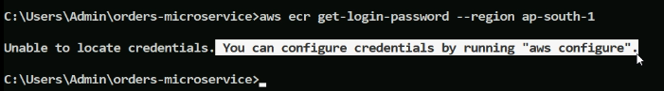

The reason of the above error is to access the aws you need credentials, but you don’t use the login credentials because they are for UI not for the CLI

We must setup our credentials so that CLI also can access AWs, to do that follow these steps

Go to IAM

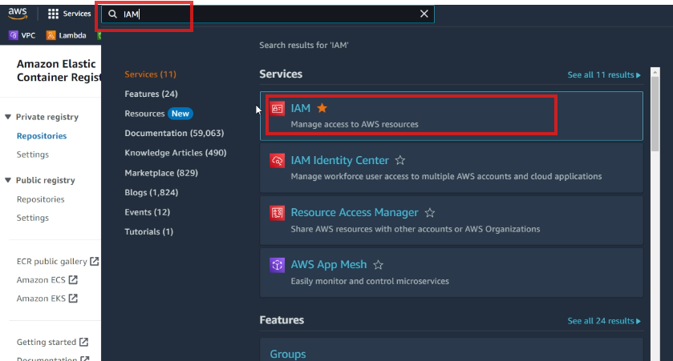

Click on IAM you get a page like below click on the Users

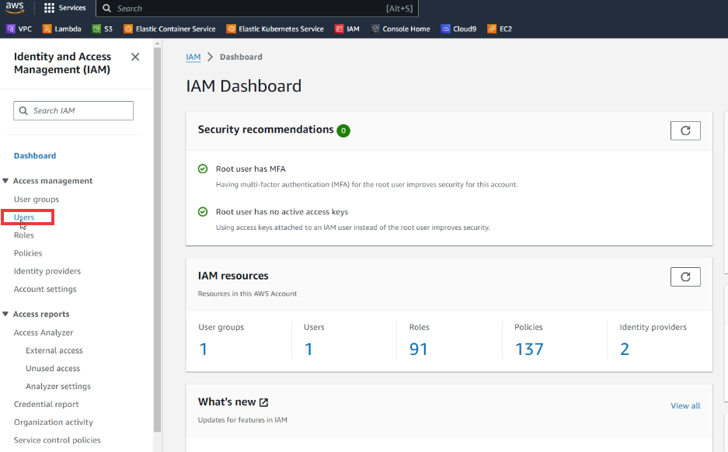Now you get a Users dashboard where you can click on Create User button

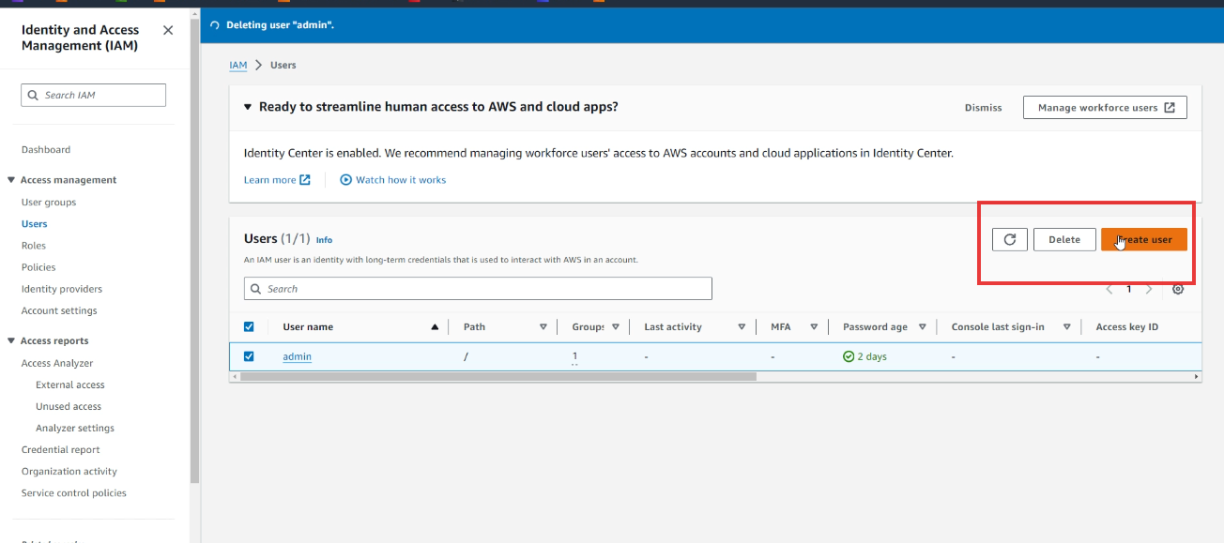

Enter the username and click next

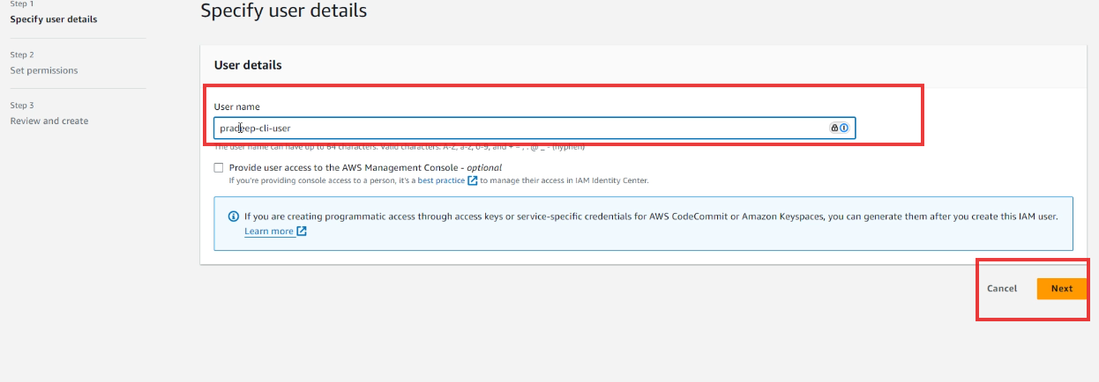

You will be taken to set permissions click next here

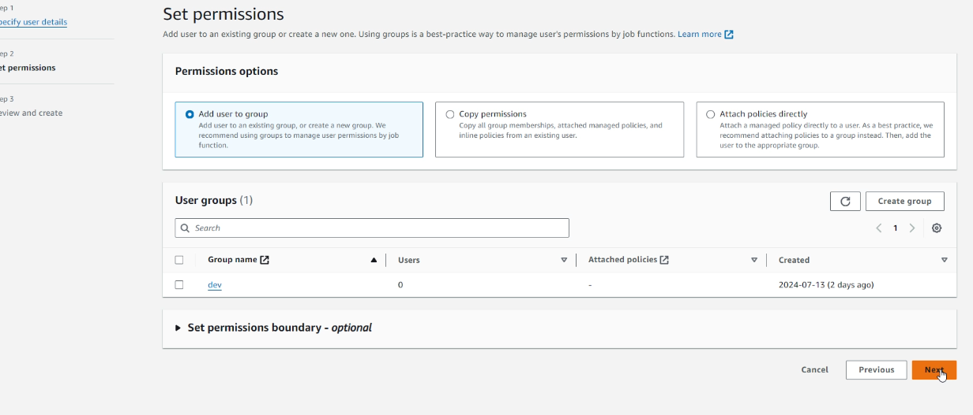

You see Review & Create click Create User

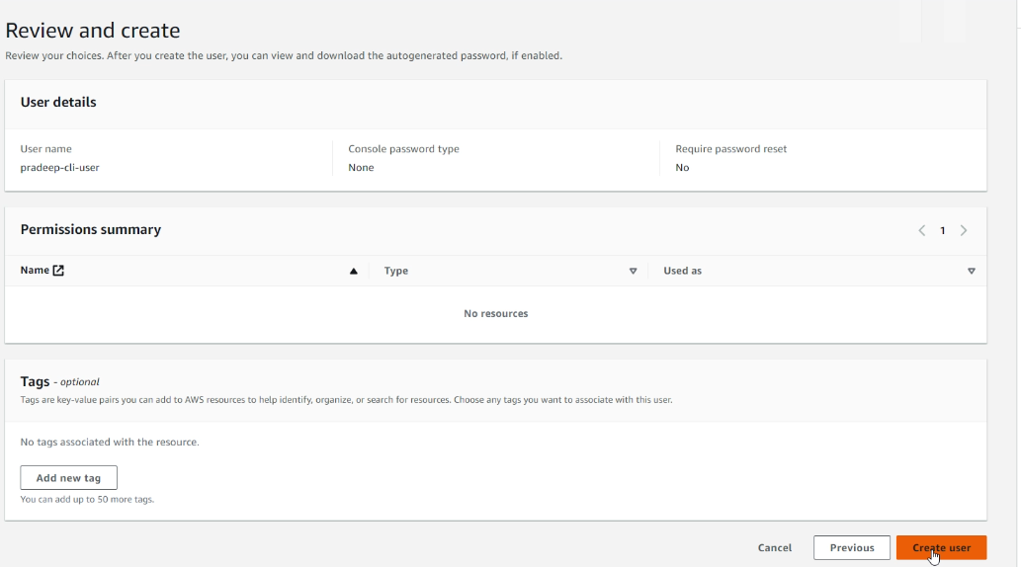  
You will see user created successfully

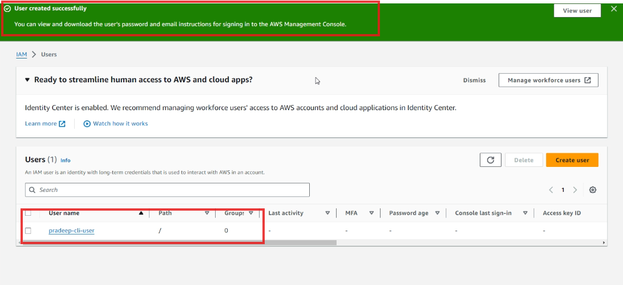

Being in the same page click on that username



Locate the Security Credentials tab and click on it

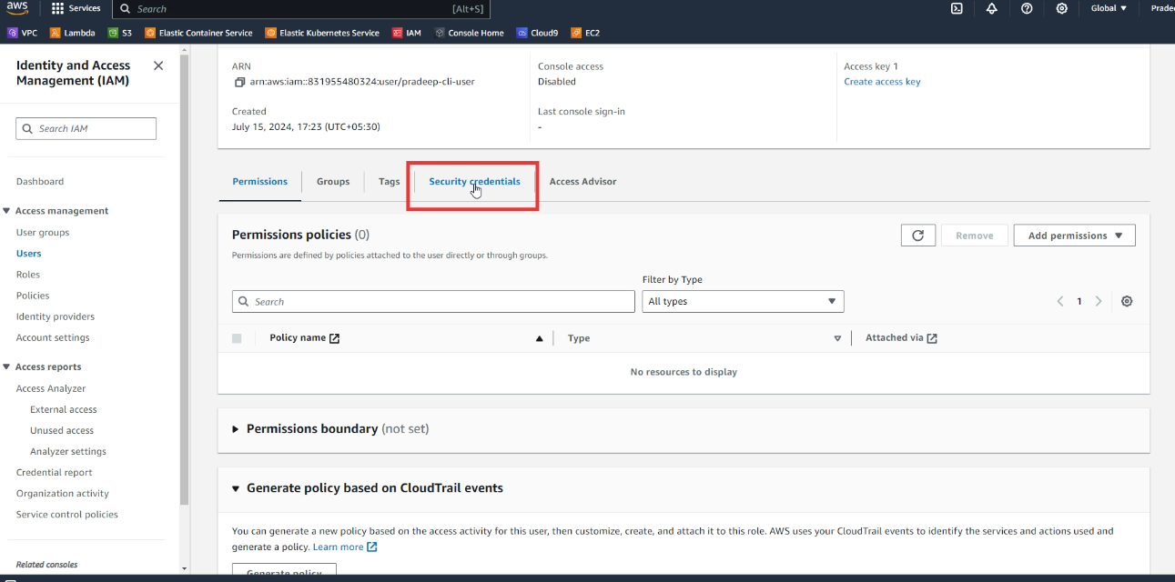

In the Access Key section click on Create Access Key

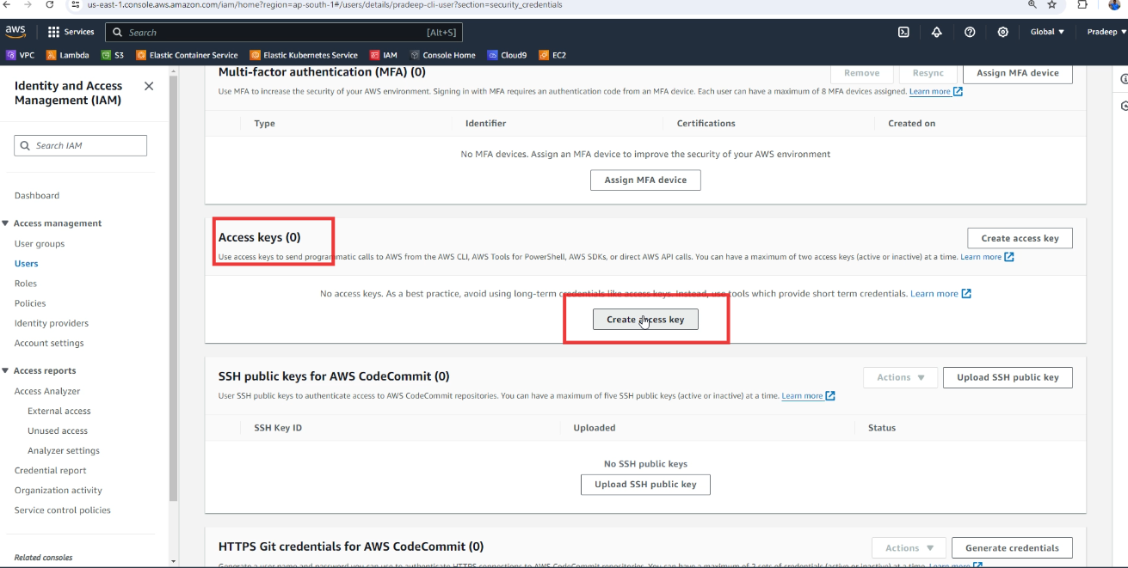

Select the Command Line interface

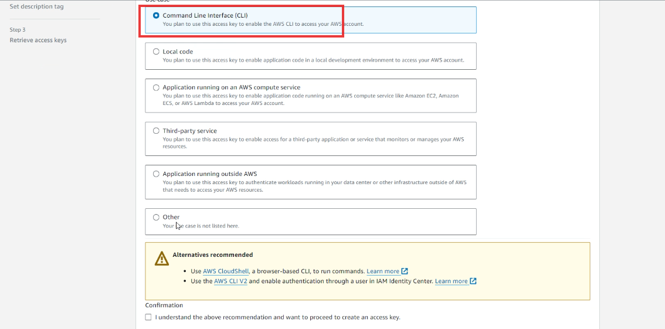

Scroll down and select I Understand & click Next button

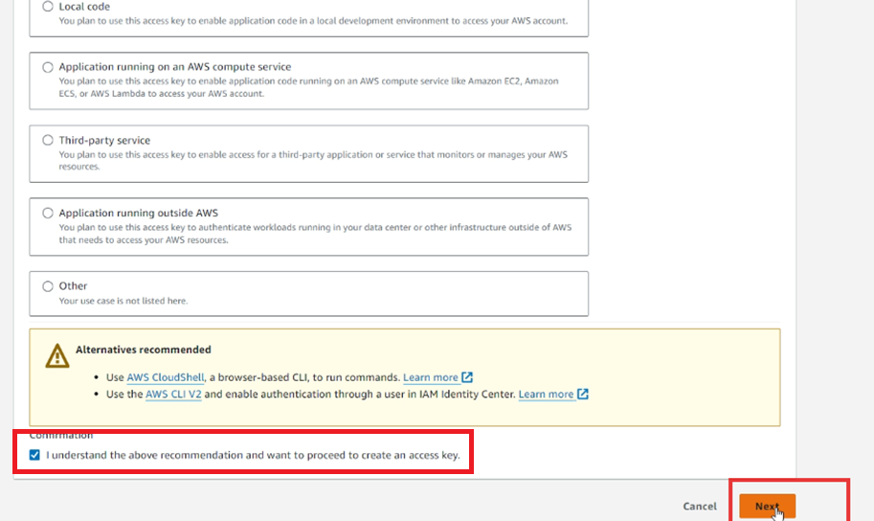



You will see Set description tag, which optional you just go on and click create access key

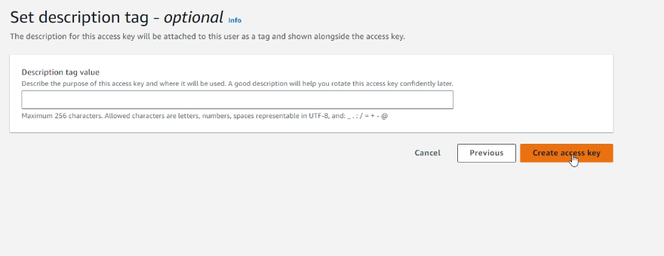

You will be taken to the next page copy the Access Key

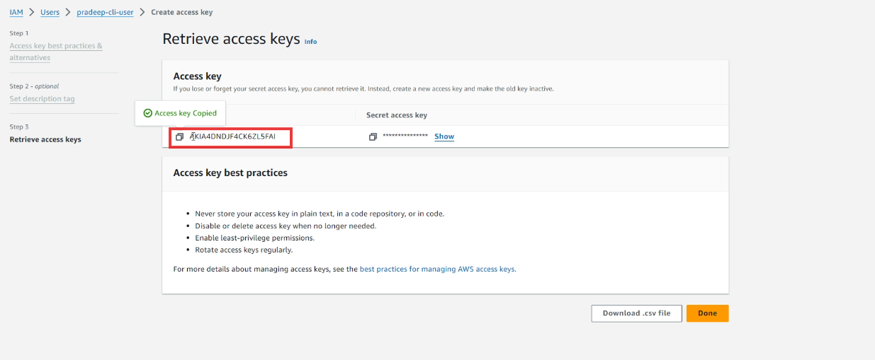

Go to your local machine command prompt and type aws configure & paste the copied access key at the AWS Access Key ID

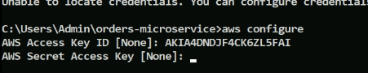

Copy the secret access key beside the key

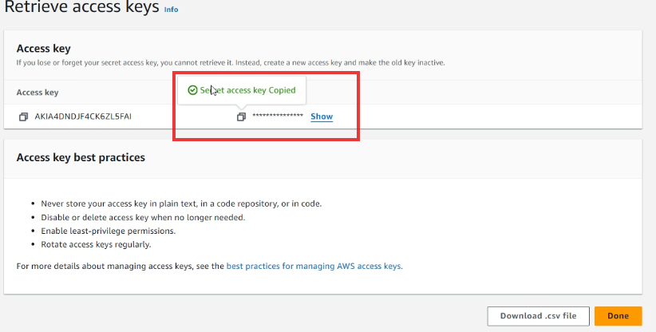

and paste at the secret access key of your command prompt

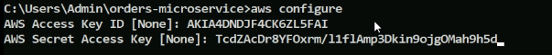

Once you enter it asks for region name & default output format, enter the region name as per the AWS region which you are using and enter output format as json

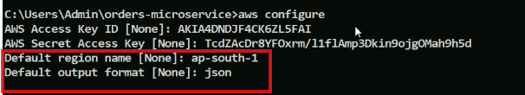

Now you can login from the command prompt, which generates a big token

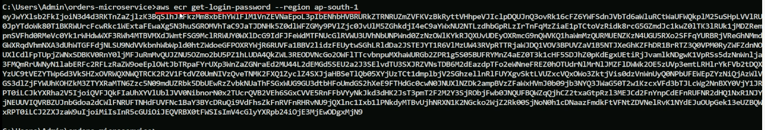

Note: Now you can able to push the image, but the admin who created your account to login from the web-page must have added you to some group before, for that admin follows these steps

Admin Attaching policies

These users which we are creating need to have certain permissions, hence the admin needs to give permissions, what admin will do is

Goes to the Access Management and selects user group and clicks on the group name like dev

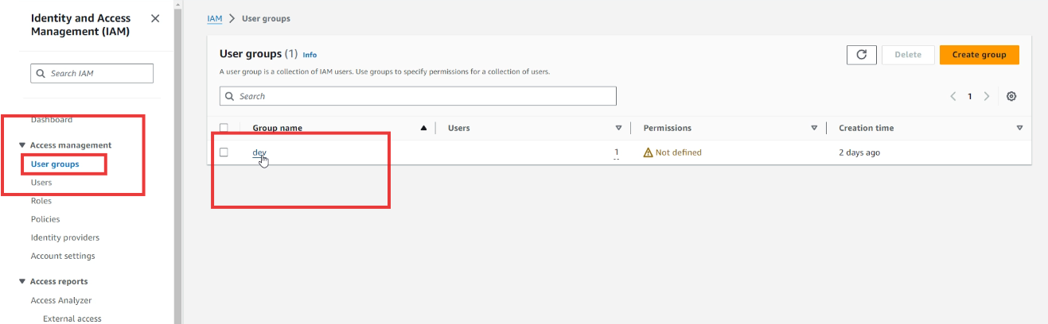

Navigates to the Permissions and in the Add permission drop down selects Attach policies

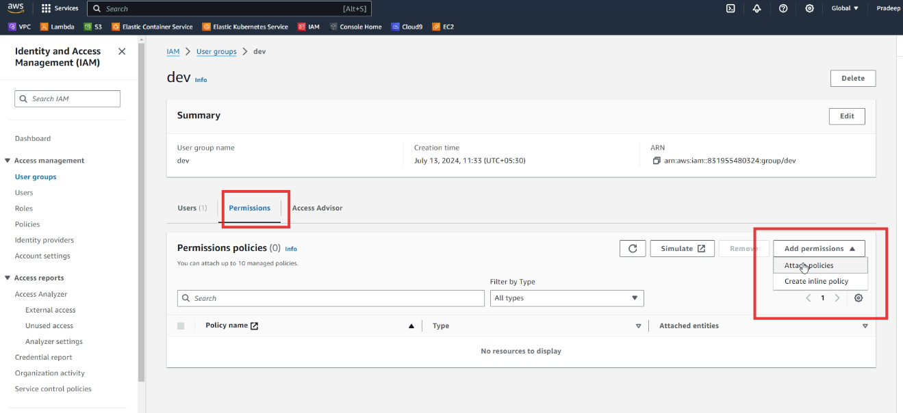

Selects the Administrative access

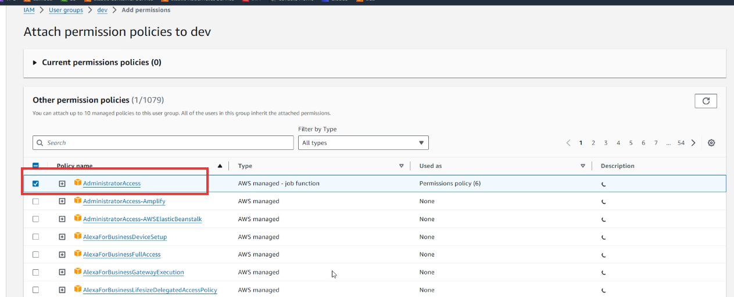

Scrolls and clicks on Attach policies

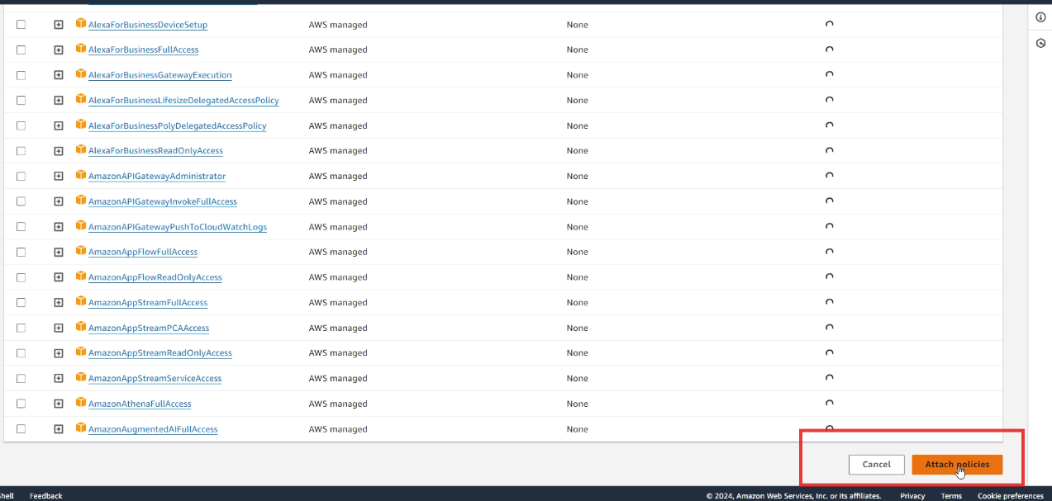

Policies attached to the user-group dev will be shown, from there navigates to Users & Clicks on Add Users

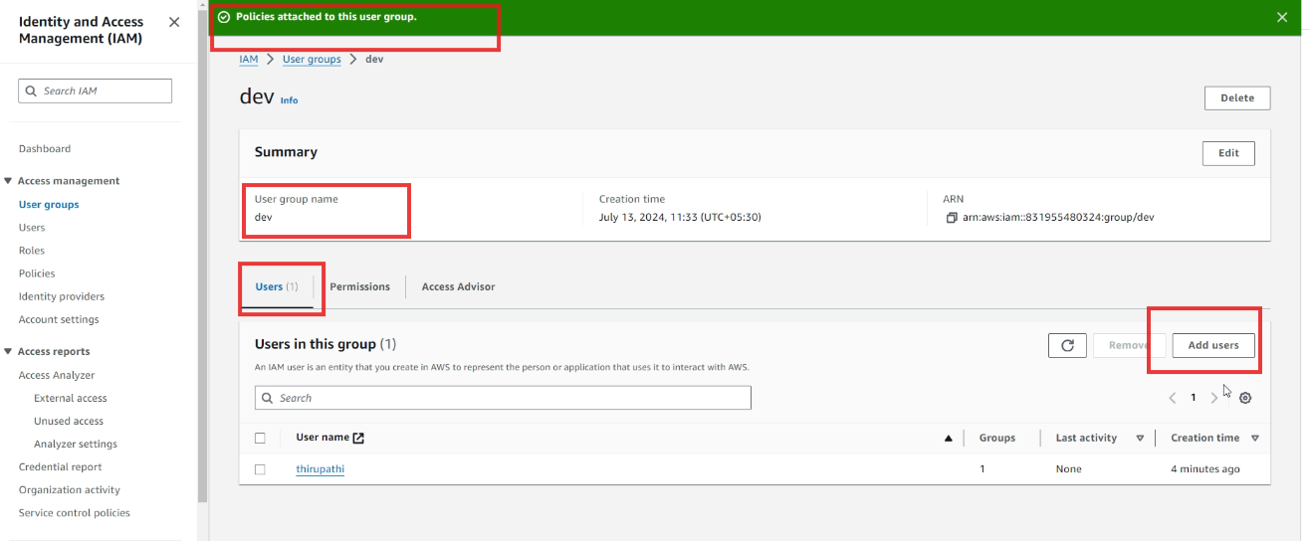

Selects all the users & clicks on Add Users buttons

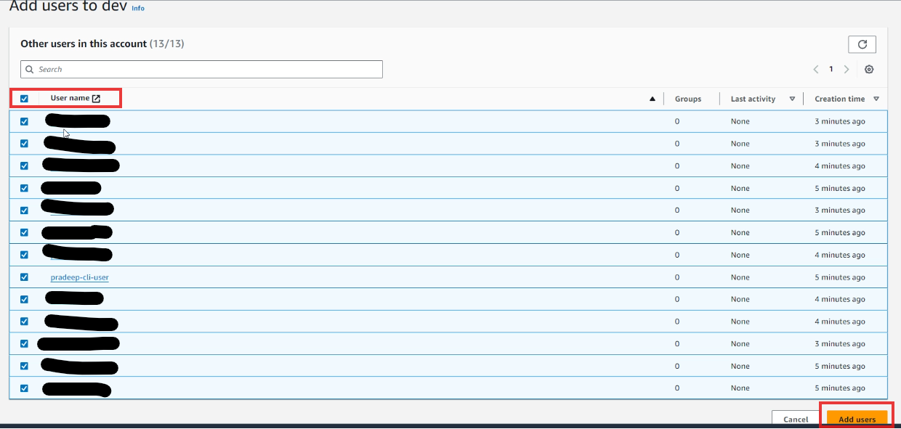

It shows how many users got the permissions

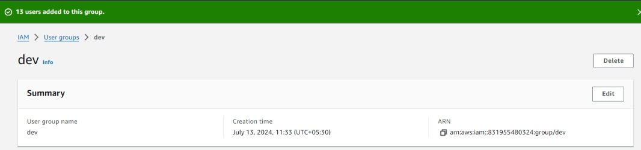

One more way to give permissions or if permissions are not set for users is to open IAM Identity center

Goto IAM Identify center > Multi-account permissions > Permission Sets

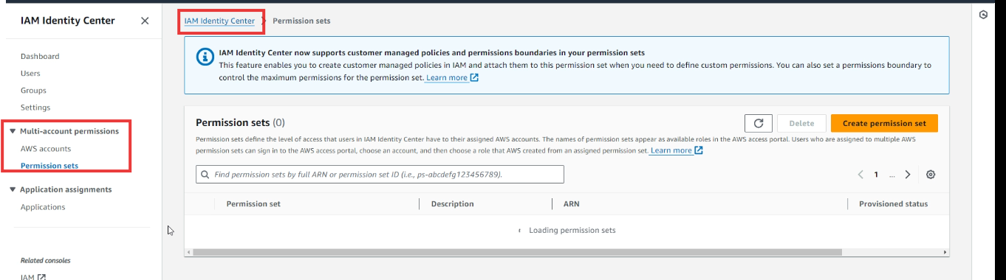

Click on the Administrator Access

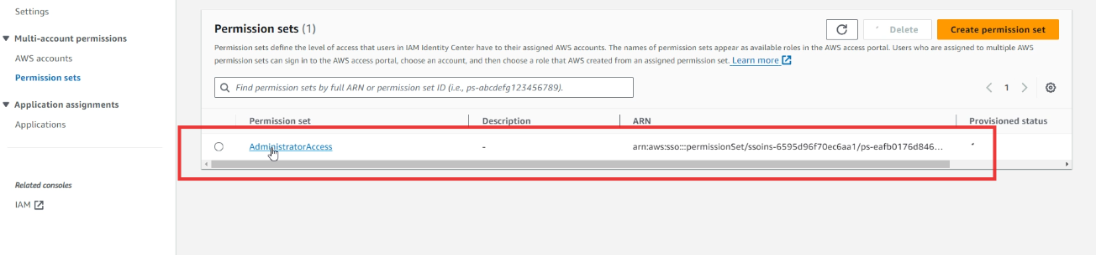

Goto AWS managed policies and click Attach policies

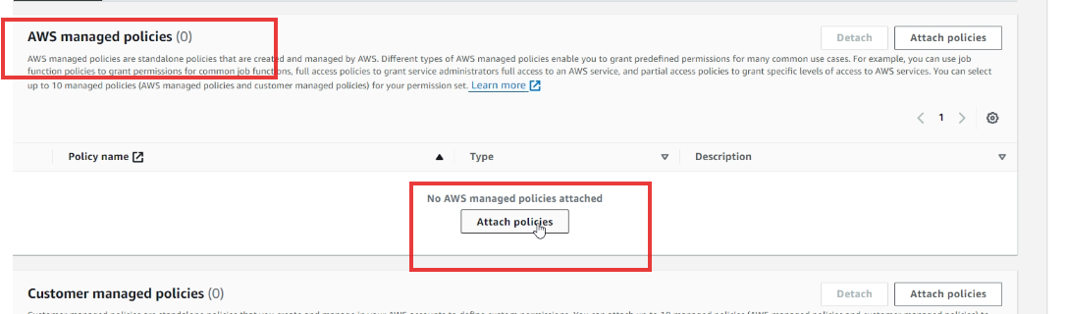

Click on Attach policies button as shown below

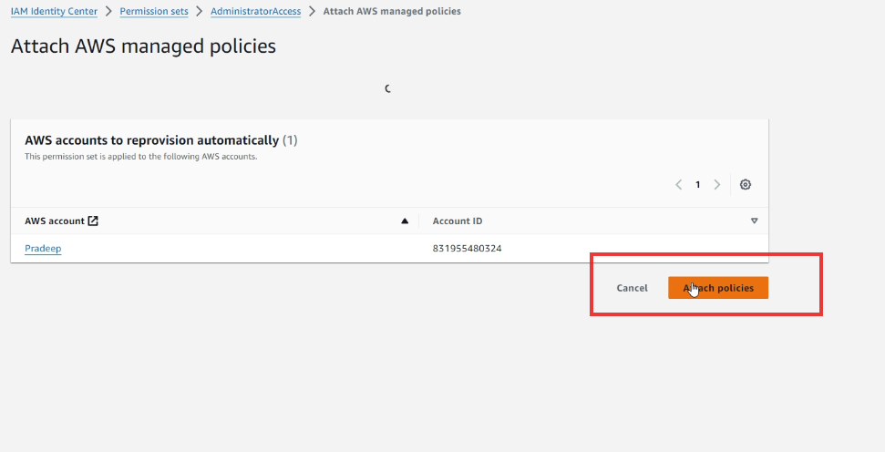

Select Administration Access

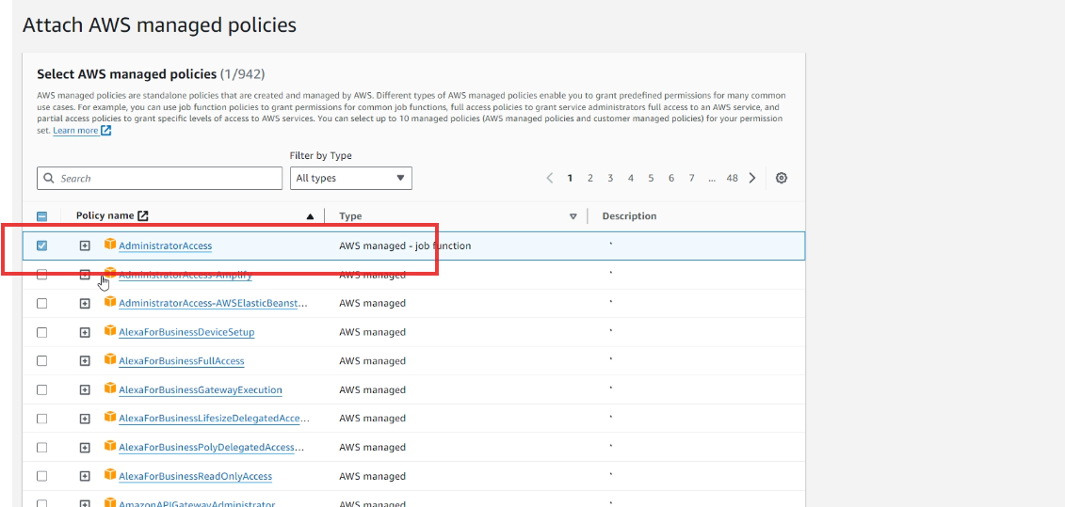

Click on Attach policies

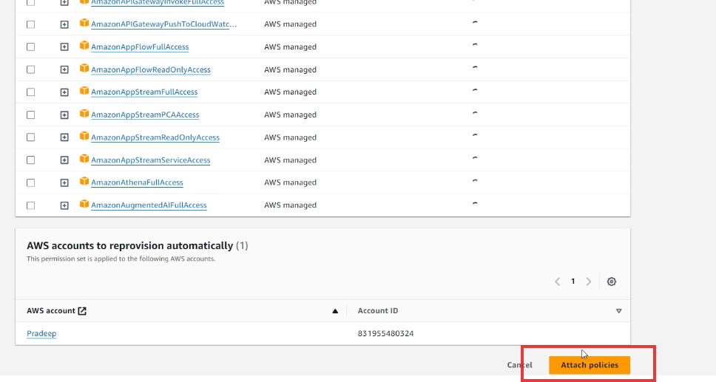

You get successfully attached

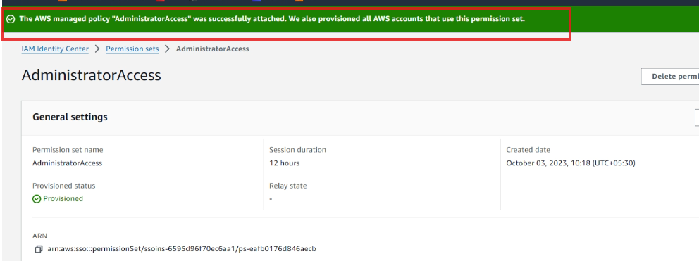

Make sure that the Administration Access is added to all the users in a group, which you will see in IAM

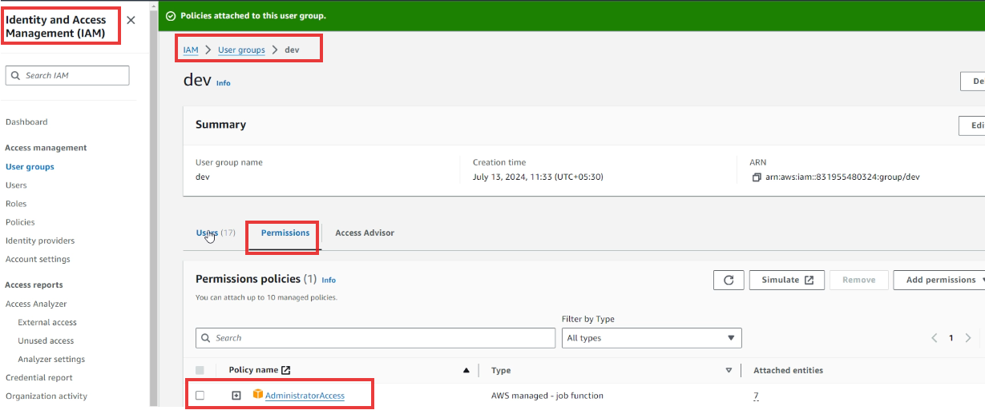

Else you will get the below error if there’s no permission

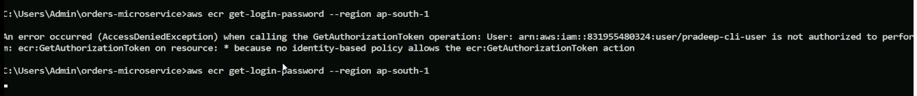

Now coming back to the command prompt that shows the token



Now Goto AWS console & type ECR

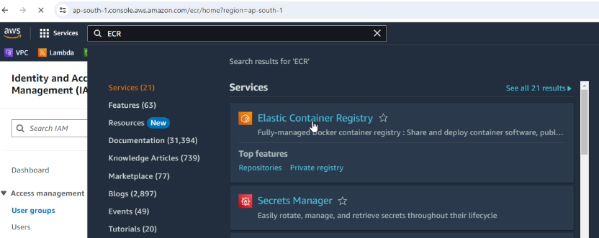

Click on the repository



Click on view push commands

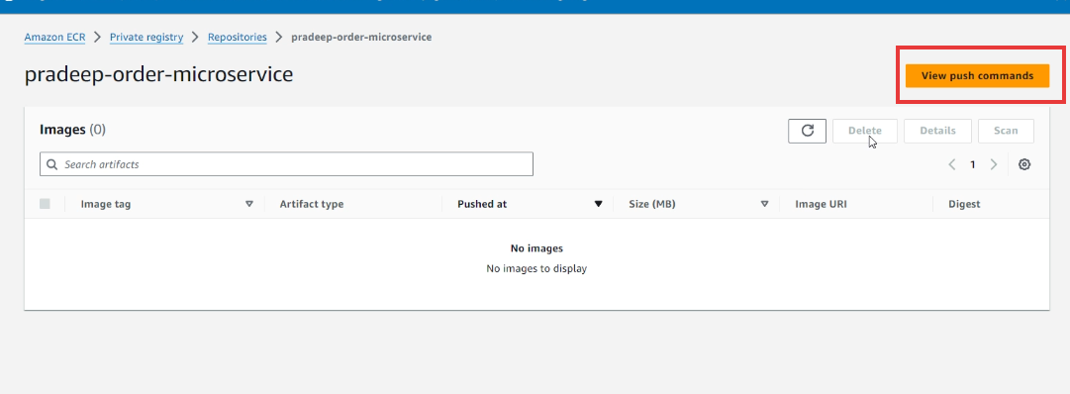

After clicking you see this window

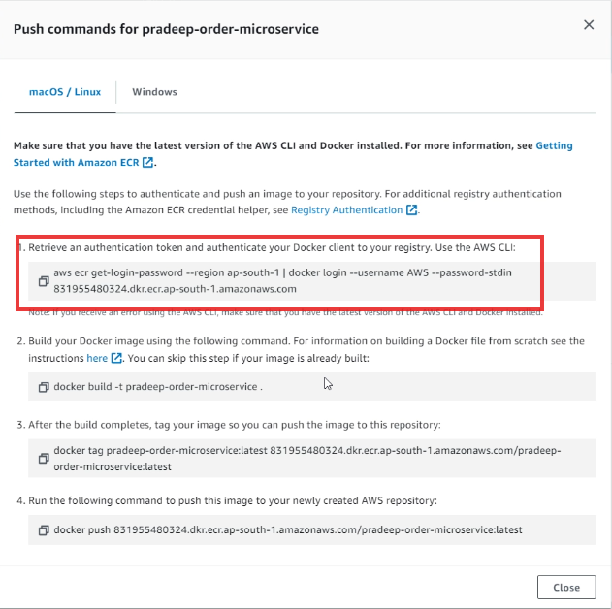

Notice the 1st command which uses pipe (|) symbol it means the get-login-password gives a token that is given as an input to authenticate your Docker client to your registry

Copy that entire command and paste in the command prompt

Note: In Powershell we must enter the command we get from the windows tab of the above dialog box, but it is not working in powershell, hence we can try the login command of mac/Linux tab



Points to know before we push

* Now we must be able to push our images, however the image you push must use the format as registry-url/repo-name
* The tag name what we create is like an alias to the image-id, we can multiple aliases for the same image-id

Listing our docker images

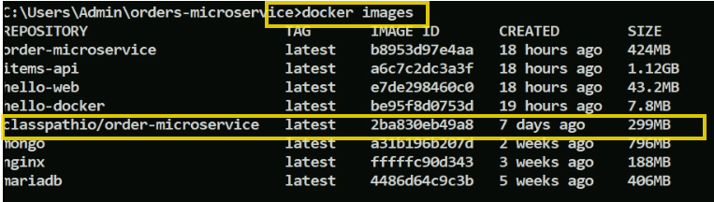

Note: to create a tag you can use image-id or name of the image

i.e., docker tag 2ba830eb49a8 or docker tag classpathio/order-microservice

Let us create another alias for the classpathio/order-microservice



The above ***docker tag*** command has following format

docker tag source-image destination-image

i.e., docker tag image-name registry-url/image-name:version

You can see those commands in the AWS as well for both tag & push, you just need to copy them into your command prompt

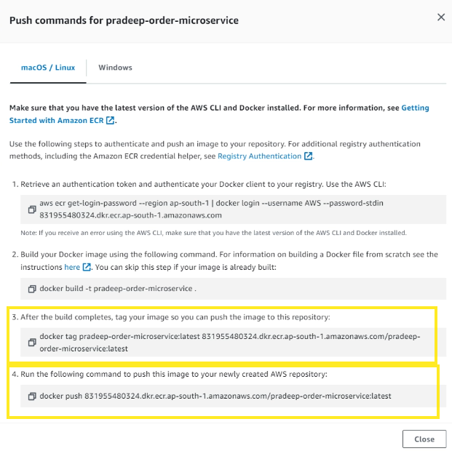

Note: You can see the docker images which lists another image-name but the id will be same as the source image-id

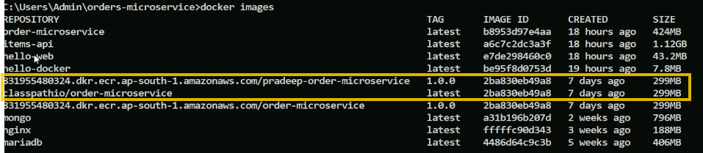

Push the docker image

Syntax: docker push image-name:version

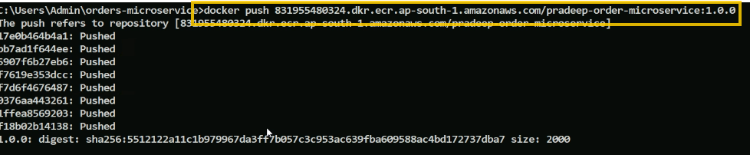

Now go to your repository in the AWS where you can see this image, when you see it then its confirmed you are successfully pushed the image present in your local machine to the registry

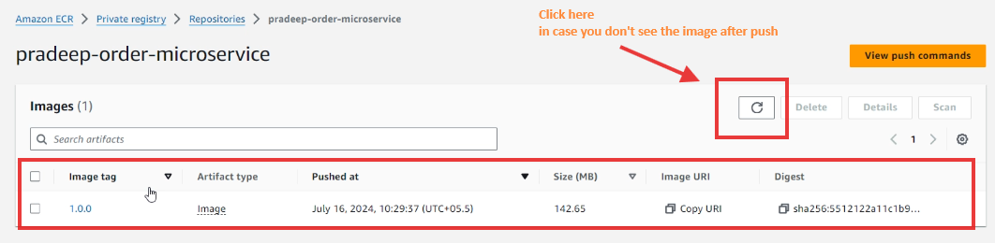

How to automate the build & push in AWS when there’s a change

In AWS you have a code commit, there you need to write the scripts in buildspec.yml file, similar to .gitlab-ci.yml of Git Lab

Navigating to Code Commit of AWS

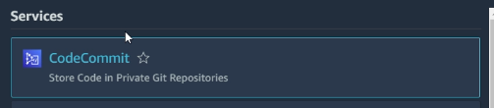

It already has same order-microservice project with pipeline script which works in AWS

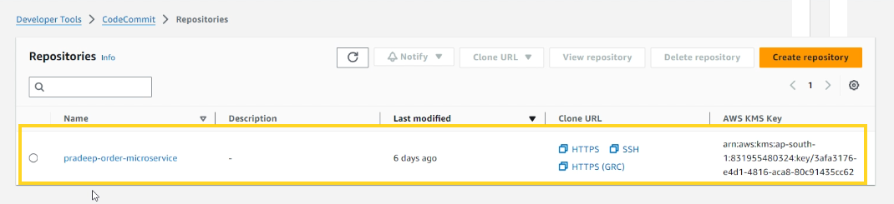

Clicking on this opens the application where you can locate the buildspec.yml

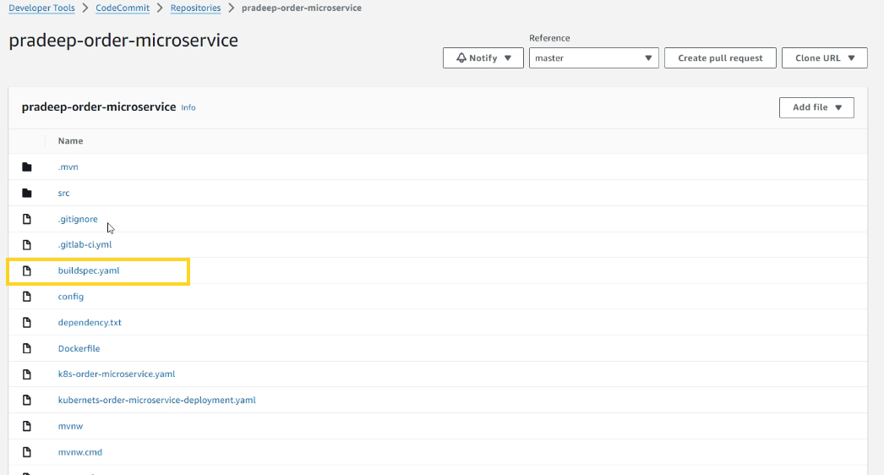

buildspec.yml

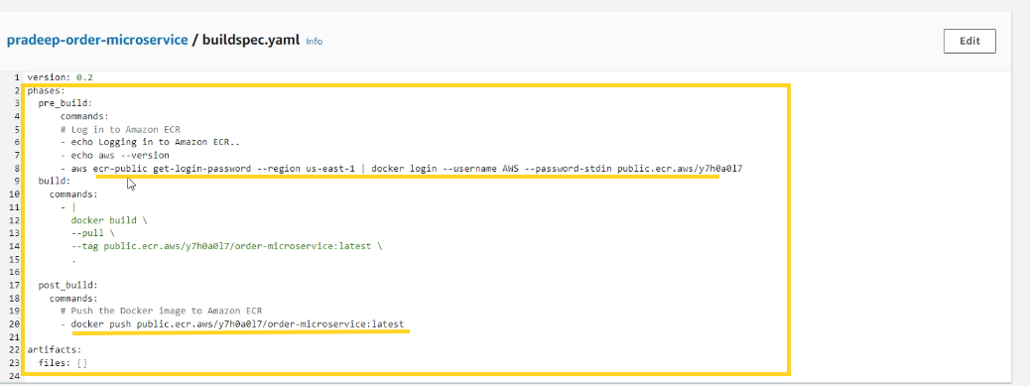

Look at the commands at pre_build & post_build those were the command we entered manually from the command prompt, but if the application is in version control and it has a buildspec.yml, then it automatically triggers pre_build, build and post_build commands, which does authentication, building an image and pushing the image respectively.

All these automation process needs to be configured by following these steps

From Where you see the buildspec.yml, look at the left side where you will see the Build option

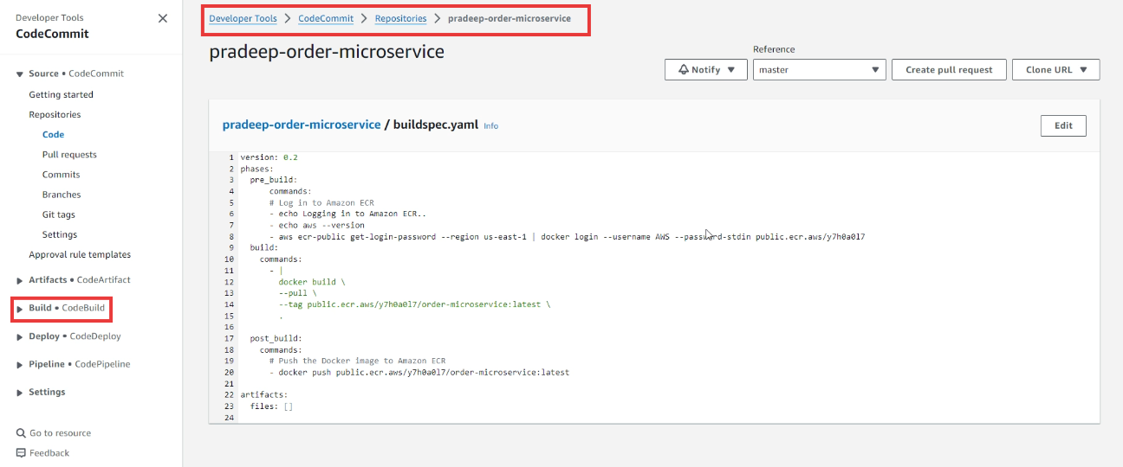

The file needs to be edited as our registry names present in the above build file is different

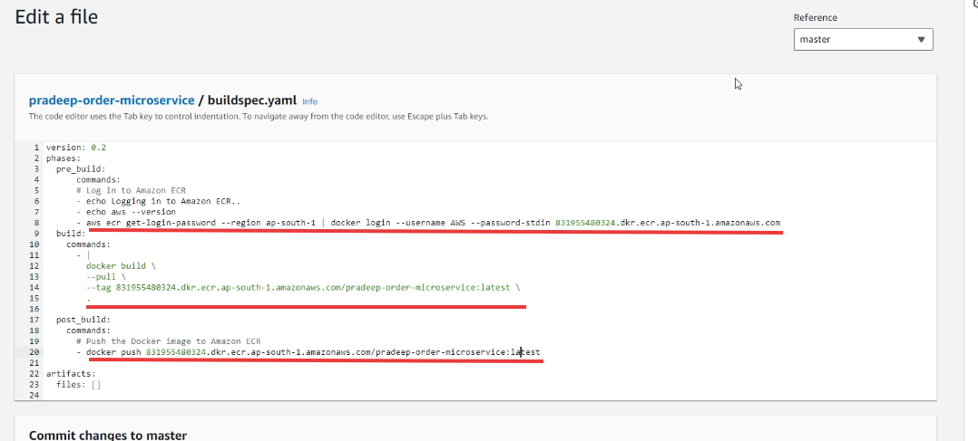

The above file needs to be committed

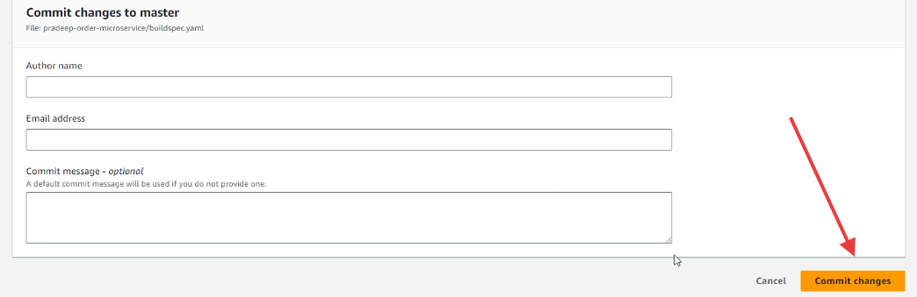

Note: You must commit by entering author name & email address

Now you click on the Build Projects

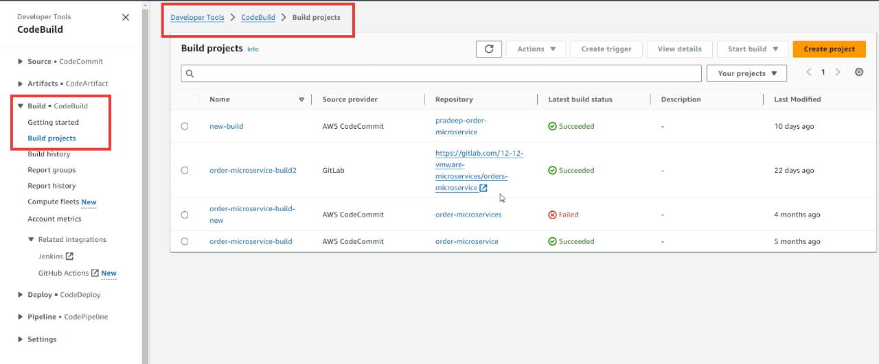

Click on the some projects or create project, click on start build

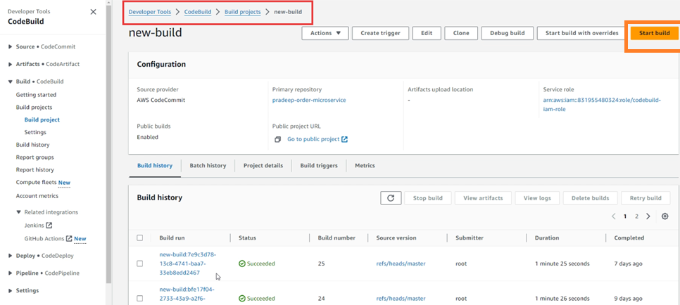

Build start automatically, click on the phase details

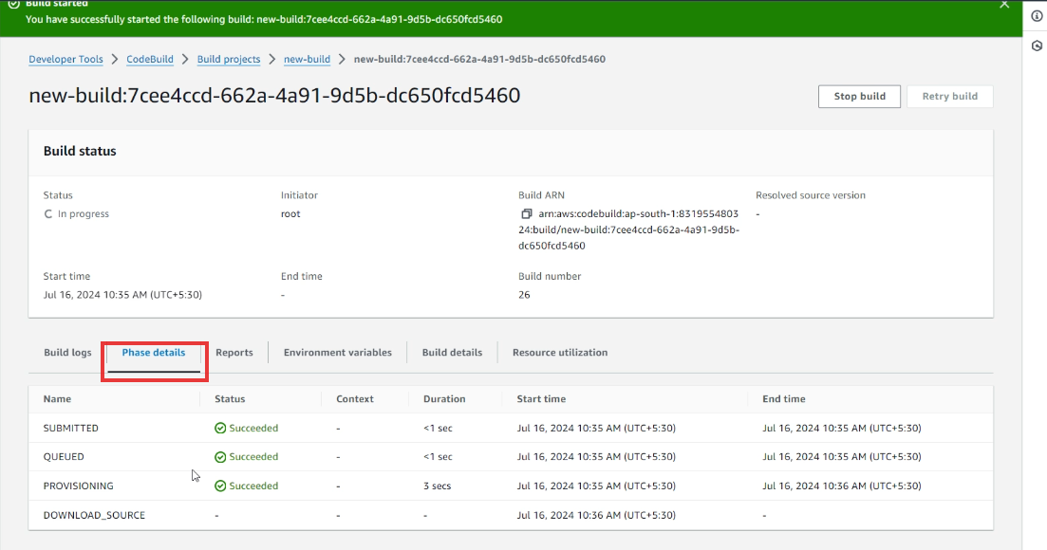

Click on Build logs to see the logs

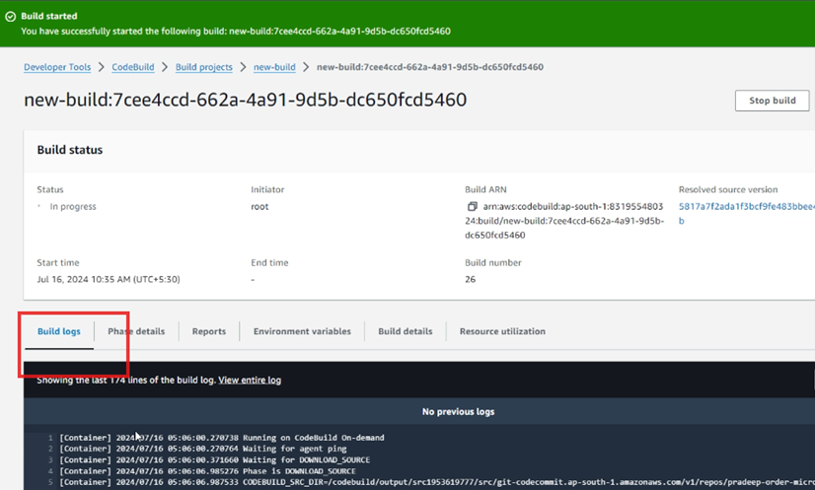

At the end you get build completed successfully

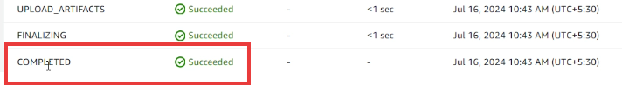

Note: These process will be same in all the cloud providers

Now we must able to see this artifact in the docker registry of our ECR

Goto ECR

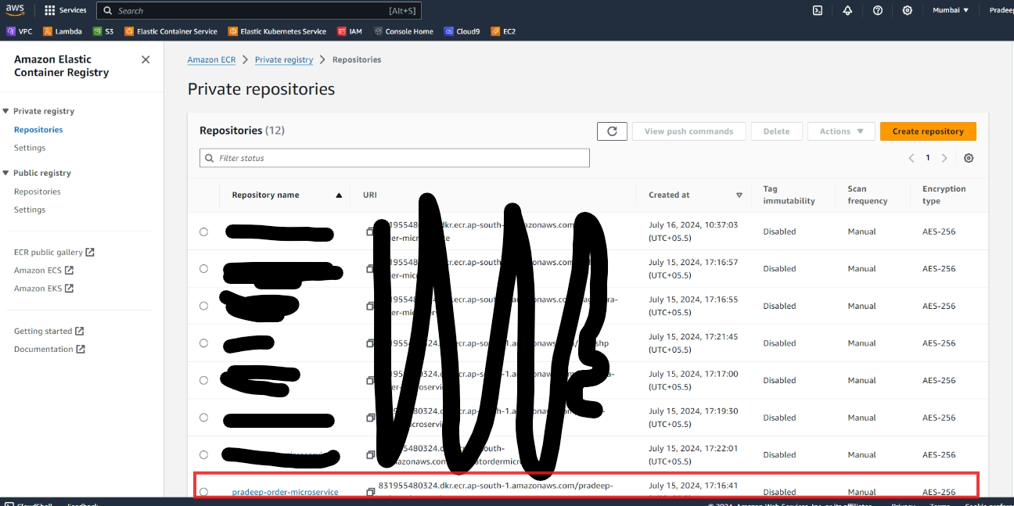

You must see the latest image that has been pushed

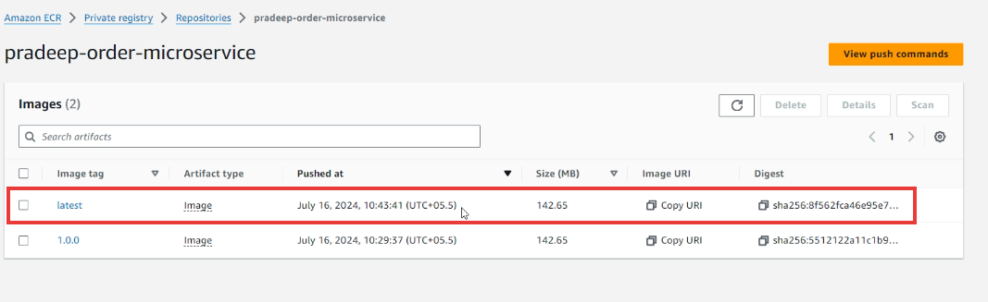

What is the advantage of these above steps

* Once we commit the code the build will be triggered automatically and image will be available in the registry without any manual process.
* This process is called Continuous Integration

Now the operations team take care of pulling the docker images and running the container

Networking

We need networking when a container wants to connect with another container be it within the host or remotely

Below is an example to understand how a container1 can communicate with two containers (container2 & container3) and no connection between container2 & container3

Scenario1

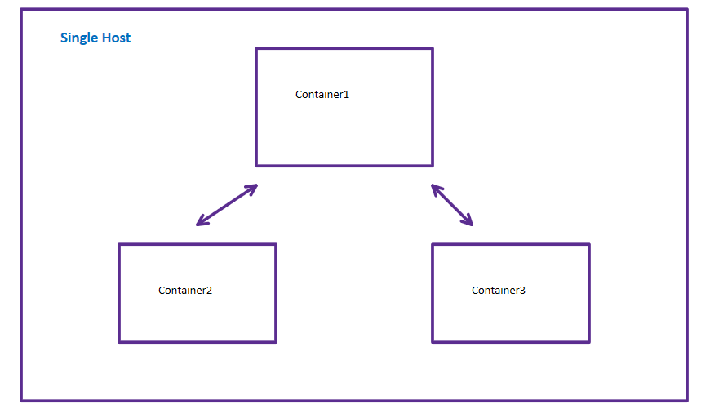

Another example to understand how networking can allow web container to communicate with app container, app container to db container but db container & web container must not communicate

Scenario2

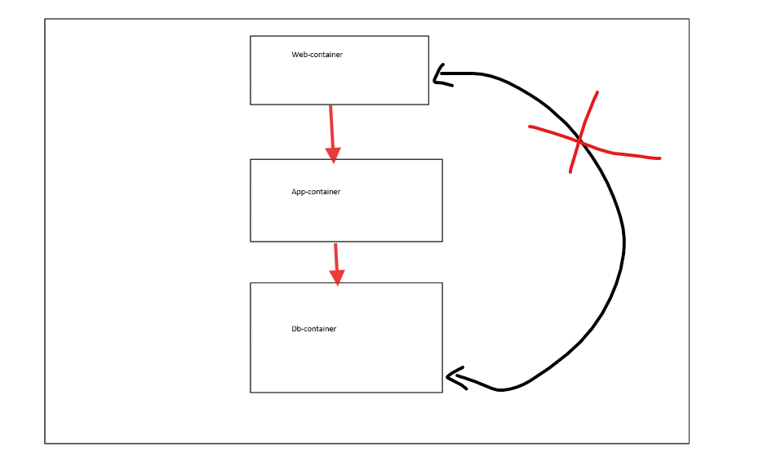

However when there’s a single host and all the containers are running in a single host we can’t rely, because if the entire host goes down then all the container goes down, so we want multiple host and each host runs different containers and want to make remote containers to communicate, as shown below

Scenario3

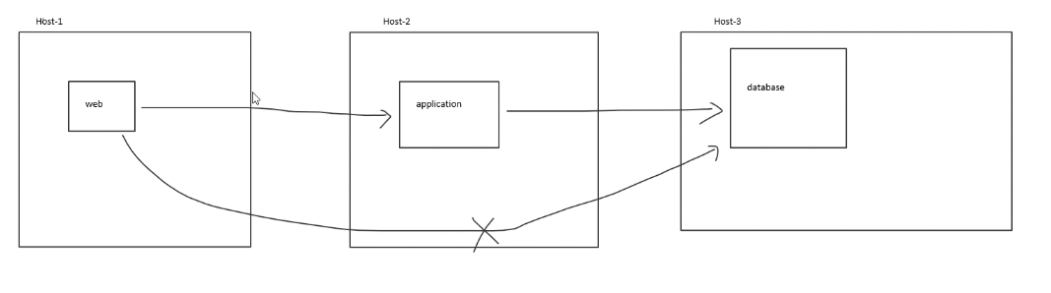

The above diagram has 3 hosts, where web container in host1 wants to talk to application running in host2, then application in host2 wants to talk to database in host3, but web & database must not talk, this is intra-host communication, this can also be achieved with networking

All the above scenarios are illustrated to understand what networking can do

Docker Networking terminologies

* Networking
* Protocol
* Interfaces
* Ports

Networking: It is about the communication between the processes which may or may not share the same local resources

Protocol: A communication language the network use like HTTP, HTTPS, there will be SSL handshake happening, SSH key pair all these are protocols. Two parties agreeing upon a protocol can understand the same language.

Ex: Webservices make two applications communicate even though they are written in different languages, because they follow a protocol like SOAP, similarly in REST APIs we use HTTP to communicate

Interfaces/Network Interfaces

It will have an address that represents a location, it will have IP which is unique in the network, It is common for computers to have two kinds of interfaces

1. Ethernet interface: to connect to other interfaces & processes
2. Loopback interface: it is not connected to any interface, useful to communicate with programs within the same computer

Note: A device can have multiple ethernet interface, so a computer can have multiple IP, however a computer will have only one loopback interface

Ports

The port numbers are where the processes are listening, like MySQL will be listening in 3306, Tomcat will be listening in 8080, TCP port will be listening in 80 and so on.

Note: Several processes might send/receive messages to/from the same port

Docker container networking

Docker networks configure communication between neighboring containers and external services. Containers must be connected to a Docker network to receive any network connectivity. The communication routes available to the container depend on the network connection it has. Docker comes with five built in network drivers that implements core functionality of networking, it abstracts the complexity of networking keeping end users in mind i.e., Development team and IT operations team so that both must be able to setup network them without getting involved in how it is achieved

Networking is a first class citizen

Docker networks are independent from the container, they have their own life cycles you can create/delete/edit/list networks and attach to the containers or detach from the containers

Docker network commands

Docker provides a network commands like docker network <sub-commands>

Using docker network command to list the networks

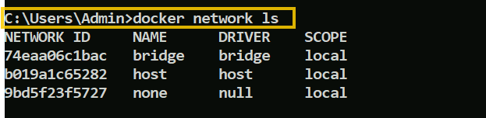

Types of network docker support

By default docker supports 3 types of network

1. Bridge
2. Host
3. None

Each have their own drivers and scope

Scope: It is local for all the networks it means you can communicate only to the neighboring containers in the same machine

Note: If you want containers to communicate outside the host network then you need to use overlay network these are distributed network that span multiple Docker host, there are two more types of network which can be used in docker like ipvlan & macvlan which are used for advanced networking options.

Bridge: Bridge Network create a software bridge between your host and the container. Containers connected to the network can communicate with each other, but they are isolated from those outside the network, it acts like a router when one container wants to communicate with other

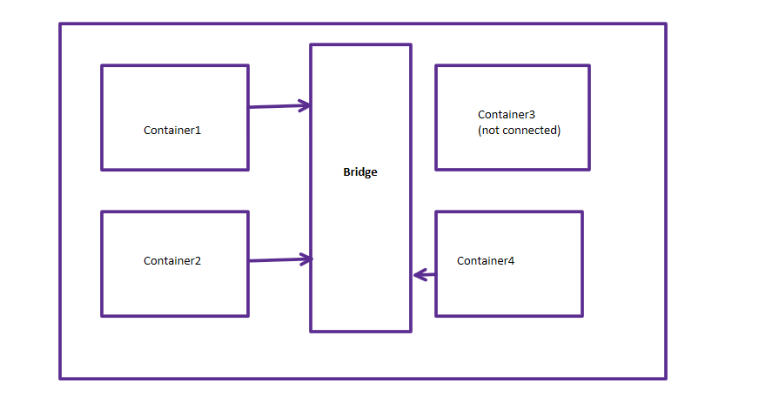

Those containers connected to the bridge network can communicate with other containers who are also connected to the same bridge, if the container is not connected to the bridge then it can’t communicate with other containers.

Containers have private loop back interface and a separate virtual ethernet interface

Note: All Docker containers, including closed containers, have access to a private loopback interface.

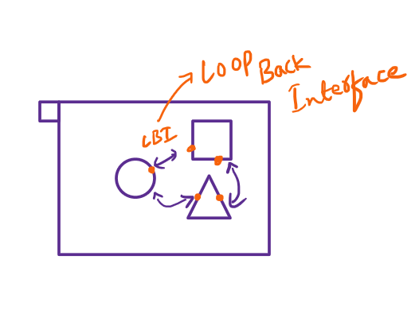

Containers with loop back interface allow processes running inside it to communicate with each other

Creating a bridge network

docker network create --driver bridge --label project=dockertraining --label env=dev --attachable --scope local --subnet 10.0.42.0/24 --ip-range 10.0.42.128/25 user-network

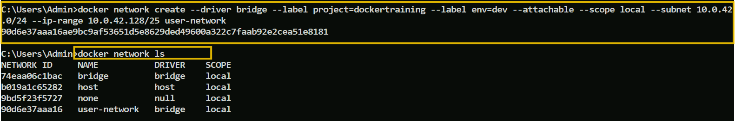

You can see the bridge network created using network ls

Inspecting the network

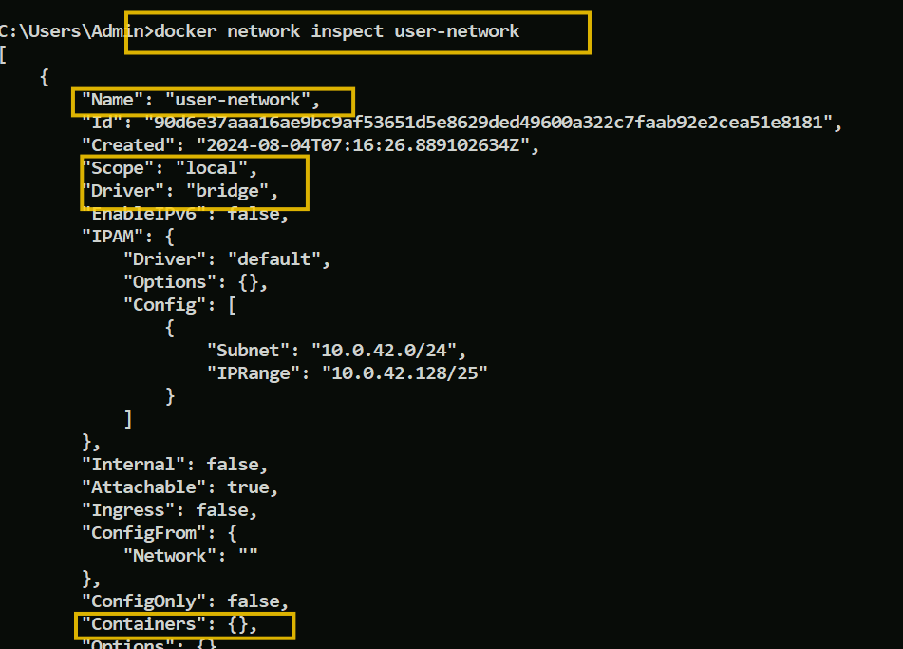

You can inspect what is the network name, id, when its created, subnet, ip range, how many containers are attached to it, right now the number containers attached to this network is empty(0)

Note: We created the bridge network, then we need to attach the container to it

Creating the container and attaching to the network

Enter below commands

docker container run -it --network user-network --name network-explorer alpine:3.8 sh

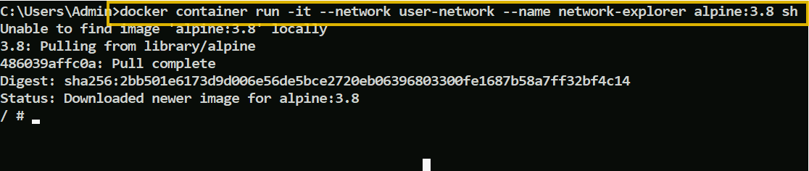

We are not using any image, instead we are directly using alpine, it has ‘sh’ which creates process called sh, that takes us inside container, this creates a container called network explorer

You are now inside the container and can see two interfaces

Ethernet and loop back interface, to view these you must use ifconfig command

Being inside the container run ifconfig

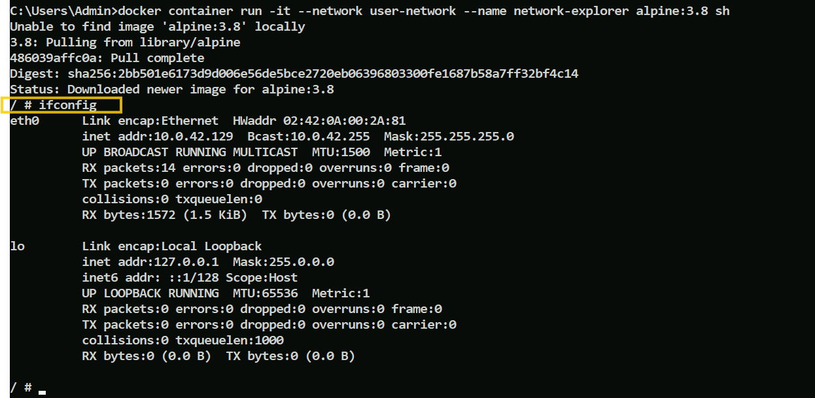

Observe the two interfaces which has the names

* eth0: Ethernet, It has its own IP
* lo: Loopback, It has an IP, which is the container localhost, not the host machine localhost

The container is now attached with one network, however we can attach the same container to another network also, for that we need to have another bridge network and connect the network with this container, lets do that

Create another bridge network and attach it to the container

Exit from the container using exit

List the container where you can see that sh is exited, but its stopped



Let us create another bridge network now

--name user-network2  
--subnet 10.0.43.0/24  
--ip-range 10.0.43.128/25

Enter the command

docker network create --driver bridge --label env=dev --attachable --scope local --subnet 10.0.43.0/24 --ip-range 10.0.43.128/25 user-network2



Now check the network list

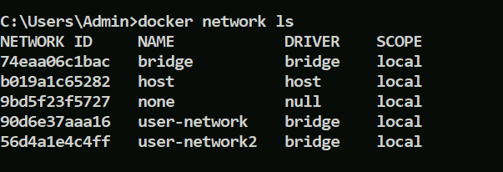

Inspect both of them to see no containers attached

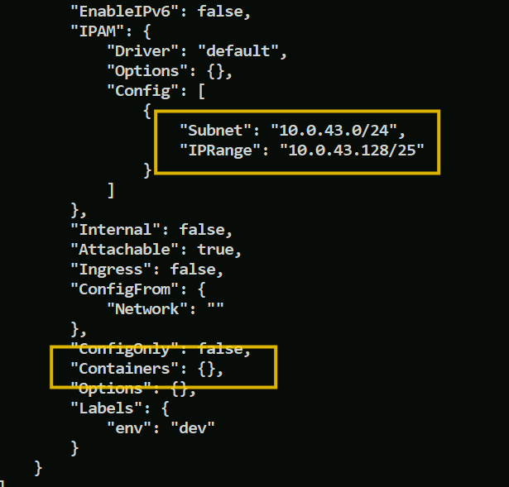

Subnet & IPRange is highlighted to understand it belongs to user-network2

Now attach user-network2 to the network-explorer (a container created earlier)

Command is docker network connect network-name container-name

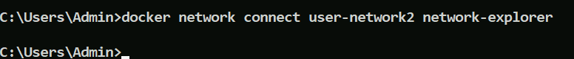

Now start the network-explorer and get inside the container using attach

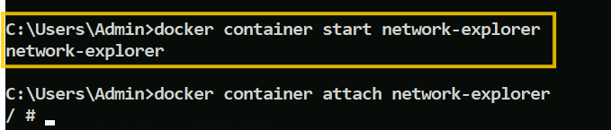

This network-explorer is now attached to both the bridge network, user-network, user-network2

Use ifconfig to see that

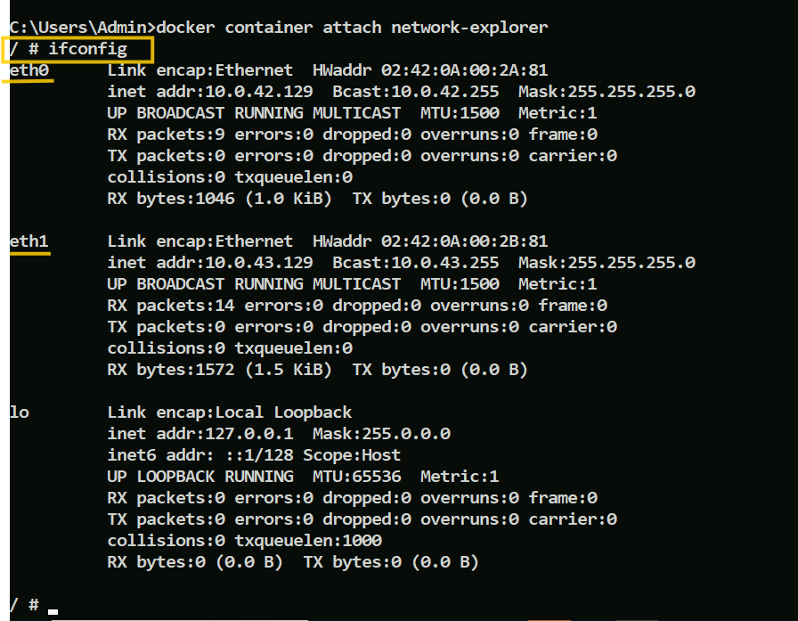

Note: The container has 2 IP, look at the inet address of each ethernet interface

Let us start the alpine container using start and inspect the two networks we created.

Firstly you must exit from the container, it exits and container stops, we must start it

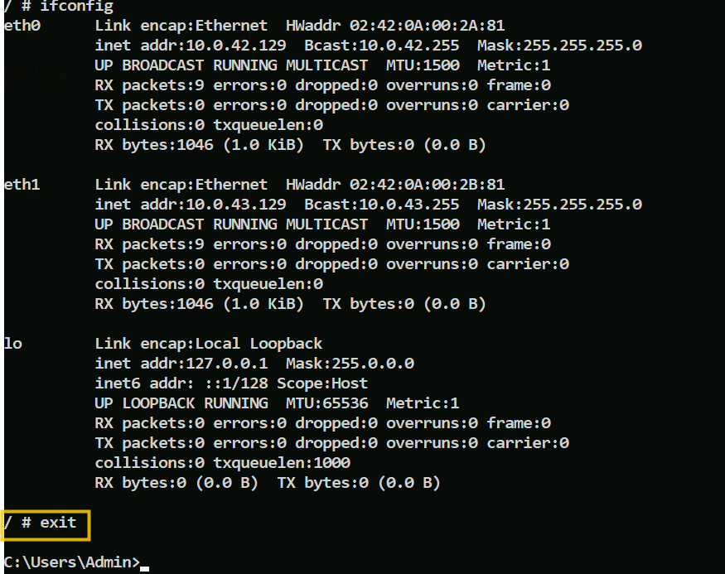

Check the container id using container ls --all

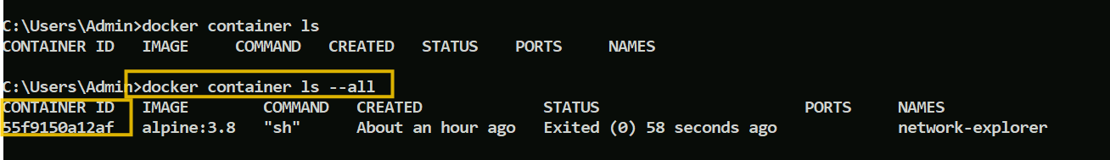

Now start the container again using start command

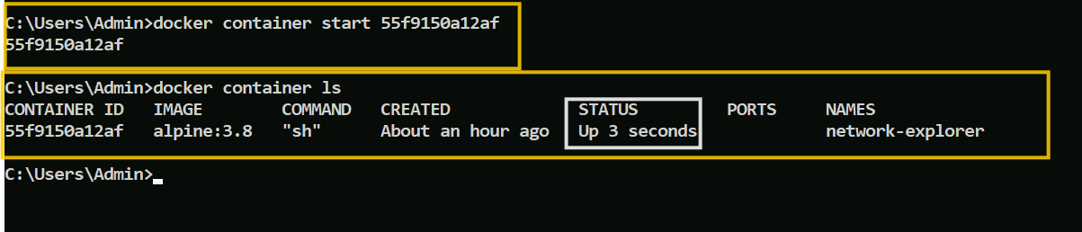

Now you can inspect both the networks to see the same container id in the containers property

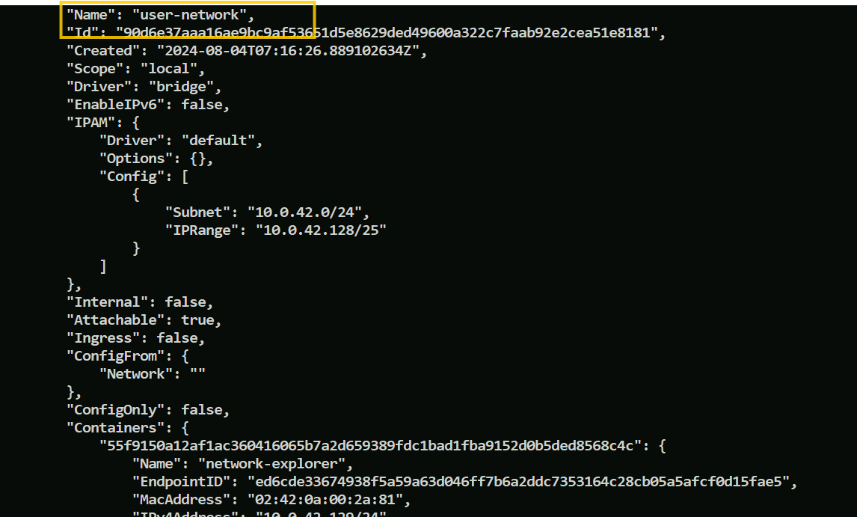

user-network2

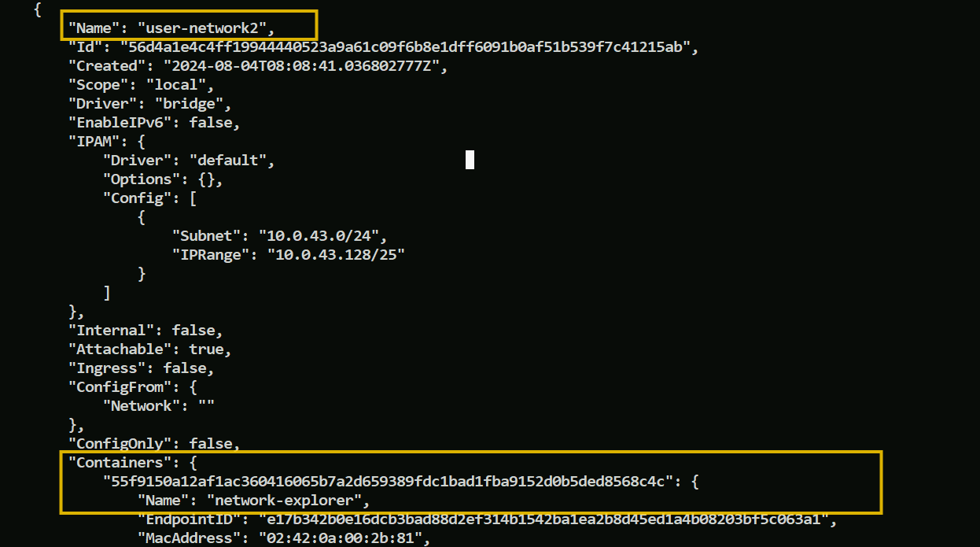

Lets create another container try communicating with the container network-explorer

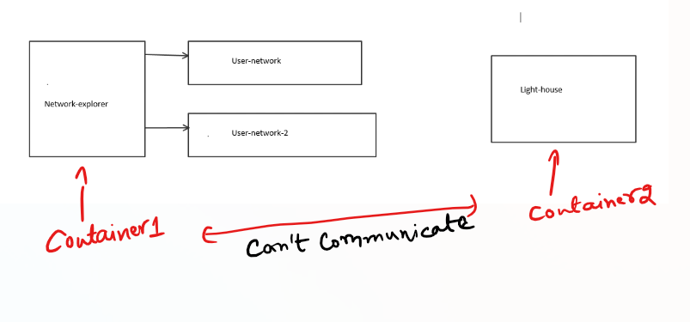

We will use the same image

docker container run -d --name lighthouse --network user-network2 alpine:3.8 sleep 1d

The command says sleep for 1day

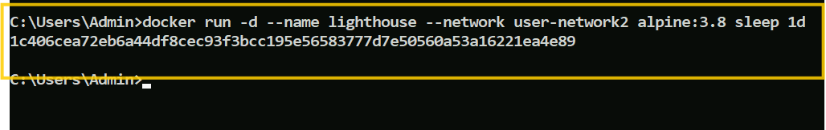

Note: use docker container run, instead of docker run, though both works

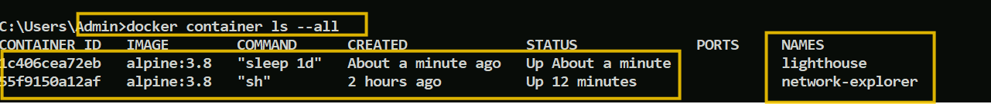

Both the containers are running, lighthouse is attached to user-network2, network-explorer is attached to user-network & user-network2 both.

Below image illustrates what we have done till now

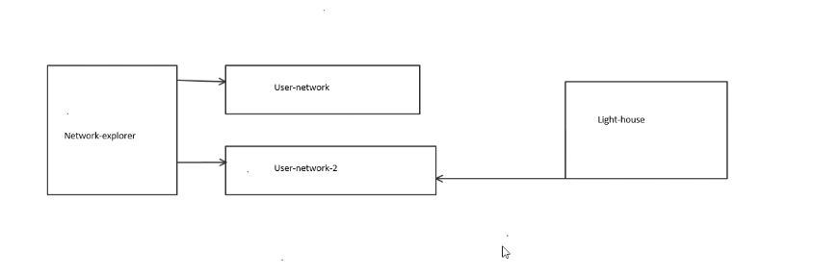

Both the network can communicate over user-network2, however then can’t communicate over user-network

Open a new command prompt and attach to network-explorer

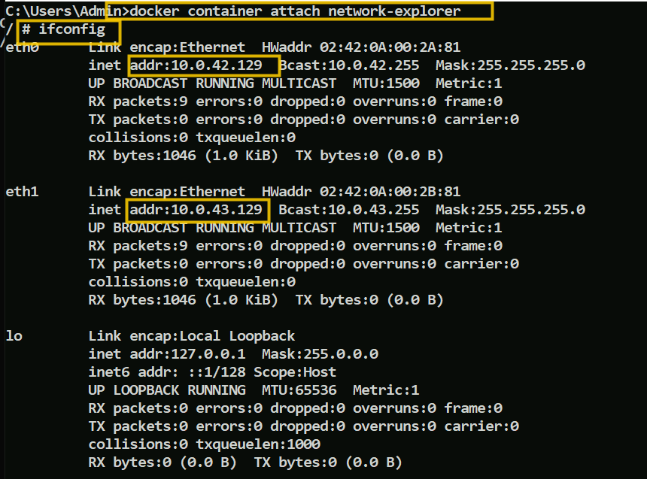

Note: eth1 is connected to user-network2

So from the light-house ping using eth1 address of network-explorer, and ping using eth0 address where you don’t get response

Using ping to eth0 inet address of network-explorer from the lighthouse

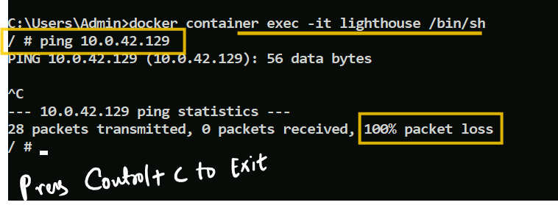

Using ping to eth1-inet address of network-explorer from the lighthouse

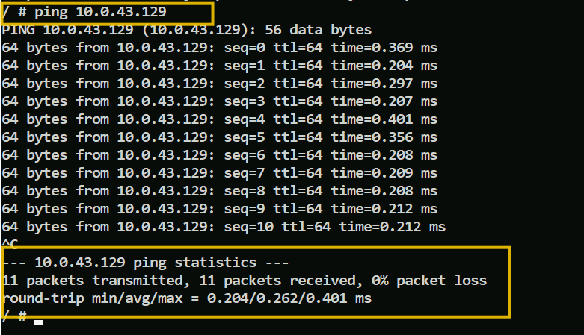

Note: Here the IP address of the containers change when it restarts, however we have higher order configurations on top of this where we user a service linked with the container, through service we will communicate with the container, if container restarts the service-id doesn’t change, ex: instance-id of the services in microservice

Now try to connect user-network to lighthouse, then ping to the user-network IP address it should work

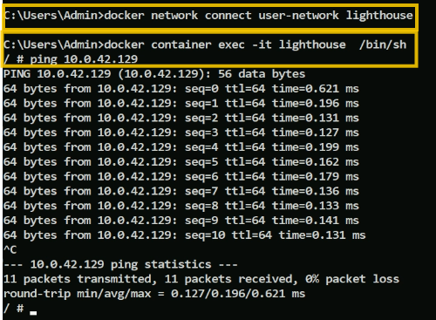

On Inspect user-network2

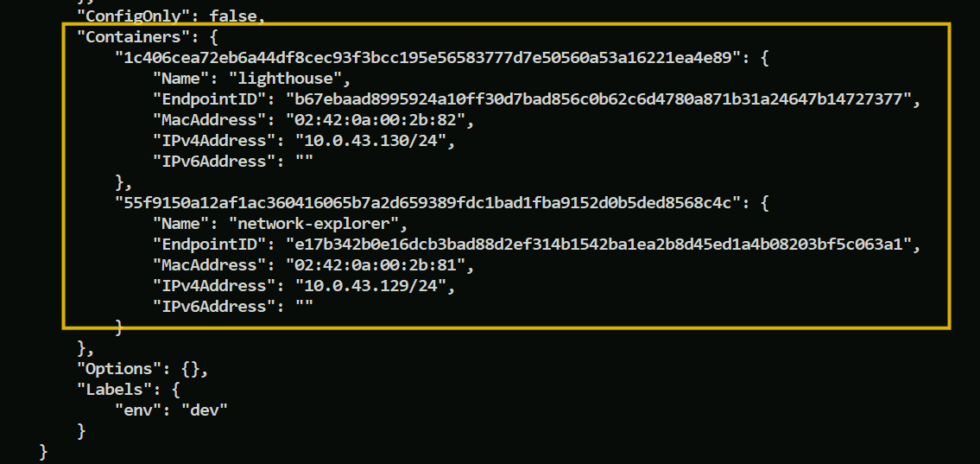

Limitation of bridge network

It is only for single host deployment, there’s no much uses cases for this except for single host network, because the driver itself is single host.

Host Network Driver

This enables the program running inside the docker container look like they running on the host itself , i.e., on the host machine rather than the docker host, if the container runs with host network then it doesn’t get its own IP address, for instance if you run a container which binds to port 80 and you use host networking, the container’s application is available on port 80 on the host’s IP address.

Note: Since the container doesn’t have its own IP while using host network, using port binding option will be ignored, producing a warning instead.



Host mode networking can be useful for the following use cases:

* To optimize performance.
* In situations when container needs to handle a large number ports.

This is because it doesn’t require network address translation (NAT) and no userland-proxy is created for each port.

Below are some more benefits of using host network

* Without any networking namespace, all the kernel tools for tuning the network stack are available for modification, which means if there’s any vulnerability in the host machine, then the container can modify it with full privileges, no permissions required.
* Containers running on the host network are able to access host services running on localhost and are able to see and bind to any of the host network interfaces

Note: The host networking driver only works on Linux hosts, but is available as a Beta feature, on Docker Desktop version 4.29 and later.

Creating a host network

Enter below command

docker run -d --name host-network-container --network host alpine:3.8 sleep 1d



List the container id and get inside the container and ping to google just like you ping from the host machine, we use /bin/sh not /bin/bash here

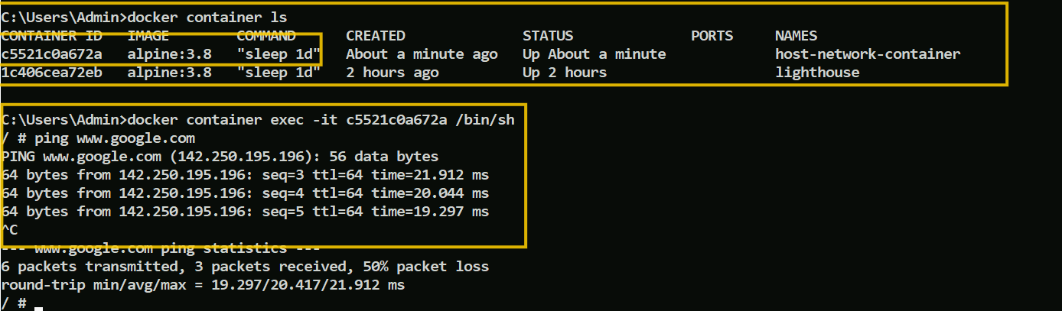

What can be the real time use case of this host network for the container

You do this when you want the process to be run as a an isolated container, let us say you have 100’s of EC2 instances means 100’s of hosts, those have access to cameras, talking to sensors or they are IOT devices, but you don’t want to install the software’s on each of the devices, instead you can create a docker image and then they will be run as a container, whenever some upgrade needs to be done you don’t do each of the machine, you do at the image level and run them as containers with host network

Another use-case would be assume a machine connects to a payment-gateway or vault service, but some processes are getting conflicts with some dependencies, then you can create containers and create those dependencies inside it and access these services, but we must be very careful while using container with host network as they will have full privileges just like processes running in the host

Summarizing the possible ways of communication between host to container, then container to host, container to container

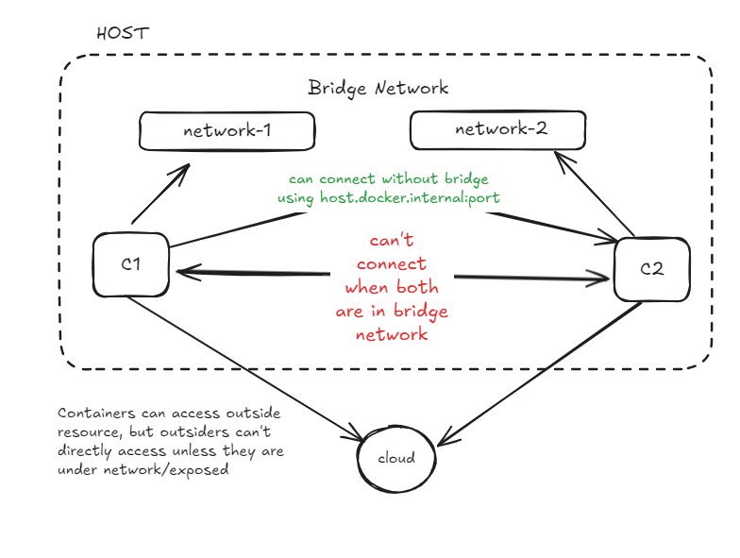

Doubt:

A container under bridge network is able to connect to the outside resource

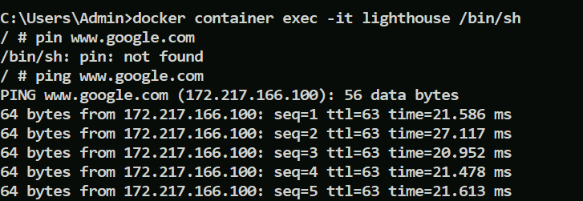

Container to Container via Bridge Network

Host to Container via Port Binding

Container to Host via Host Network

Bridge network is specific to the host

Another network type is None Network

When you create a container with none network mode, then docker doesn’t create any network infrastructure for the container It will have its own network namespace and will be isolated.

* It will not be able to use the network to communicate outside of the container.
* Containers will still have their own loopback interface and hence, multi-process containers can still use connections to localhost for inter-process communication.

Command to crate none network container

docker run -d --name none-network-container --network none alpine:3.8 sleep 1d

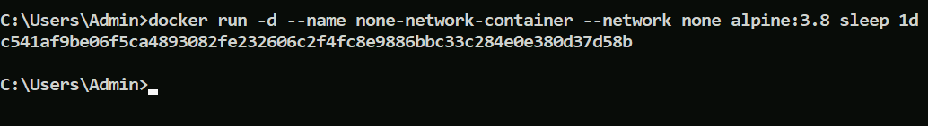

Getting inside the container and try ping and ifconfig will give us below results

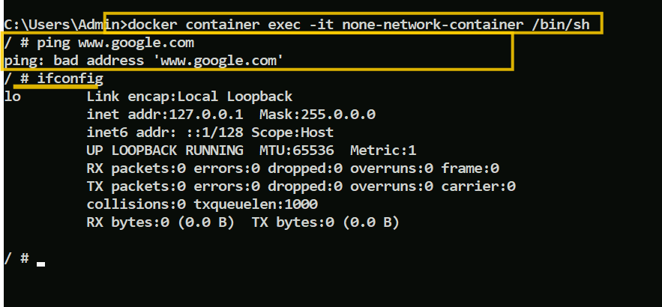

You can see the none network container doesn’t have an ethernet interface, but has a loop back interface, so it can communicate within the container, it also can’t ping to outside world

Note: It is always better to use inspect on network to know which container is using the particular network instead of the reverse idea which would be difficult to inspect, though its possible with docker container inspect [docker-id or docker-name]

what could be the use cases of none network in the container

1. Let’s say you are writing an algorithm to generate passwords, some cryptographically secured passwords and you don’t want it anybody to connect through the network or connect to the container, then you can run them in an isolated container with none network
2. When You have your own network stack, you don’t want to use docker networking but you want to use some other networking stacks, in those cases also you can use none network, ex: when you are using docker with Kubernetes, OpenShift, ECS or other orchestration tool who manages the container, they will take care of adding their own networking stack by setting the docker container network to none

Few more things to know in networking

What happens if you use -p while running the docker containers without specifying the host port to bind

Then docker containers are going to be bound to some random port on the host.

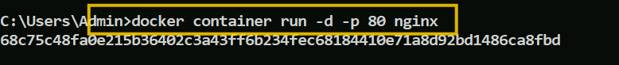

You can see binding on the host port has taken random port

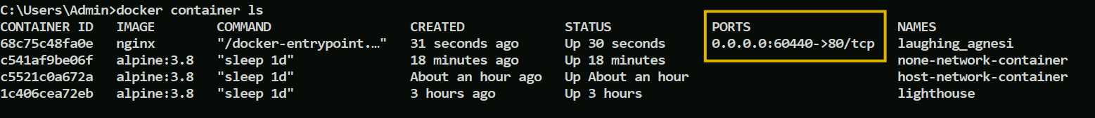

Curl request gives us below output for that random port

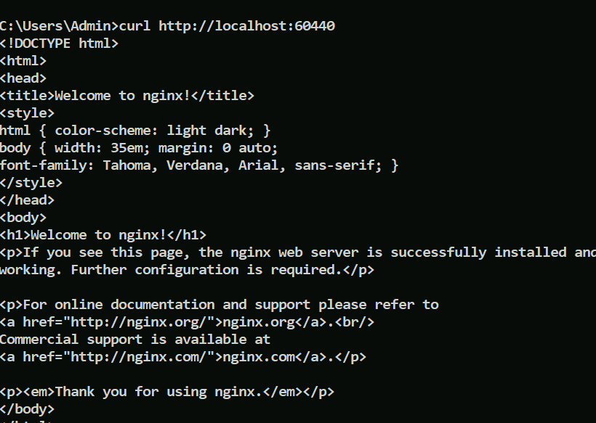

These random ports are assigned when the dockers are run programmatically, because it would be difficult to always give a free port of the host

You can give which protocol while running the container

docker run --rm \

-p 8088:8080/udp \

alpine:3.8 echo "host UDP 8088 -> container UDP 8080"

You can also give ip address

docker run --rm \

-p 127.0.0.1:8080:8080/tcp \

-p 127.0.0.1:3000:3000/tcp \

alpine:3.8 echo "forward multiple TCP ports from localhost"

Understanding what containers take and give during data processing

Container will have two things

1. Input (not the HTTP request, this about data)
2. Output

The input can be application configuration, DB Configuration, server configurations, ex: If you are running a tomcat, then there will be server.xml, if you are running a node.js then there will be node.js configuration, if you are running a DB then there will be DB configuration

The container will have a process running, it can be DB, webserver, application server, message broker

The output will be application log files, application generated data, db configurations data

Note: We have externalized the input & output and running only the process

But what happens if the container is terminated

We lose all the data once the container is killed, we created the container with the input, output everything is inside the container till now, however we can’t recover the application state if the container restarts, hence we must be able to recover the application data

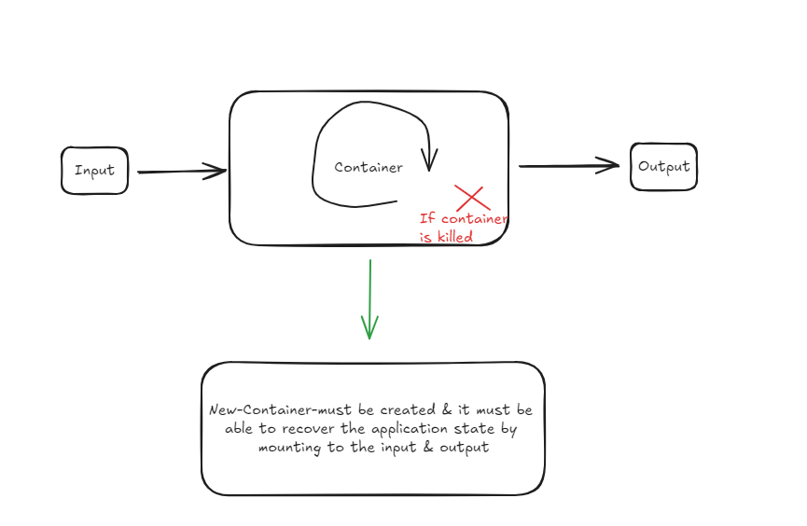

This is where we use Volumes where we mount to the container

Volumes: It will detach the storage from the process, you are going to manage the volume externally so that what runs in the container is just a mere process, the advantage is lets say you have 50 containers, all these 50 containers are using java application & they are talking to the DB & DB credentials needs to be changed, then you can’t go to each of the container & update the yaml files with DB credentials, instead you will change it in one place and it will be reflected to all the 50 containers, so that way you are going to ensure that the containers are running with the exact same configuration even when configuration is updated

Scenarios:

To cut the cost you run a postgres without volume mount in some instance like EC2, if in case the EC2 is terminated then all the data’s will be lost. which is why volume mount is very critical in the real time, So for that reason only we want the data to be durable even when the container is deleted or restarted or stopped

Things we are going to see in volumes are

* Different types of volumes
* Ensuring the data will be durable even if something goes wrong
* Controlling where the data needs to be maintained
* How to ensure container are resilient to failure at the container level / host level

Note: Volume lab will be updated later

Docker compose

Docker Compose is a tool that simplifies the process of defining and running multi-container Docker applications. Instead of running each container manually with complex docker run commands, Docker Compose allows you to define the services that make up your application in a single YAML file (typically named docker-compose.yml).

Verifying docker compose installation

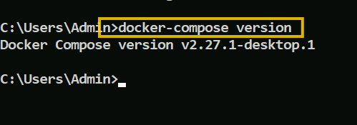

Clone the below repository

git clone <https://gitlab.com/classpath-docker/docker-compose-examples.git>

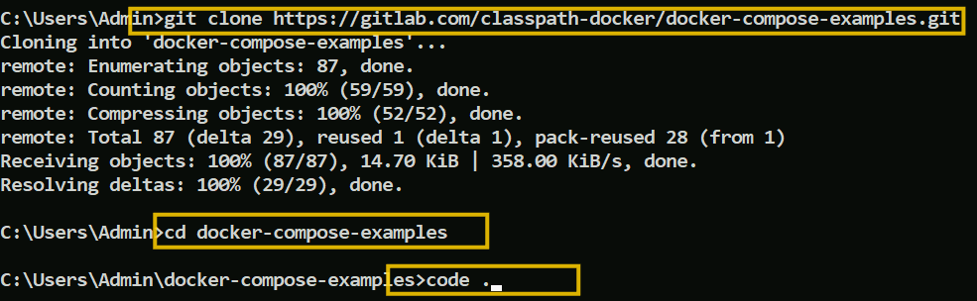

You will see below examples in the vscode

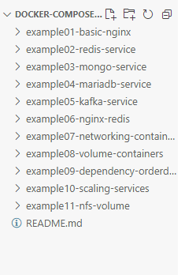

VS Code provides an extension for docker which gives you a provision to start, restart, stop, remove the containers without using the shell

Install this Docker & Docker extension pack in the VSCode

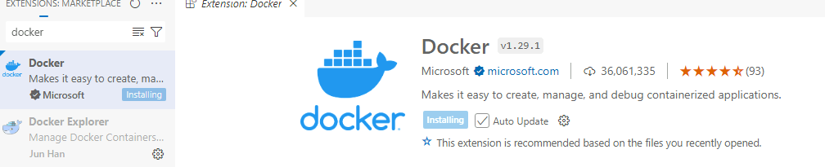

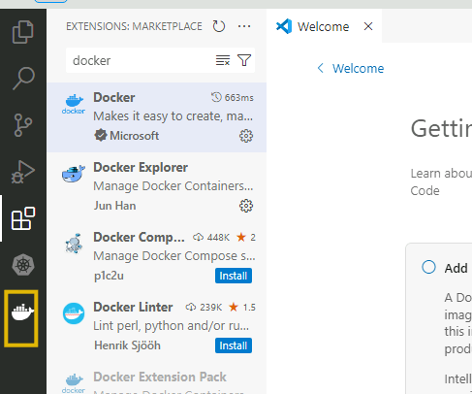

Click on the docker icon you must able to see the containers & images

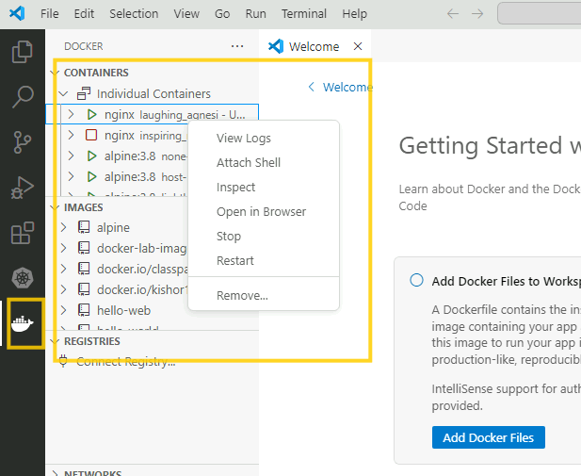

On clicking attach shell you see the shell that prompts

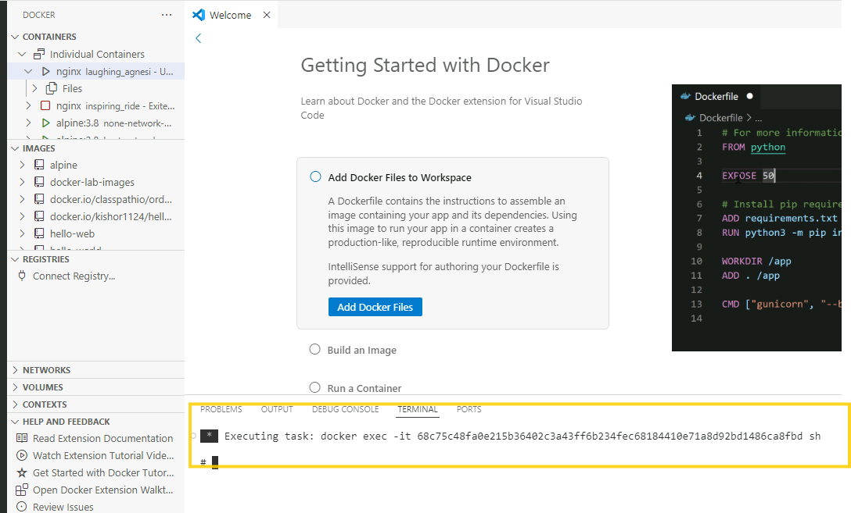

Install Docker Extension pack also

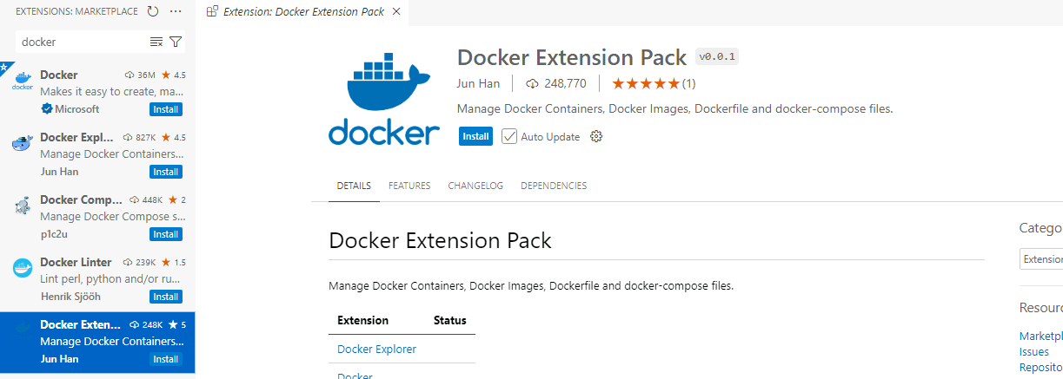

Open the first project where you will see docker-compose.yml file

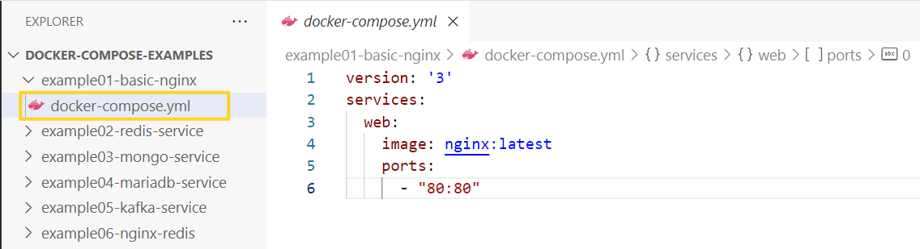

You see the instructions about the image & the port

Navigate to the example01 in the command prompt

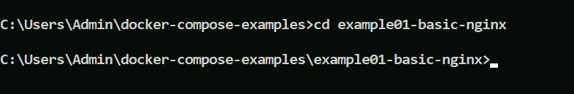

Use docker-compose up command

docker-compose up: creates the container

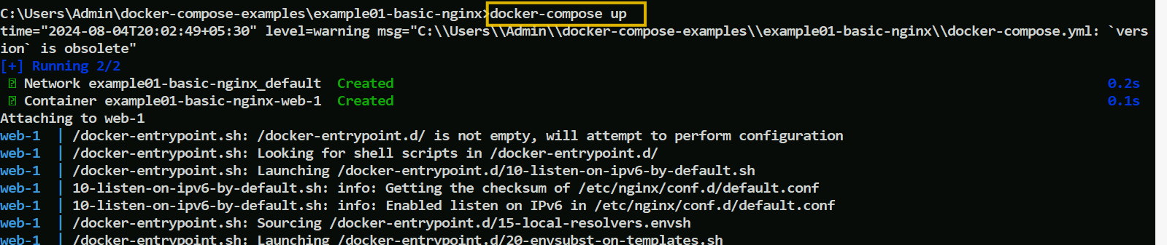

At the end the command prompt shows view in docker desktop like this

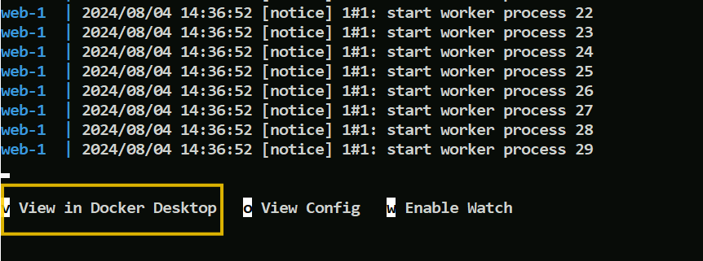

Goto docker desktop and you must be able to see the running container

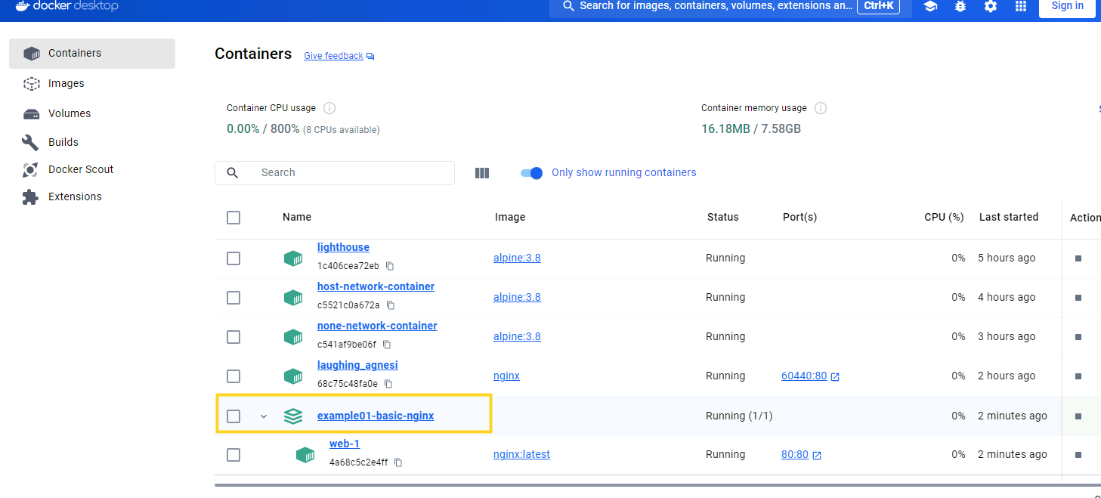

Click on it to see the container logs

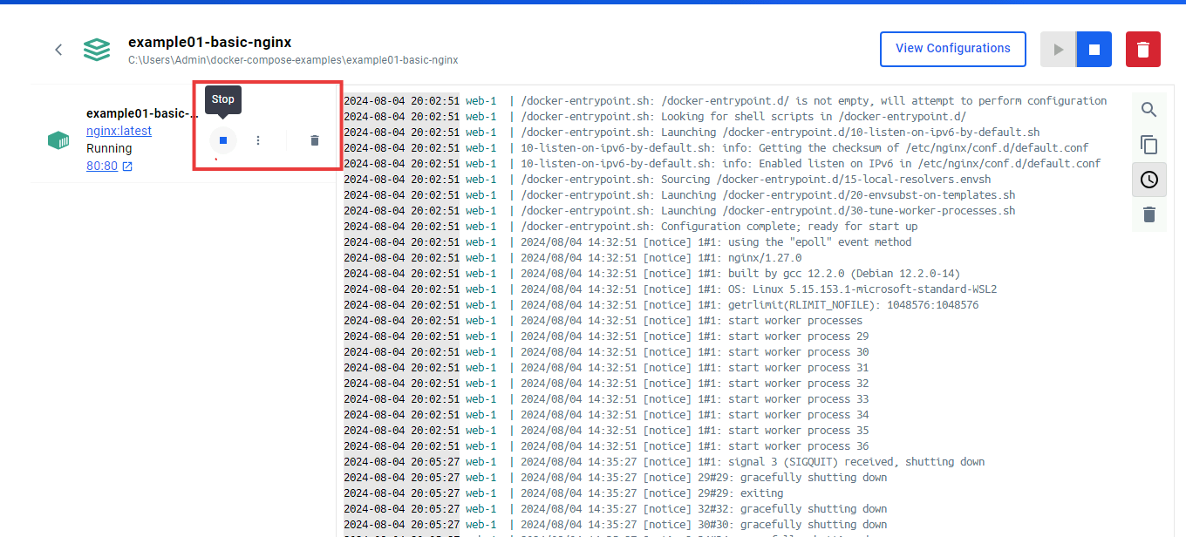

You can see you can stop or delete from the docker desktop

You can run with -d option for detach mode

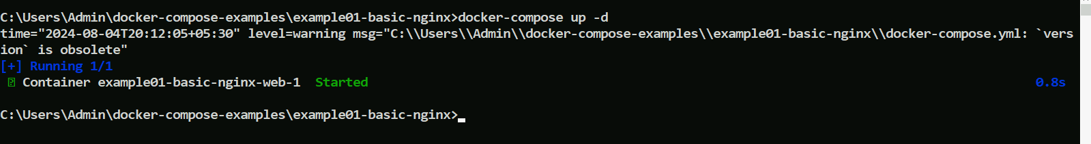

You can observe how to write the docker-compose.yml in the official documentation

example if you want to know what to write in the docker-compose.yml at the top level, you can visit the Compose file reference

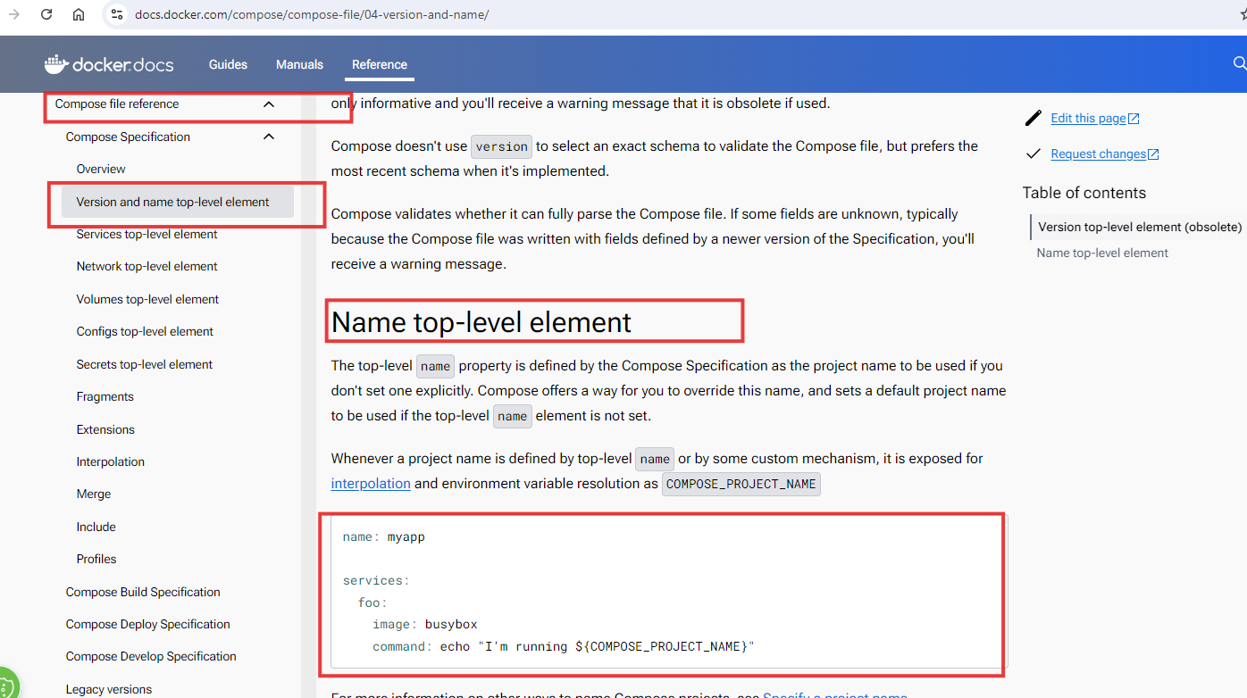

Now navigate to example02 where you have docker-compose configuration for redis

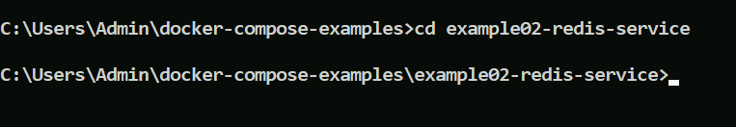

In the example02 there’s a compose.yml file

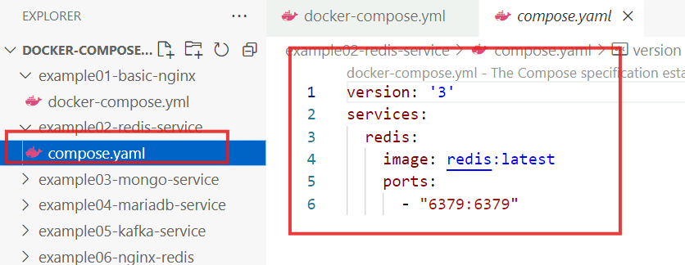

It has a redis image and the container is using 6379 and binds to 6379 port of the host

Redis is a in-memory database.

You just need to use docker-compose up -d

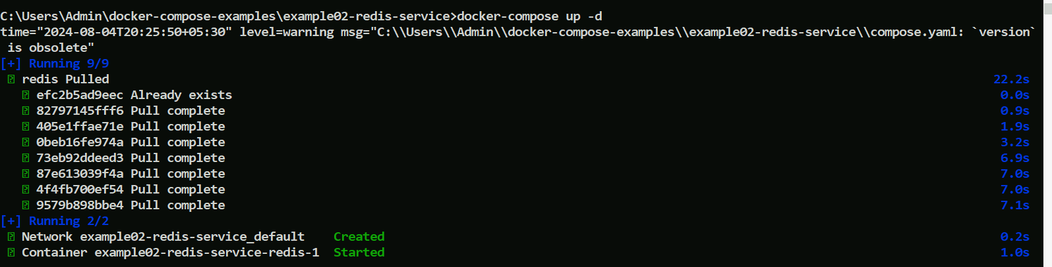

List the containers & network you must be able to see both the containers using bridge network

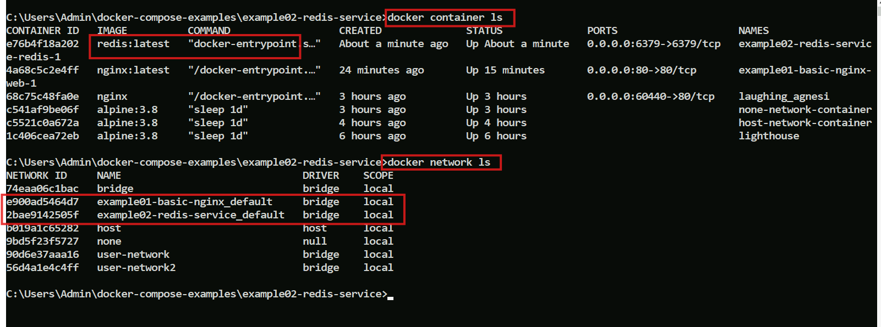

Note: The bridge network is automatically created, we didn’t configure network for the container

You can inspect using the network-id to see the redis container mapped to the bridge network

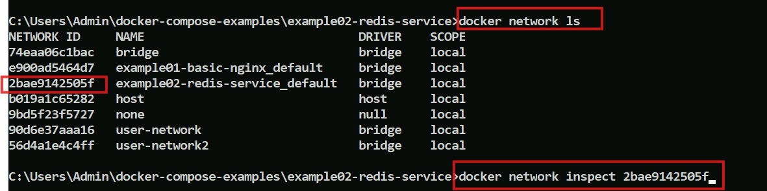

You will see the redis container attached to the network

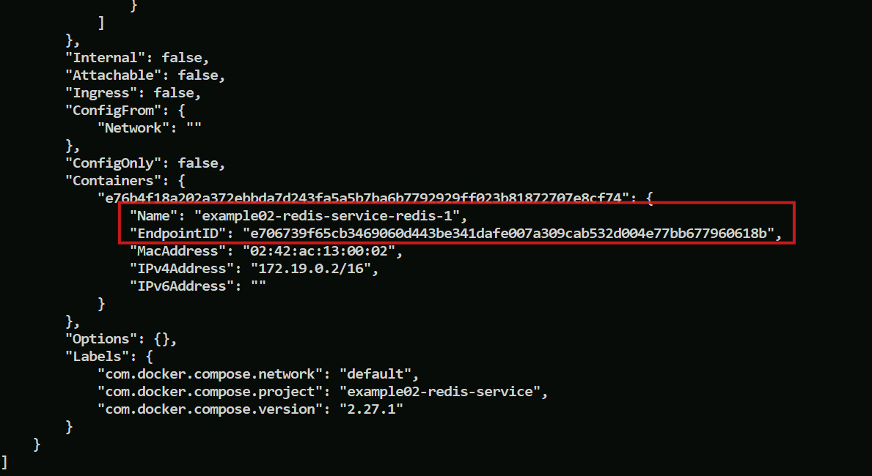

We can also inspect network for the first demo i.e., example01, which has different network id below is the output of the network inspect

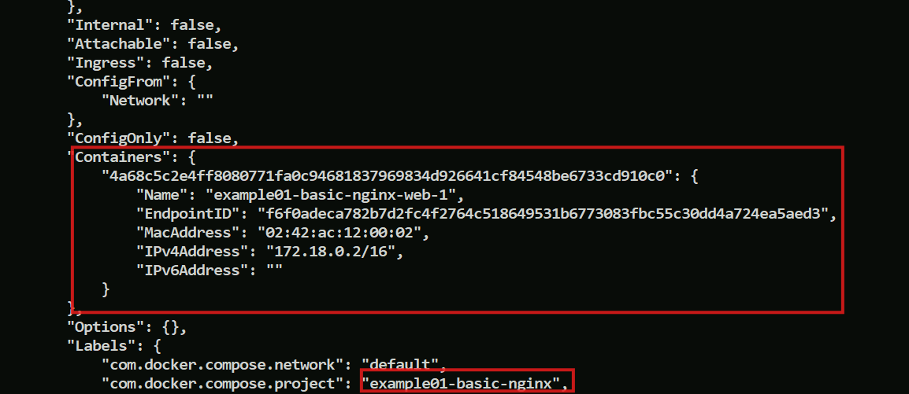

docker-compose down

This command deletes the container as well as the network, it is a clean way to manage your container

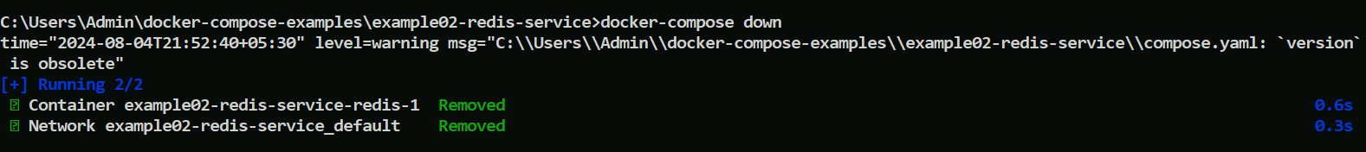

You don’t see the container & network of redis

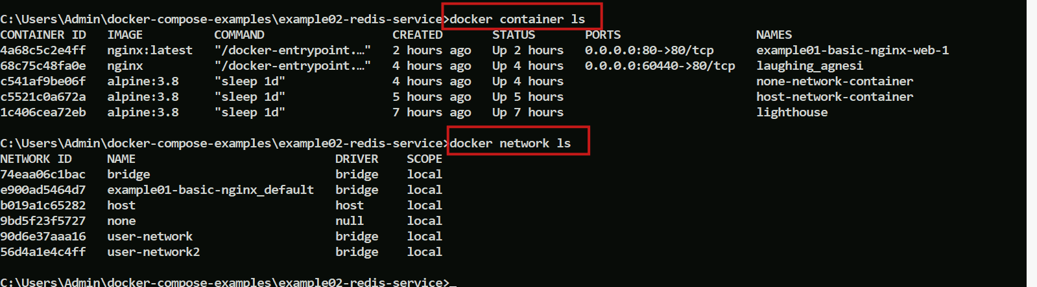

Will navigate to the 3rd example example03, here we have a different file mongo-db.yaml

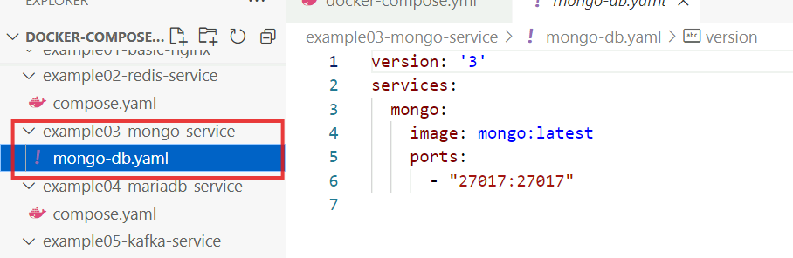

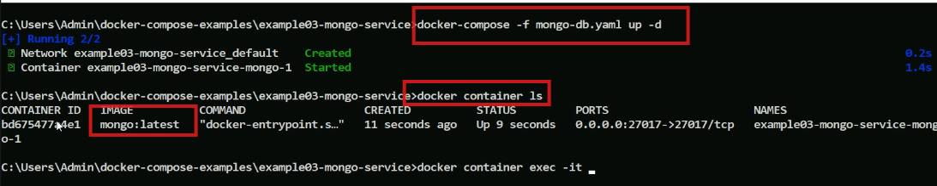

We use the -f option to specify the file name having docker compose commands as it has a different name, you can list the containers and network as they are automatically created.

You can go inside the container using the same docker container exec with mongosh

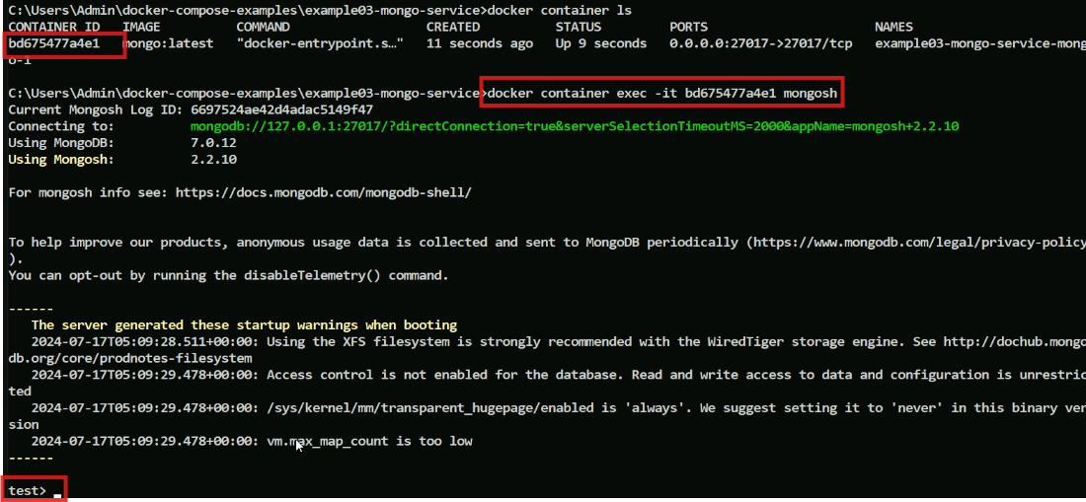

The 4th example is of mariadb, we will see few more options like env which has DB credentials

Navigate to the 4th example

Enter the docker-compose up -d command

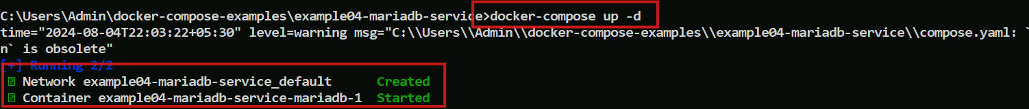

You can see container started and network created.

List the container to know the container-id so that we can use env

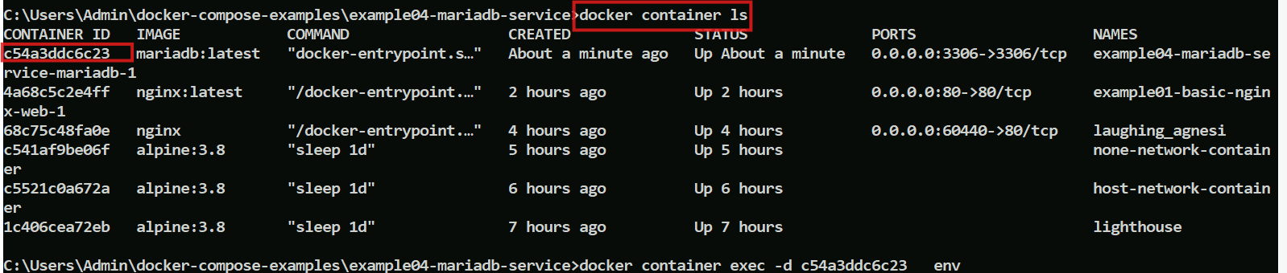

Listing the credentials of the mariadb

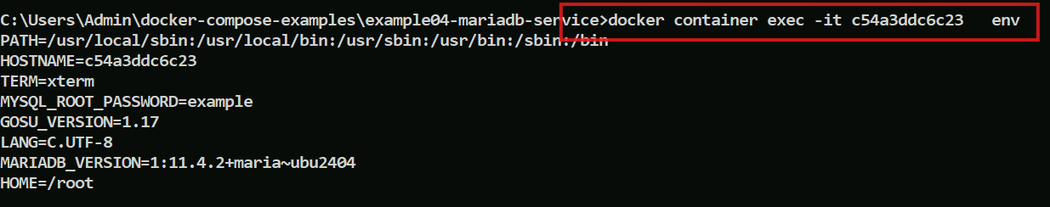

Let us remove the instances now with down command

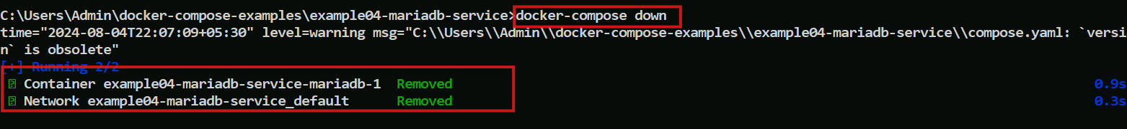

What are the other options we can use with docker-compose, just type docker-compose and hit enter you get below options that you can try like restart, rm, attach and etc.

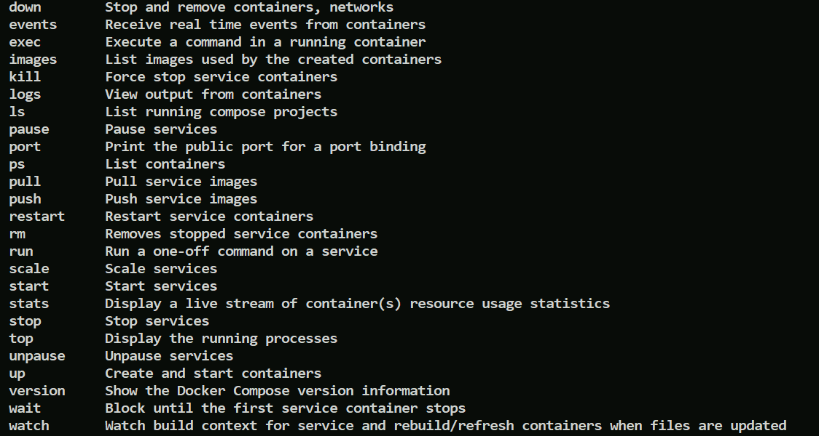

How to scale the container in docker-compose

Lets navigate to example06 which has this content in the docker compose file

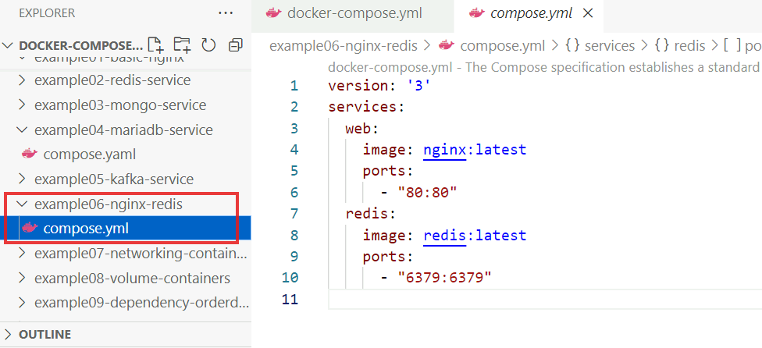

We can scale with a simple command using the services name web as below

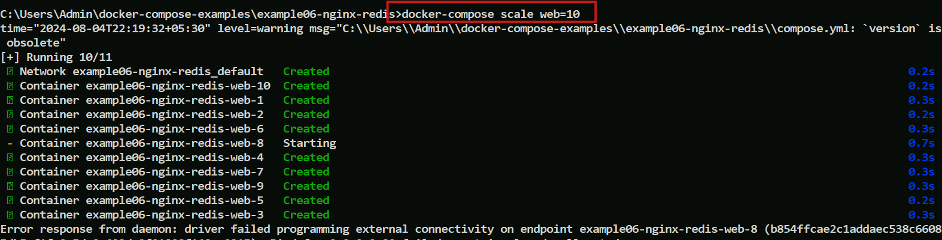

We can scale down by mentioning the lesser value

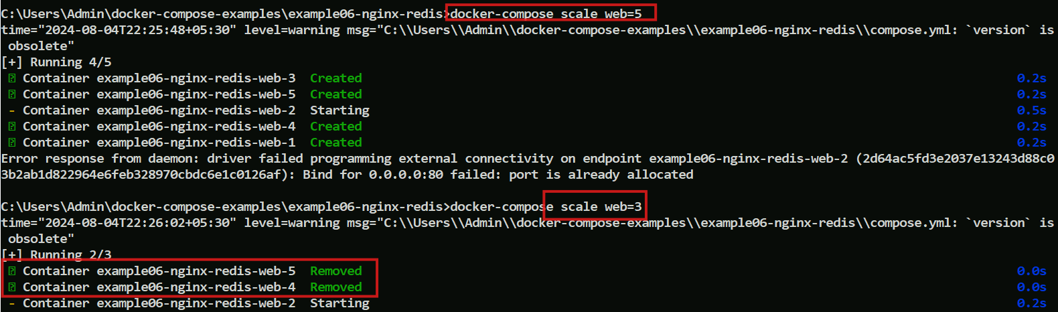

We can scale both the services at once with docker-compose as shown below

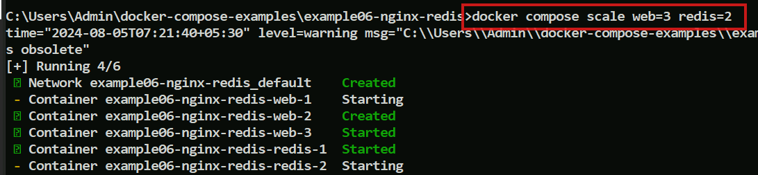

example10 has 2 containers

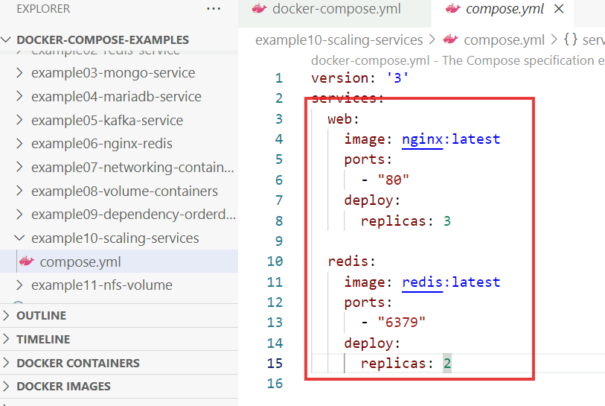

You can see the replicas which are number of instances of those images, we can navigate and run this file

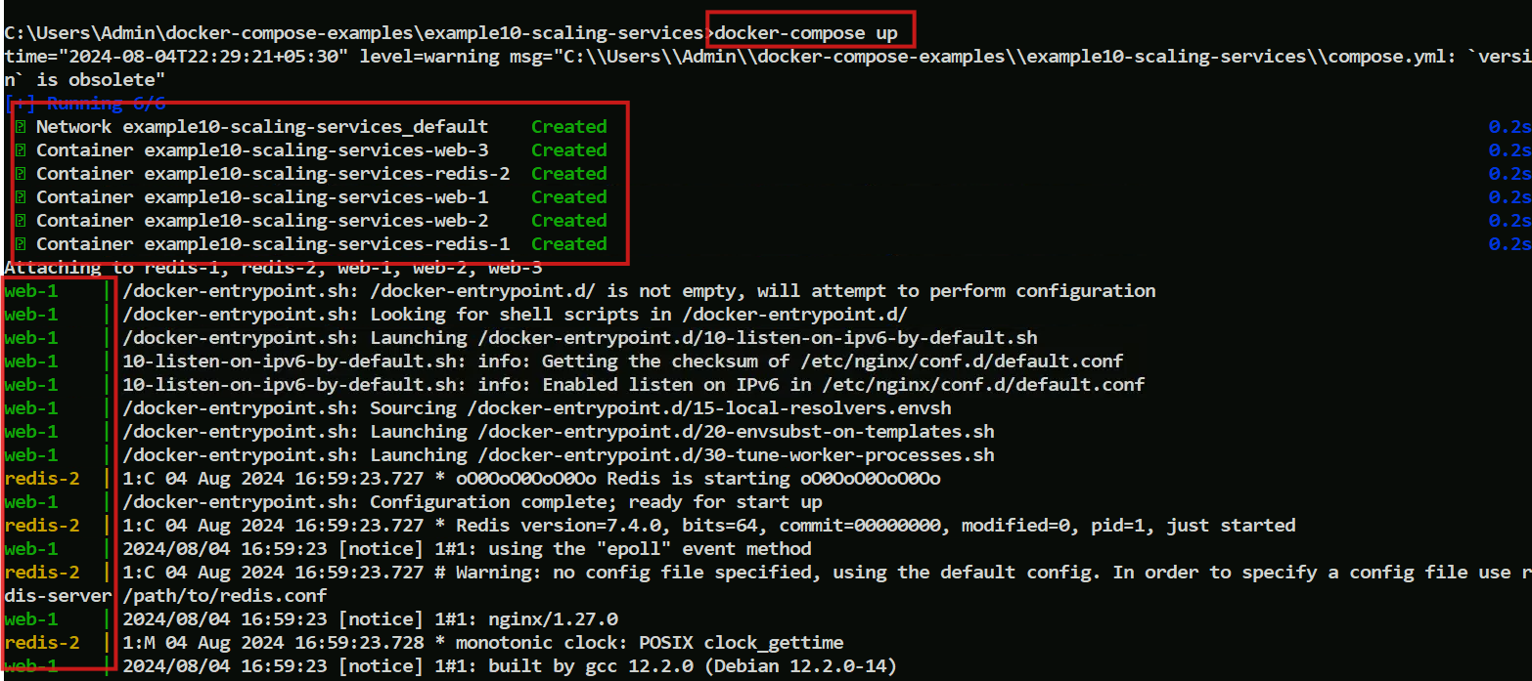

It is creating replicas for the containers, we can observe them in docker desktop as well

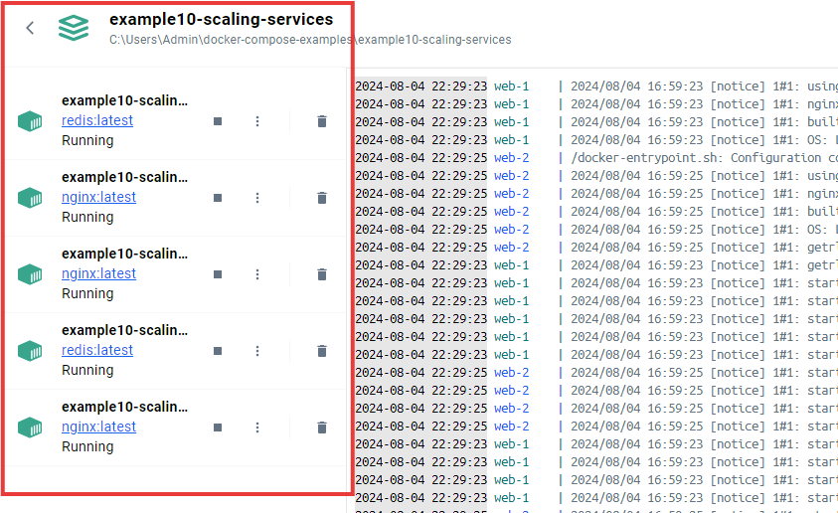

Listing the containers

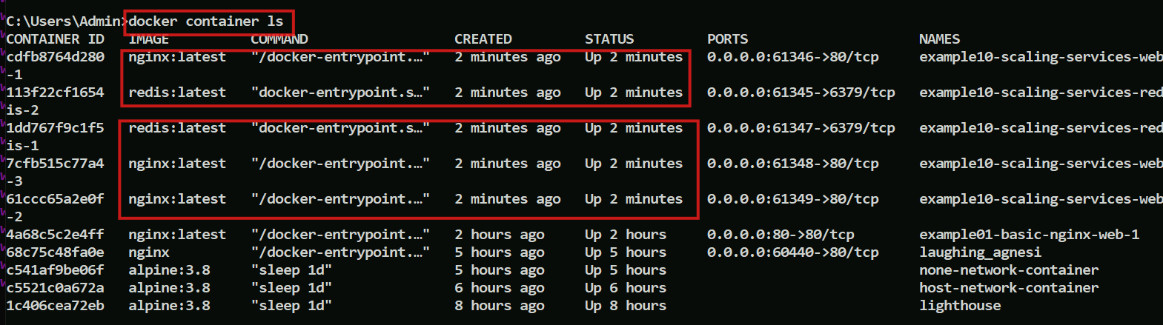

We can see 3 replicas of nginx and 2 replicas of redis

Docker swarm

Till now we have seen containers in single host, swarm helps to span containers in multiple host.

It is an orchestration engine available in docker to manage the docker containers, scaling the services, networking, managing the life cycle of the containers

Currently we were working with a single host/node cluster, which is good for your development, however we would need multiple host in the real time in that case we use a sophisticated orchestration container solution, which can create your container on multiple hosts and then they provide connectivity between the hosts, all together is considered as a cluster, for this we need docker swarm.

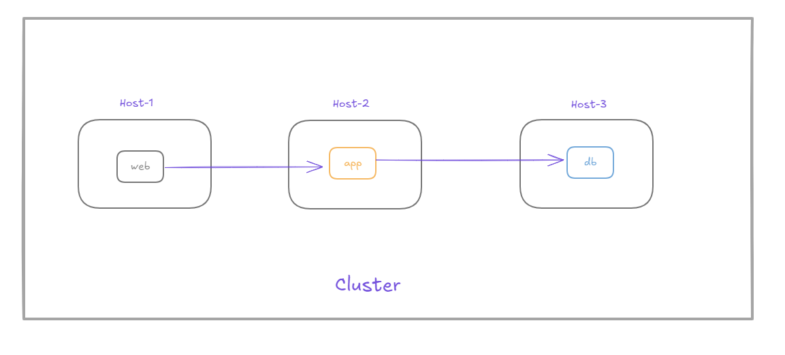

In the cluster there will be two nodes

1. worker nodes which are the instances of docker engine, who execute containers
2. manager nodes that manages the cluster state, scheduling services

Docker swarm is good for simple to medium applications, having only a few microservices and you don’t have the bandwidth of separate dedicated operations team to manage the cluster or you are working in pre-prod with small to medium applications, however if you have a complex deployment topology, you are going to work with having dedicated operations team then having full fledged container orchestration solution like Kubernetes is the right choice, because the full fledged container orchestration tool provides many features like deployment, scaling, resiliency, monitoring, health-checks and etc., Most of the companies are using Kubernetes as their container orchestration solution because it supports it provides a Container Runtime Interface to support many containers like Docker, Containerd, CRI-O and other implementations

First we will use docker swarm to get a glimpse of container orchestration solution

Swarm comes inbuilt in docker, but it will be inactive by default

Enter docker info and see the swarm option in the docker

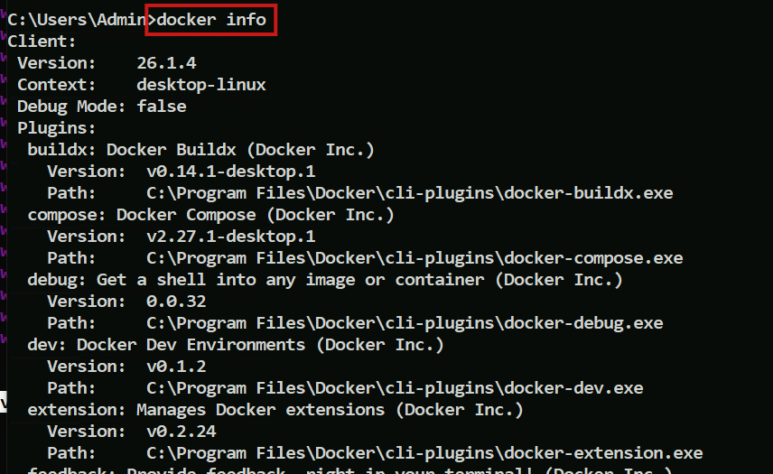 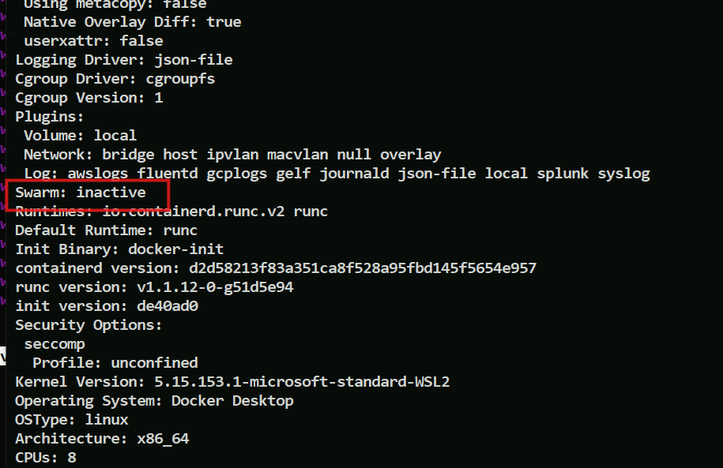

To initialize the swarm you must enter docker swarm init

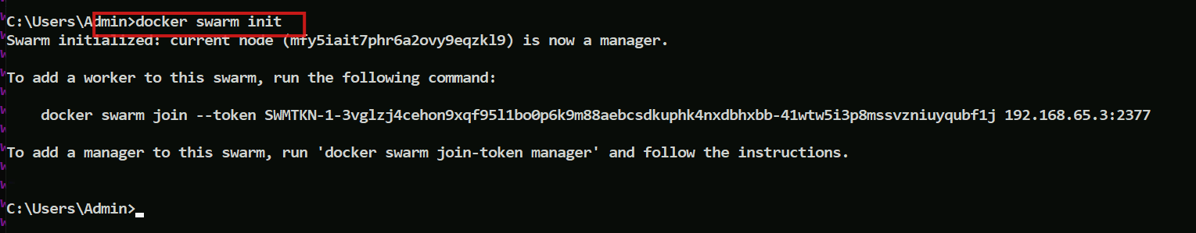

Then you get two messages to add a worker & add a manager to this swarm

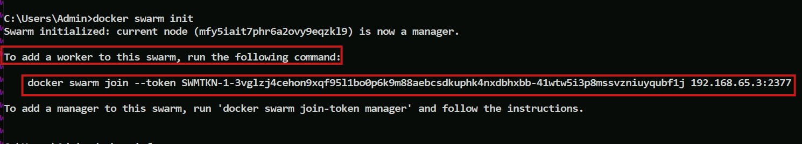

Let us see what docker info gives now

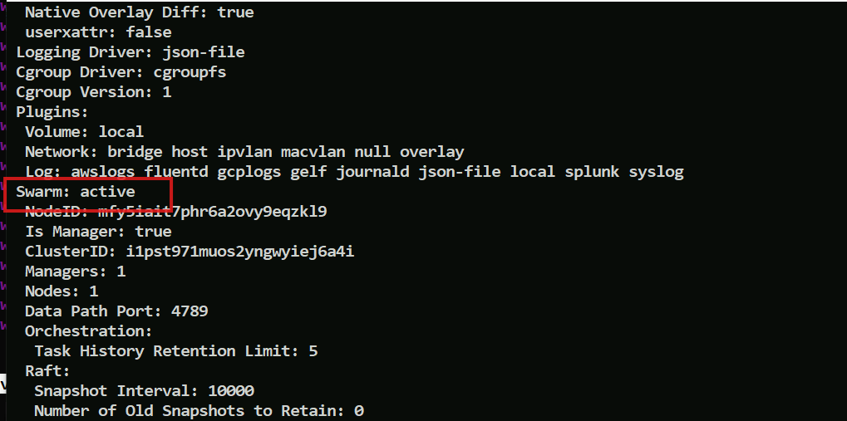

You can see swarm is active